SELF STUDY REPORT
(Cycle-2)
Reaccreditation

Submitted by:-

The Principal
Malyagiri Mahavidyalaya,Pallahara
Odisha-759 119

Track ID-ORCOGN12883

Submitted To :-

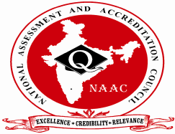
The Director
National Assessment and Accreditation Council
Bangalore-560 072
CONTENTS
--------------------------------
Page- No.
PART-I
1. Preface 2
2.Executive Summary- SWOC Analysis 4
3.Profile of the Institution 12

PART-II
4. Criterion Wise Analytical Reports
- Curricular Aspects 22
- Teaching-Learning and Evaluation 37
- Research, Consultancy and Extension 56
- Infrastructure and Learning Resources 70
- Student Support and Progression 83
- Governance, Leadership and Management 96
- Innovations and Best Practices 115

PART-III
5. Evaluative Report of the Departments 123

PART-IV
6.Post Accreditation Initiatives : 167

PART-V
7. Future Plans : 171
PART-VI
8(a). Declaration by the Head of the Institution 172
8(b). Certificate of Compliance 173

PART-VII (ANNEXURES)
9. Copy of 2f & 12 B Certificate.(Annexure-I) 175
10. Master Plan of the Institution.(Annexure-II) 176
11. Copy of Cycle-1 Accreditation Certificate.(Annexure-III) 178
12. Peer-Team Report (Cycle-1) (Annexure-IV as hard copy) 180
13. Certificates on the upload of AISHE data (2010-11 to 2014-15)
(Annexure-V) 194
14. Copy of UGC-XII-Plan Development Assistance Sanction Order
(Annexure-VI) 199
15. Information on Location of the College 200
PART-I
1.Preface
Malyagiri Mahavidyalaya ,Pallahara an affiliated College of Utkal University ,Odisha was established in the sub-divisional head-quarters Pallahara in the year 1979. The College is named according to the name “ The Malyagiri “ the third highest mountain of Odisha located in Pallahara.
The College has been recognized by Govt. of Odisha and affiliated to Utkal University to the Intermediate of Arts from the session 1981 and upgraded into degree College getting the affiliation for Bachelor of Arts course from the session 1984-85 which subsequently converted to +3 Arts stream. The honours teaching facilities in two subjects History & Pol. Sc. were introduced from the session 1992-93. Moreover the College is added a new feather into its cave by introducing +3 Science from the session 2000-01 and four new honours subjects from 2012-13. At present the College enjoys the status of a composite College having +2 Arts & Science and +3 Arts & Science faculties.
During the last 36 years the College has been catering to the needs of Higher education in an Educationally Backward and Underprivileged region of the state. The College comes under the districts which have educationally backward infrastructure as pointed out by Planning Commission of India in its Social Sector Development report. The Tahasildar ,Pallahara (local authority ) certifies that the College is established in a rural , SC/ST dominated and educationally backward Grama Panchayat area with SC/ST population of 54.58 % as per 2011 census.
This co-educational institute, the Premier centre of Higher Education has the objectives of imparting quality education to face the Challenges of life , helping to develop an all round personality of the students by inculcating civic values and promoting a general aura of self employment and gender equality.
The College stands on a forest land measuring 10 acres (4.068 ha) with hundreds of seasoned “ Sal Trees” (Shorea robusta) standing on & around the campus and a thick stretch of “Sal ” shrubs creates a calm & tranquil atmosphere of Shantiniketan.
The College is recognised under 12 f and 12B of UGC since 1993 vide UGC letter No . F-8-4/92 (CPP-1) dated 23 December, 1993. Assessment of an educational institution on quality parameters is important in achieving a place of prominence and making it a favourable destination for education. The College subjected itself to quality assessment by National Assessment And Accreditation Council (NAAC), Bangalore in the year 2006. It was assessed to our satisfaction and was accredited with at C++ level with a cumulative score of 69.00 with effective from October 17, 2006 under the old system of assessment. The Letter Of Intent (LOI) for the 2rd cycle was submitted on 7th July 2015. (Track ID number ORCOGN12883). SSR has been prepared by collecting documents & information from different sections and staffs and with internal discussions. The steering committee has been constituted and IQAC has played a vital role for the preparation of this SSR.

Much effort & time has expended for the preparation of SSR. We acknowledge the support , guidance and assistance received from everyone in particular from Dr. C.M.Pradhan Principal, Mr. K.C.Dash Steering Committee Coordinator , Mr.B.K. Acharya IQAC Coordinator , Mr. R.N.Sahu Lecturer in English and faculty & staff members.

December
2015
Coordinator
Steering Committee
DR. CHANDRAMANI PRADHAN
Principal
Malyagiri Mahavidyalaya
Pallahara
2.Executive Summary (SWOC Analysis)
Criterion –I : Curricular Aspects
The Primary aim of the college is to impart University education to the students of socio-economically backward ,underprivileged and ST & SC community dominated region to shape them morally upright , socially committed ,intellectually and scientifically trained.
The College functions with its vision & mission and runs two programmes BA & BSc under the Curriculum designed by the Utkal University. Our teachers submit their feedbacks to the members of the Board of Studies in their concerned subjects for their inclusion in the progressive revision of the courses. Though Annual system has been adopted, Utkal University has planned to implement the CBCS system from the next academic session. The lesson plans & progress register along with monthly course coverage feedback are being maintained for verification by the Principal and with the functioning of Academic Council & Bursars the curricula is effectively implemented. Monthly tests, remedial classes are also conducted. All sorts of available supports like encouragement for refresher/orientation courses are provided to the teachers to improve the teaching practices. The College has hired CMS-ERP for the library & office automation. ICT is being used in teachings during seminars/workshops/ meetings/ trainings etc and the teachers make use of various teaching aids, such as projectors, charts, maps, models etc. to make learning more appealing. It is difficult to interact with industries as there is no such industry in the vicinity.
The College provides higher education on 13 under graduate departments both in Arts and science with different combinations. It is an aided degree College that follows annual system with limited scope for horizontal mobility and elective options. There are core & elective options in the syllabi prescribed by the University. The College plans to open the study centre of Odisha State Open University for the combination of face-to-face and distance mode of education. The College has applied to the Registrar ,Utkal University ,for audit of academic affairs of the college .The majority of the faculty members are assigned with valuation works of both Hons. and Pass papers by the University.
Feedback is collected from stakeholders regarding the College curriculum and on all aspects.
As the vacant DP posts are not filled up in time the College appoints contractual and guest lecturers to maintain the proper academic standard. Due to lack of provisions of entrance during admission it is difficult to judge the students quality during admission.
Criterion –II : Teaching-Learning and Evaluation
The admission into UG classes is presently undertaken by e-admission process under SAMS (Students Admission Management System) of the Government of Odisha. However, proper weightage is being given to various categories, such as SC, ST, differently-abled, NCC, scout & guide, sports persons, etc. as per the reservation provisions of the government. The demand ratio in the admission to BA & BSc programmes gradually increases and hence increase of seats has been made from 64 to 92 in BSc .The college assesses the knowledge base of the students from their +2 marks. Thus, advanced and slow learners are identified. The students also discuss their problems with their proctors for bringing about necessary solutions. College prepares teaching and learning programmes, annually and monthly. Literary magazine, wall magazines have been introduced to encourage creative minds for cultivating critical thinking & innovative ideas. To enhance the quality of the teachers, the college administration encourages them to pursue higher studies such as M.Phil. & Ph.D. They are also advised to attend orientation and refresher courses organized by Universities/ Research Institutions and to participate in Seminars/ Workshops/ Conferences so as to make them more competent and meet the challenges of new curriculum more effectively. The students get the opportunity to see the evaluated scripts of college examinations. Model questions are provided to the students. The faculty members have been well informed to focus on learning outcomes during the process of teaching.
Remedial Classes are taken for the SC/ST/OBC (Non-Creamy layer)/Minority students. The institution maintains the practice of imparting holistic education with emphasis on the ethical and moral philosophy. The college being a coeducational institution sensitizes its staff and students on issues such as gender, inclusion, environment etc by holding departmental seminars , guest lectures, workshops, day celebrations etc.
The College plans its teaching-learning process by following academic calendar , CMS-guideline of Govt. and through IQAC.
Teachers are transferred & posted by DHE , Odisha and through SSB. GB of the College appoints against vacant DP posts & created posts. The major challenge to the institution is non availability of the qualified teaching staff as the College offers low salary to the newly recruited staff due to its limited financial resources and lack of clear policy of Govt. on Grant-in-Aid. The regular appointment against the vacant aided posts is restricted on the part of College and the same are not filled up by the Govt. over a long period. However teacher quality is being maintained through participation of teachers in refresher/orientation/seminar/workshops etc. About 80 % of our teachers are computer qualified.
Students performance is evaluated through the University Examinations, Test Examinations , monthly tests, home assignments ,seminars , proctorial classes and through class room interactions.
Due to lack of entrance examination during admission , the students are not properly screened as a result the input quality is not maintained and hence the result is comparatively low in some batches.
The College still maintains the quality of teachings though most of the teaching staffs are under Block Grant Payment and Management payment with low salary structures.

Criterion –III : Research, Consultancy and Extension
Although the college has limited research infrastructure of its own and it is not a recognised centre for research it allows the teacher to go on study leave to complete higher studies like M.Phil & Ph. D to keep their academic knowledge sharp, and interest alive.
The institution is proud of that Principal has received the Ph.D degree during last four years. Adjustments in workload are made to assist the teacher to improve the academic qualification. The College also allows the teachers to attend orientation and refresher courses to polish their knowledge.
There is a scope for availing UGC funds under minor research projects but no staff has availed this opportunity due to some personal and common causes during last four years.
The College has developed 6878 Nos. of Library Books and some of the major equipments out of UGC funds which can be utilised for research.
The College provides consultancy services free of cost in the locality and periphery through its staff and IQAC is planning to make MoU with some NGOs for collaborations for extension activities.
The College undertakes various extension activities with the help of N.S.S units & Red-Cross. It includes community development ,Population education ,Health awareness ,blood donation , forest conservation, empowerment of women , ST/SC .The N.S.S units of the College adopts villages periodically to develop socio-economic status and awareness.
Criterion –IV : Infrastructure and Learning Resources
The College has 10 acres (4.068 ha) of land .The infrastructural facilities includes 05 lecture halls , 09 class rooms, 05 laboratories , a general library with reprography , computers with internet connection, SAMS Laboratory, administrative block , girls’ common room with attached urinal , boys’ common room ,students’ union room , auditorium, a temporary canteen , staff common room with attached lavatory, sports room , two dug wells for water supply and a play ground .The teaching hours of the college are between 9:30 AM and 4:15 PM . The College is yet to develop its infrastructures like BSc Laboratories , Smart Class rooms , Boys & Girls Hostel , Boundary , Class rooms etc.
There are 6878 books in the general library and it subscribes 03 numbers of news papers for the benefits of the students and staff. The library is kept open from 10 AM to 5 PM on all working days .The annual working days of the library is 280 .The library has reprography facility. Library automation work is going on steadily. The networking job for computers of library & office has been completed. The data entry works for library books are under progress. The College has hired Online CMS-ERP with modules such as Library Management , Fee management , examination management etc. The College has purchased a dynamic website. After the uploading of books data OPAC will be available through the College website shortly. The College is planning to install three computers in library with internet facility. Besides ,there is a need of increasing the number of Books & Journals in the Library. So the College is planning to allot more funds for Books & Journals from XII-Plan UGC grants. The Library building is to be extended. Moreover links have been given to e-book resources through the College website.
Major equipments have been purchased for Science Laboratories out of UGC funds to meet the needs of +3 Science Practical classes. Moreover IT-Lab. has been developed out of XI-Plan UGC fund. ICT facilities have been enhanced by purchasing Computers , printers , Copiers , Scanners , Online Inverters. All the Class rooms have been fitted with Green boards for comfortable teachings. The College has power backup facilities with 03 Generators and Inverters.
Although the +3 Science stream has been opened since the session 2000-01 , the College has no resources to provide well furnished laboratories for the +3 Science students. So they depend upon the labs meant for +2 Science stream.
The play ground is inside the campus to facilitate the students to play outdoor games like cricket , foot ball , badminton & volley ball and indoor games like carom ,chess board ,table tennis are provided for utilisation of leisure. The college football team and cricket team join the university games and got selected for practice in university .The College provides T.A. and D.A as incentives for participation of such games. The teachers encourage the students for active participation in sports and Athletics that are organised annually. The outstanding sports persons are given certificates and cups to boost their spirit.
As the College fund is not sufficient and it is not possible to develop the infrastructure from its own resources.
Criterion –V : Student Support and Progression
The College publishes the College magazine , Calendar when fund permits and about 40 % of the students are provided with Free-ships and scholarships like PMS , SSG etc. But due to lack of awareness and arrangement of necessary documents some students do not apply for scholarships in due time. There are schemes of Senior merit scholarships , primary school teachers scholarships , scholarships for physically disables available to students. Students’ safety insurance is provided to all the students. Remedial coaching classes and Career Counselling are conducted for the betterment of the students. Grievance redressal Cell , sexual harassment cell & anti-ragging cell are functioning in the College to solve the problems of the students.
The passes out rate of two streams are satisfactory in some years. However the low % age of results in some years is due to low input quality during admission. The percentage of students appearing qualifying examination is as high as 89 %. The 11 % drop out is due to the poor economical condition of the parents and due to the getting of jobs without taking CLC from the institution. Although no record is maintained a good number of students get employment in both public and private sectors. Students are also selected to join Army ,police constables, teachers, IT-sectors etc. The teachers counsel the academically weaker students and motivate them to have self employment.
Though a good number of students are progressing for higher education or employment the data are not maintained by the College.
A pool of students participates in activities like sports & games, literary & cultural competitions and other extra-curricular activities. Every year the students participate in the inter-college sports & athletic meet organised by Utkal University. Mr. Linkan Kumar Pradhan, +3 1st Year Science has been selected to the University Football Team and has represented the University Team at Kerala & Gwalior during 2013-14.
Different academic & administrative bodies are functioning in the College for the smooth management of the institution.
The exact numbers of students who have appeared and qualified in various competitive examinations like NET, GATE, TOFEL , GMAT etc. are not recorded properly since it happens after the students complete their courses.
Criterion –VI : Governance, Leadership and Management
The administration of the College is managed by the Principal assisted by Academic Bursar, Administrative Bursar and Accounts Bursar. The College has an internal co-ordinating and monitoring mechanism through various academic and non-academic portfolios. Being the affiliated College of Utkal University ,it remains abide by the principles laid down by the University.
The College plans the various academic and non-academic activities as per the stated vision & mission of the institution. The Principal in synchronization with Staff Council, different committees, HODs, Students’ Union, Governing Bodies, NSS & YRC programme officers, IQAC Coordinator, different Bursars monitors all the institutional activities. As the College is a Grant-in-Aid College the decision regarding policy planning & implementation depends upon the Department of Higher Education, Govt. of Odisha and the affiliating University. Governing Body is the next to the DHE Govt. of Odisha in taking important decisions on the management of the institution and internal policy matters.
The College is under the e-admission process of SAMS developed by the Govt. of Odisha. Therefore, full transparency is maintained in the admission process with automation and everywhere accessible. The Common Minimum Standard (CMS) and the Common Academic Calendar provided by Govt. of Odisha is strictly followed.
To evaluate annual performance the CCR and Teachers’ Self Appraisals are maintained. As the vacant DP posts remain vacant for a longer period GB makes Guest & Contractual appointment in order to maintain the proper academic standard.
The College has introduced the system of collection of Feedback from students , teachers and other stakeholders. The faculty members are encouraged to attend in the staff development programmes such as Seminars, conferences , workshops , Orientation & refresher courses etc. and to join in individual M.Phil/Ph.D programmes.
Day to day administrative activities has been automated by the use of different online softwares provided by Govt. agencies such as Utkal University www.uuums.in, HRMS , treasury software , local fund audit software , Campus Management system-ERP , SAMS software etc.
The different welfare schemes have been adopted for the benefit of the teaching & non-teaching staff.
The College runs in a not-for-profit manner with the students’ fees & fines the only source of regular income. The College faces financial deficiencies as most of the students fund is utilised for the payment of staff salary to the management & block grant staff and as the college is located in a rural & economically underdeveloped area it does not charge much fees from the students. However for infrastructural development the College depends upon the funds of UGC , MLA & MP-LAD funds and other sources.
IQAC has been established in the College and is functioning as per the its guideline. Many decisions taken in the 1st meeting have been implemented.
Criterion –VII : Innovations and Best Practices
The College is established in a natural eco-friendly green environment with good number of “ Sal “ ( Shorea Robusta) and other trees standing on & around the campus and a thick stretch of “Sal ” shrubs creates a calm & tranquil atmosphere of Shantiniketan. Some steps have been taken for making the campus eco-friendly such as energy conservation, carbon neutrality and waste management. The Campus has been declared Polythene Free by the IQAC and accordingly polythenes are being avoided.
Many innovations have been implemented during the last four years which have created a positive impact on the functioning of the College, few of them are described below.
- Use of LCD projectors & OHPs in seminar teachings
- Issue of driving license to students by RTO office through Campus- Camp
- Renovations of staff common room
- Self defense training programmes for Girls students
- IQAC has been established
- e-admission process of SAMS under Govt. of Odisha.
- Monthly Tests
- Purchase of major IT-equipments and Laboratory equipments.
- Opening of New Hons. in Chemistry , Zoology , Economics & Odia Subjects
- IT-laboratory has been established
- Remedial Coaching Classes under UGC funding
- Networking of all the computers of Office , Library & SAMS with internet facilities has been done along with the purchase of Online CMS-ERP to facilitate the automation of Library and Office.
- Issue of in-campus driving license to the students by the RTO office , Talcher

----------

Principal
Malyagiri Mahavidyalaya
Pallahara

SELF STUDY REPORT
1.Profile of the College:-
1. Name and Address of the College:

Name : | MALYAGIRI MAHAVIDYALAYA , PALLAHARA
Address : | At/PO-Pallahara , Dist-Angul , Odisha ,PIN-759119
City : | Pin :759119 | State : Odisha
Website : | www.malyagirimahavidyalaya.ac.in
* The old website www.malyagirimahavidyalaya.org will expire in Jan-2016.
2. For Communication:

Designation | Name | Telephone  with STD code | Mobile | Fax | Email
Principal | Dr. Chandramani Pradhan | O:06765279232  R: | 9861446052 | 06765279133 | Malyagiri119@gmail.com
Vice Principal | - | O: R: | - | - | -
Steering Committee Co-ordinator | Kailash Chandra Dash | O:06765279232  R: | 9078435980 | 06765279133 | Kailashpuri14@rediffmail.com

3. Status of the Institution:
Affiliated College √
Constituent College
Any other (specify)

4. Type of Institution :-

a. By Gender
i. For Men
ii. For Women
iii. Co-education √

b. By Shift
i. Regular
ii. Day √
iii. Evening
5. It is a recognized minority institution?
Yes
No √

6. Sources of Funding :-
Government
Grant-in-Aid √
Self-Financing
Others
7. a. Date of establishment of the college: …25/06/1979… (dd/mm/yyyy)
b. University to which the college is affiliated /or which governs the college (If it is a constituent college)

UTKAL UNIVERSITY , BHUBANESWAR, ODISHA

c. Details of UGC recognition:

Under Section | Date, Month & Year  (dd-mm-yyyy) | Remarks(If any)
i. 2 (f) | 23-12-1993 | UGC letter No.F.8-4/92(CPP-I)  dt.23-12-1993
ii. 12 (B) | 23-12-1993 | UGC letter No.F.8-4/92(CPP-I)  dt.23-12-1993

(Enclose the Certificate of recognition u/s 2 (f) and 12 (B) of the UGC Act)- ENCLOSED-Annexure-I

d. Details of recognition/approval by statutory/regulatory bodies other than UGC (AICTE, NCTE, MCI, DCI, PCI, RCI etc.) N.A.

Under Section/  clause | Recognition/Approval details Institution/Department Programme | Day, Month and Year  (dd-mm-yyyy) | Validity | Remarks
i.

8. Does the affiliating university Act provide for conferment of autonomy (as recognized by the UGC), on its affiliated colleges ?
Yes No
√

If yes, has the College applied for availing the autonomous status?
Yes No √

9. Is the college recognized

a. by UGC as a College with Potential for Excellence (CPE)?
√
Yes No

If yes, date of recognition: …………………… (dd/mm/yyyy)

b. for its performance by any other governmental agency?

Yes No
√

If yes, Name of the agency NAAC…… and

Date of recognition: …………………… (dd/mm/yyyy)

10. Location of the campus and area in sq.mts:

Location * | Rural , Tribal
Campus area in sq. mts. | 40468.6
Built up area in sq. mts. | 2727
(* Urban, Semi-urban, Rural, Tribal, Hilly Area, Any others specify)

11. Facilities available on the campus (Tick the available facility and provide numbers or other details at appropriate places) or in case the institute has an agreement with other agencies in using any of the listed facilities provide information on the facilities covered under the agreement.
• Auditorium/seminar complex with infrastructural facilities √
• Sports facilities
∗ play ground √
∗ swimming pool
∗ gymnasium

- Hostel No HOSTEL
- Boys’ Hostel
    - No. of Hostels
    - No. of Inmates
    - Facilities (mention available facilities)

- Residential facilities for teaching and non-teaching staff (give numbers available — cadre wise) √
04 Government Quarters have been allotted to the College, outside the College Campus.
• Cafeteria — No

• Health centre – No
  - Canteen √

First aid, Inpatient, Outpatient, Emergency care facility, Ambulance…First Aid Facility available….

Health centre staff –
Qualified doctor | Full time | Part-time
Qualified Nurse | Full time | Part-time

• Facilities like banking, post office, book shops.-Available within 1.5 Kms from the College , in the Pallahara Town.

• Transport facilities to cater to the needs of students and staff
The does not have its own transport facilities. But the College is well connected to different places of the periphery through N.H.-49 , nearby Pallahara bus stand and other roads , so that a good number of students are coming to the College and returning to their home, daily through Public buses.

• Animal house No

• Biological waste disposal √
Yes, the College has compost pit where all the collected biological disposals are discarded.

• Generator or other facility for management/regulation of electricity and voltage √
03 Generators(6.5 KVA , 2.5 KVA , 2.5 KVA) and One separate electrical transformer has been installed inside the Campus. Inverters have been installed in staff common room(900VA) , Girls Common Room (900VA) and in Laboratories. Moreover for Office automation purpose 10 KVA Online Inverter has been installed in the Principal’s office and 6KVA Online inverter is in the IT-Laboratory.
• Solid waste management facility No

• Waste water management No

• Water harvesting Yes
Specially during rainy season , water is harvested into a small pond present within the campus, which is utilised for useful purposes.

12. Details of programmes offered by the college (2015-16).

SI. No. | Programme  Level | Name of the  Programme/  Course | Duration | Entry  Qualification | Medium of instruction | Sanctioned/  approved  Student  strength | No. of students admitted
1 | Under-Graduate | BA(+3 Arts) | 03 years | +2 Arts/ Science | English & Odia | 3X128=384 | 324
2 | Under-Graduate | BSc(+3 Science) | 03 years | +2 Science | English | 2X64+92=220 | 192
 | Post-Graduate | - | - | - | - | - | -
 | Any Other (specify and provide details) | - | - | - | - | - | -

NB-20 % additional seats have been declared by DHE , Odisha for admission into +3 1st Year courses for the session 2015-16. Moreover though seat has been increased from 64 to 92 in +3 Science from the session 2015-16, the permission letter has been received after the admission process is over.
13. Does the college offer self-financed Programmes?
√
Yes No

If yes, how many?

14. New programmes introduced in the college during the last five years if any?

Yes |  | No | √ | Number
New Hons.Subjects in Economics & Odia and Chemistry & Zoology have been opened from the session 2012-13.

15. List the departments: (respond if applicable only and do not list facilities like Library, Physical Education as departments, unless they are also offering academic degree awarding programmes. Similarly, do not list the departments offering common compulsory subjects for all the programmes like English, regional languages etc.)

Faculty | Departments  (eg. Physics, Botany, History etc.) | UG | PG | Research
Science | English , Odia , PHY, CHEM, Math., Bot, Zoo , IT. | √
Arts | English , Odia ,Hist., Pol. Sc. , Eco , Philosophy ,Sociology. | √
Commerce
Any Other
(Specify)

16. Number of Programmes offered under (Programme means a degree course like BA, BSc, MA, M.Com…)
02
a. annual system

b. semester system Nil
c. trimester system Nil
17. Number of Programmes with
NIL

a. Choice Based Credit System

b. Inter/Multidisciplinary Approach
NIL

c. Any other (specify and provide details)
NIL

18. Does the college offer UG and/or PG programmes in Teacher Education?
√

√
Yes No

19. Does the college offer UG or PG programme in Physical Education?

Yes No

20. Number of teaching and non-teaching positions in the Institution

Positions | Teaching faculty |  |  |  |  |  | Non-teaching staff |  | Technical staff/  Demonstrator
 | Professor |  | Associate  Professor |  | Assistant  Professor
 | *M | *F | *M | *F | *M | *F | *M | *F | *M | *F
Sanctioned by the UGC / University / State Government  Recruited |  |  | 01 | 00 | 08 | 01 | 16 | 01 | 03 | 00
Yet to recruit |  |  | 04 |  | 05 |  | 02
Sanctioned by the Management/ society or other authorized bodies Recruited |  |  |  |  | 11 | 01 | 01 | 00 | 00 | 01
Yet to recruit |  |  |  |  | 02 |  |  |  | 03
*M-Male *F-Female

21. Qualifications of the teaching staff:

Highest qualification | Professor |  | Associate  Professor |  | Assistant  Professor |  | Total
 | Male | Female | Male | Female | Male | Female
Permanent teachers
D.Sc./D.Litt.
Ph.D. |  |  | 01 |  | 01
M.Phil. |  |  |  |  | 06 | 01
PG |  |  |  |  | 07 | 02
Temporary teachers
Ph.D.
M.Phil. |  |  |  |  |  | 01
PG |  |  |  |  |  | 01
Part-time teachers
Ph.D.
M.Phil.
PG |  |  |  |  | 02 | 01
04
22. Number of Visiting Faculty /Guest Faculty engaged with the College.

23. Furnish the number of the students admitted to the college during the last four academic years.

Categories | 2011-12 |  | 2012-13 |  | 2013-14 |  | 2014-15
 | Male | Female | Male | Female | Male | Female | Male | Female
SC | 30 | 24 | 37 | 23 | 39 | 30 | 33 | 22
ST | 50 | 24 | 47 | 19 | 63 | 26 | 51 | 31
OBC/General* | 131 | 113 | 127 | 112 | 160 | 143 | 178 | 156
General
Others
*In the OBC/General category more than 90 % students belong to OBC.
24. Details on students enrolment in the college during the current academic year: (2015-16)

Type of students | UG | PG | M. Phil. | Ph.D. | Total
Students from the same  state where the college is located | 516 |  |  |  | 516
Students from other states of India | -
NRI students | -
Foreign students | -
Total | 516 |  |  |  | 516

25. Dropout rate in UG and PG (average of the last two batches.) UG PG
11 %
The above dropout % age is based on the number of students who have not appeared the Final year examination and also have not taken CLC. But the actual drop out may be too less as most of the students get a job before appearing the final exam. and without taking the CLC; whose data is not maintained by the College.
26. Unit Cost of Education
(Unit cost = total annual recurring expenditure (actual) divided by total number of students enrolled )

(a) including the salary component
Rs. 24336.00

(b) excluding the salary component
Rs. 3709.00

27. Does the college offer any programme/s in distance education mode (DEP)?

Yes No
√

28. Provide Teacher-student ratio for each of the programme/course offered.
BA:- 1: 20.25
BSc:- 1: 11.29

29. Is the college applying for

Accreditation : Cycle 1 Cycle 2 √ Cycle 3

Re-Assessment:

(Cycle 1refers to first accreditation and Cycle 2, Cycle 3 and Cycle 4 refers to re- accreditation)

30. Date of accreditation* (applicable for Cycle 2, Cycle 3, Cycle 4 and re-assessment only)

Cycle-1-17/10/2006 (dd/mm/yyyy) Accreditation Result…C⁺⁺
Cycle-2..........(dd/mm/yyyy)Accreditation Outcome/Result…….....
* Kindly enclose copy of accreditation certificate(s) and peer team report(s) as an annexure. (ENCLOSED)

31. Number of working days during the last academic year.

241 Days

32. Number of teaching days during the last academic year
(Teaching days means days on which lectures were engaged excluding the examination days)
182 Days

33. Date of establishment of Internal Quality Assurance Cell (IQAC) IQAC 09/08/2014 (dd/mm/yyyy)
Though the IQAC Committee was constituted on 08/07/2010, no significant progress of the Cell was seen from this date and even no AQAR was submitted. After getting UGC fund of Rs. 3.00 Lakh , the Cell was reconstituted & established on 09/08/2014 and from this date it is functioning properly.

34. Details regarding submission of Annual Quality Assurance Reports (AQAR) to NAAC.
.

AQAR (i) 2014-15 Submitted on 13/11/2015
AQAR (ii) ……………… (dd/mm/yyyy)
AQAR(iii) ……………… (dd/mm/yyyy)
AQAR (iv) ……………… (dd/mm/yyyy)
35. Any other relevant data (not covered above) the college would like to include. (Do not include explanatory/descriptive information).

The College is located in an educationally backward, Rural block which is also dominated by SC , ST and OBC.
--------

Criterion Wise Reports

PART-II

Criterion-I
(Curricular Aspects)
CRITERION I: CURRICULAR ASPECTS

1.1 Curriculum Planning and Implementation

1.1.1 State the vision, mission and objectives of the institution, and describe how these are communicated to the students, teachers, staff and other stakeholders.

OUR SLOGAN
“ Satya Meba Jayate”
OUR VISION
“To Become A Friend , Philosopher & Guide of the Region by Incessantly Dispelling Ignorance And Inculcating Self-Confidence & Knowledge.”
OUR MISSION
- To promote quality Higher Education through dedication and honest labour.
- To generate opportunities for Employment and Community development.
- To develop a Platform for Access to the world of Information.
- To train the youth to get involved in socio-economic growth of the region & lead a decent life.
- To promote a sense of gender equality and to introspect the needs of the weaker section with sympathy.

OUR OBJECTIVES
- Promote Quality Higher Education:-
The College cherishes a goal of providing quality educational programmes , services and opportunities for successful completion of degrees.
- Dedication & Honest Labour:-
The teachers & employees put their head & soul together to enhance and enrich the standard of the students.
- Opportunities for Employment:-
The College prepares students with educational foundation , knowledge & skills to face the challenges of the 21st century.
- Community development:-
The NSS , Red-Cross , Scout & Guide etc. of the College extend helping hands to the rural poor of the periphery by organizing vocational camps.
- Platform for Access:-
The College trains all students to be skilled & competent to enter the world of internet and avail the world of books.
- Train the Youth:-
The College trains the youth to develop a work force allied with socio-economic empowerment.
- Decent Life :-
The College teaches the sermon “Honesty bears a beautiful face ”.
- Gender Equality:-
The coeducation does not allow dichotomy between male & female in any field.
- Needs of weaker sections:-
The College collaborates with NGOs & GOs of the area for economic development of densely populated ST ,SC & OBC & disadvantage groups.
Institutional Motto
“Enter Here To Learn,
Go Forth To Serve”
Communication to the Stakeholders
Vision , Mission & Objectives are communicated to different stakeholders through :-
a) Website of the College.
b) printing in the College Magazine
c) Wall Painting in primary location of the campus.
d) interaction and meeting with them
e) Various activities conducted by the College.
1.1.2 How does the institution develop and deploy action plans for effective implementation of the curriculum? Give details of the process and substantiate through specific example(s).
- The College is affiliated to Utkal University . The curricula of BA & BSc programme are designed by the Board of Studies of the University. Suggestions are given to the member of Board of Studies regarding the development of curricula through interactions during valuation works , subject seminar/workshops/ conferences and other events. Our teachers have contributed through suggestions for the development of curricula of Choice Based Credit System(CBCS) which is going to be implemented in all the Colleges of Utkal University from the next session.
- The College has an Academic Council consisting of all HODs , Academic bursar , OICs of Examinations and where the Principal is the Chairman. Before the commencement of academic session, meeting of the academic council is conducted to review the progress and performance of the previous year and frames the action plan for the current session for the effective implementation of curricula.
- At the beginning of the session pre-printed lesson Plan & Progress registers are issued to teachers , which are maintained meticulously by them. Units and chapters are distributed with No. of periods required for completion and also daily progress of the courses are reflected in the lesson Plan & Progress register which is countersigned by the HOD and finally verified by the Principal every month.
- The teachers submit the monthly course completion report in a format designed by IQAC stating the No. of Chapters/Units allotted, completed & remained and also the weekly class taken report to the Principal.
- Monthly Unit tests are conducted and assignments are given internally by the teacher besides the normal Test Examination in order to monitor the progress of the students.
- Besides the normal classes , UGC sponsored Remedial Coaching Classes are conducted for the SC , ST , Minority and OBC (Non-Creamy layer) in order to improve their performance. In our College a major portion of the students belong to this group.
- Academic Calendar is prepared every year following the Calendar supplied by the Dept. of Higher Education Govt. of Odisha.
- Staff Council meets at regular interval and when needed to discuss the academic progress of each department and designs methods for effective implementation of curricula.
- The faculty members use Information Technology to know the current development in their subject and use them in the class room teaching to upgrade the knowledge & understanding of the students and take adequate care to complete the courses in time.

1.1.3 What type of support (procedural and practical) do the teachers receive (from the University and/or institution) for effectively translating the curriculum and improving teaching practices?
- Utkal University conducts Refresher courses, Orientation courses , workshops etc. at regular intervals through its Academic Staff College to update the teaching aptitude and knowledge of the teachers.
- The College encourages the teachers to participate in the said programmes by sending the names to the Director Higher Education , Odisha , Bhubaneswar because an aided lecturer/reader cannot directly apply to the University for refresher courses etc. During the session 2014-15 , names of two lecturers i.e. Kailash Chandra Dash , Lect. in Philosophy and Bhupen Ku Acharya , Lecturer in Chemistry have been forwarded to the Director for refresher courses. The teachers also attend the same courses conducted by other Universities inside and outside the state after getting permissions from the Govt. of Odisha.
- The College allows the teachers to use computers with internet facility , Wi-Fi (in a small area) in order to update their knowledge.
- The College library is wealthy with books , some journals & Magazines , News papers etc. which are being used by the teachers.
- Some teaching departments like Chemistry , Botany , Zoology are supplied with Teaching Models , Charts , software etc. to enable the teachers for effective delivery of curriculum.
- The College allows the teachers to attend the Seminar/Conferences /symposium/ Conferences organised by other Institution , to improve the depth of knowledge in the respective fields.
- The teachers are allowed to make Xerox copies of lesson notes and hand-outs and other teaching materials freely , required for the students.
- Recently the College has hired Online Campus Management System-ERP software through which every teacher can login online and can give assignments to students. Also OPAC will be available within few days through the College website.
- Student Feedback on teachers and curricula is implemented to make teaching-earning more successful.
- The College has planned to send the marks of internal/test examinations by SMS to the parents/guardians of the students through the CMS-ERP software which has been already purchased.

1.1.4 Specify the initiatives taken up or contribution made by the institution for effective curriculum delivery and transaction on the Curriculum provided by the affiliating University or other Statutory agency.
- In spite of restrictions from the Govt. College publishes advertisement for the filling up vacant teaching posts and pay salary from its own limited resources in order to maintain better academic standard. Principal also informs the Govt. to fill up the vacant aided posts.
- College provides latest text books and reference books.
- Modern teaching aids like LCD Projectors, Document Camera, Software(ChemDoodle) are provided for the departmental seminars and other activities.
- Green Chalk boards have been fixed in all most all the Class rooms.
- Provides internet facilities to the teachers to upgrade their knowledge by downloading the study materials.
- Implementing Academic Calendar and Schedule of Teaching works.
- Organising Guest Lectures.
- The Principal of the College takes necessary steps to reduce academic losses.
- Extra Classes and Remedial Classes are taken to clear the doubts of the students.

1.1.5 How does the institution network and interact with beneficiaries such as industry, research bodies and the university in effective operationalisation of the curriculum?
- The institution is taking efforts to network and interact with the industries of Angul District , Commercial establishments ,research bodies and Universities. The main purpose of this is better academic exposures and to increase employability of the students.
- Reputed persons from Industries like NALCO and other beneficiaries are sometimes invited to the College during Annual Day Celebrations and other occasions. Students interact with them and gather knowledge regarding the qualifications required and recruitment procedure for getting a job in their organisation.
- Students visit the industries , universities & other establishments during their Annual excursions & picnic , meet the experts and acquire knowledge in order to strengthen their curricular progress and practical understanding.
- Experts and academicians from Universities are invited to the College to deliver lecture on career counselling and other burning topics to strengthen the will of the students for the curricula.
- The affiliation team consisting of Professors of the Utkal University visits the College for inspection and interact with the students and advice them how to get a seat in PG departments and scope for employment.
- The Colleges faces difficulties in inviting resource persons as it is situated in a remote place which is 100 KMs from the district Headquarters and 220 Kms from the State Capital. There are no such large industries in the Pallahara subdivision where the College is located.

1.1.6 What are the contributions of the institution and/or its staff members to the development of the curriculum by the University?(number of staff members/departments represented on the Board of Studies, student feedback, teacher feedback, stakeholder feedback provided, specific suggestions etc.
- The curricula are normally developed by the affiliating University through its Board of Studies. The College collects feedback in online and offline modes from the teachers, students , alumni , parents etc. regarding the modifications in the present curricula and implementation of new. The same is intimated to the HODs of the PG Departments of the University who are the members of the Board of studies.
- Some of our teachers have completed Ph.D from the Utkal University to which the College is affiliated and some teachers have passed out from the same. Therefore, they are in constant touch with the Professors and HODs of those PG Departments. The teachers suggest them on the modification of existing syllabus citing the problems during teaching to students.
- Teachers of our College meet the senior members of their subject, who are the members of Board of studies of University during the examination valuation works. They discuss and suggest the members on the development of curricula of the University.
- The affiliating team consisting of Professors of the Utkal University visits the College interacts with the teachers and collect feedback on modification of present syllabus.
- Directly or indirectly our teachers have contributed to the CBCS syllabus developed by the Utkal University and which is going to be implemented from 2016-17 session.

1.1.7 Does the institution develop curriculum for any of the courses offered (other than those under the purview of the affiliating university)by it? If ‘yes’, give details on the process (’Needs Assessment’, design, development and planning) and the courses for which the curriculum has been developed.
The curricula of the programme(BA & BSc) offered by the College are developed by the Utkal University and the College has no freedom to develop the curricula directly for the same programme. At present the College does not offer any course of its own other than those by the affiliating University.
1.1.8 How does institution analyze/ensure that the stated objectives of curriculum are achieved in the course of implementation?
- Principal verifies regularly the Lesson Plan & Progress registers maintained by the faculties. Class inspection in presence and in absence of the Class teacher is carried out by the Principal in order to know the actual progress of courses and to examine the teaching ability of the concerned teacher.
- Monthly feedback on course completion and classes taken are submitted by each teacher to the Principal.
- Academic calendar is prepared by the Academic Bursar with the help of some senior most faculties and by following the Govt. guidelines.
- Based on the above records ,the College academic council and staff council meets in regular interval to analyse whether the stated objectives of the curriculum are achieved in the course implementation. The conclusion drawn from those meetings are informed to the teaching staff for the improvement of stated objectives.
- The Principal also meets the members of different departments periodically to ascertain the successful implementation of the Lesson Plan.
1.2 Academic Flexibility
1.2.1 Specifying the goals and objectives give details of the certificate/diploma/ skill development courses etc., offered by the institution.
On the basis of the local needs and to meet the demands at National & Global level , the College offers two programmes BA & BSc with the following course details.
Programme | Details
BA | Honours :-History , Pol. Sc , Economics , Odia  Pass :-History , Pol. Sc, Odia , Economics  Compulsory:- English , MIL , Indian Society & Culture , Environmental Studies , Population Studies.  Electives :-Land Marks in Indian History , Indian Polity , Odia ,Philosophy , Indian Economy
BSc | Honours:-Chemistry , Zoology  Pass :-Physics , Chemistry , Mathematics , Botany , Zoology  Compulsory:- English , MIL , Information Technology , Environmental Studies , Indian Society & Culture  Minor Elective :-Mathematics , Biology  Major Electives :- Chemistry , Physics , Mathematics.
Excluding the above :-
- The College offers Self Defence Training to Girls Students which is a skill development programme funded by Govt. of Odisha.
- The Equal Opportunity Cell of the College which is funded by UGC has undertaken a Short Term Course on “Positive Discrimination of SC/ST for National Development” for the newly enrolled students.
- The College has planned to introduce vocational courses in near future.

1.2.2 Does the institution offer programmes that facilitate twinning
/dual degree? If ‘yes’, give details.
At present no such twinning/dual degree programme has been undertaken by the College. However the students are completing PGDCA/DCA courses in Computers from the nearby Computer institutes and other similar courses in distance mode ,during their study in the College.

1.2.3 Give details on the various institutional provisions with reference to academic flexibility and how it has been helpful to students in terms of skills development, academic mobility, progression to higher studies and improved potential for employability. Issues may cover the following and beyond:
a) Range of Core / Elective options offered by the University and those opted by the college.
The College offers two programmes i.e Bachelor of Arts (+3 Arts ) and Bachelor of Science (+3 Science ) under Utkal University.
Options for BA
Core & Elective Subjects | Options to Students
Compulsory:- English , MIL , Indian Society & Culture , Environmental Studies , Population Studies. | All subjects
Honours :-History , Pol. Sc , Economics , Odia  Pass :-History , Pol. Sc, Odia , Economics | Any one subject either from Hons. or Pass
Electives-A & B :-Land Marks in Indian History , Indian Polity , Odia ,Philosophy , Indian Economy | Any two (different from the Pass or Hons. subject)*
* e.g. A student having Economics Hons. cannot opt for Indian Economy as the Elective.
Options for B.Sc
Core & Elective Subjects | Options to Students
Compulsory:- English , MIL , Information Technology , Environmental Studies , Indian Society & Culture | All subjects
Physical Science(PCM) Stream  Honours:-Chemistry  Pass :-Physics , Chemistry , Mathematics  Biological Science Stream  Hons.-Zoology  Pass:-Botany , Zoology | Any two Subjects in each stream.
Minor Elective  Physical Science stream :- Biology.  Biological Science Stream :-Math. & Statistics | Compulsory
Major Elective :-  Physical Science(PCM) Stream  Physics , Chemistry & Mathematics  Biological Science Stream  Chemistry | Any one from the Physical Science group and Chemistry for the Biological Science.  (Must be different from the Pass/Hons. subject)
b) Choice Based Credit System and range of subject options:-
At present Utkal University has not introduced the CBCS in its affiliated Colleges. However the University authority is actively considering for the implementation of the same from the session 2016-17.
c) Courses offered in modular form :-
The courses are provided paper and unit wise. While maintaining the lesson Plan the HODs and the teachers make the courses modular so that completion of courses and the monthly unit wise tests can be managed in a better way.
d) Credit transfer and accumulation facility:-
No such facility exists.
e) Lateral and vertical mobility within and across programmes and courses.
Lateral mobility of the students is restricted within each stream (Science, Arts) . But w.r.t vertical mobility there is partial scope for changing the streams after the Under Graduate study.
f) Enrichment courses:-
  - Eminent dignitaries from various fields are invited to the College to deliver lectures and to interact with the students in order to develop skill and employability of the students.
  - Recently the College has established Career & Counselling Cell through which the students acquire information regarding the future planning of their career.

1.2.4 Does the institution offer self-financed programmes? If ‘yes’, list them and indicate how they differ from other programmes, with reference to admission, curriculum, fee structure, teacher qualification, salary etc.
The College does not offer such programme at present but it is a future plan of the institute.
1.2.5 Does the college provide additional skill oriented programmes, relevant to regional and global employment markets? If ‘yes’ provide details of such programme and the beneficiaries.
Though the College does not offer any skill development programme in the form of Degree/Certificate/diploma courses , however the students’ skills are enhanced by the following activities.
- The College invite reputed experienced persons from different sectors like NGO , Industries , Universities , IT firms who deliver lectures and training to the students to gain knowledge on skills and employability.
- The College organises different activities like Self Defence Programme for Girls students , NSS Programmes , YRC Programmes , Sports Activities etc. through which different types of skills & work experience are acquired by the students.
1.2.6 Does the University provide for the flexibility of combining the conventional face-to-face and Distance Mode of Education for students to choose the courses/combination of their choice” If ‘yes’, how does the institution take advantage of such provision for the benefit of students?
No
The conventional face-to-face and Distance mode of Education for students are offered separately by the University. However some students undertake short term courses through IGNOU & Other Universities through distance mode, during their study in the College.
The College plans to open the study centre of State Open University , Odisha , shortly , through which the students will get chance to complete additional certificate courses by distance mode.

1.3 Curriculum Enrichment

1.3.1 Describe the efforts made by the institution to supplement the University’s Curriculum to ensure that the academic programmes and Institution’s goals and objectives are integrated?
Though the institution does not have the freedom to design the curricula ,followings are the efforts made by the institution in order to supplement the University Curricula for fulfilment of Institution’s goals & objectives.
a) Remedial coaching Classes funded by UGC are taken for the students belonging to SC, ST , OBC (Non-Creamy Layer) and disadvantages group which satisfies partially the needs of the weaker sections.
b) In addition to the theory IT Classes , Practical Computer Classes are taken for those students not having computer knowledge.
c) Short term Course on “ Positive discrimination of SC/ST for National Development ” have been organised for the newly enrolled disadvantage students ; in order to oversee the effective implementation of policies and programmes for disadvantaged groups, to provide guidance and counselling with respect to academic, financial, social and other matters and to enhance the diversity within the campus.
d) Class room teachings , strict monitoring of discipline, attendance are done in a such a way to achieve the institutional goal.
e) Various extension activities viz. Orientation programmes , trainings , Days Celebrations , Guest Lectures , Special Camps in adopted villages etc.are undertaken by NSS , YRC wings in which institutional goals & objectives are clearly reflected.

1.3.2 What are the efforts made by the institution to enrich and organize the curriculum to enhance the experiences of the students so as to cope with the needs of the dynamic employment market?
- In addition to the normal classes ,departmental seminars ,Career Counselling programmes , Guest Lectures by invitees , tours to industries & Universities , Field-study in the form of Excursions & picnic are organised in order to enrich the academic foundation of the students and to improve their experience and exposure to cope with the needs of the dynamic employment market.
- The affiliating University is almost ready to implement the Choice Based Credit System in all its affiliated Colleges from the session 2016-17 , which is a strong back-bone for the students to cope with the dynamic employment market.
- Recently the College has hired Campus Management System-ERP with the LAN of all the Computers of Office , UGC NRC, SAMS , Library etc. for the automation of Library , Office , Examination , Administration and through which the students are required to login to the system by College dynamic website , which induces the students to use computers.

1.3.3 Enumerate the efforts made by the institution to integrate the cross cutting issues such as Gender, Climate Change, Environmental Education, Human Rights, ICT etc., into the curriculum?
Various efforts have been made by the institution to integrate the different cross cutting issues , Viz.
Gender :
The College is coeducational in nature and there is no constraint for the girls in any kind of curricular and extra-curricular activities.
As per Govt. instructions ,the College does not collect tuition fees from the Girls students.
Sexual harassment Cell is functioning in the College mainly to safe guard the Girls students.
Self Defence Training funded by Govt. of Odisha is organised in the College for the Girls Students in which martial arts are imparted to them.
The Girls are allowed to compete in the College Union Elections in different portfolios and also they are the members in the grievance cell , IQAC , Sexual harassment cell , anti-ragging cell etc.
The College provides well-furnished common room with toilet facilities for Girls.
Gender sensitisation training is organised with the help of NGO (JEETA).
The College has applied to the concerned authority for opening of NCC for the Girls.
Climate Change:-
Guest Lectures and essays/debate competitions on Global warming and Ozone layer depletion organized to widen the message across all sections of society.
There is a compulsory paper on Environmental Studies for all the students of Arts & Science where the different causes of Climate Change are taught .
The College campus is flourished with a good number of natural “Sal”(Shorea robusta) trees which reduce the impact of Climate change by keeping the campus environmental friendly.
Environmental Education:
As per the University curriculum ,It is taught as a compulsory subject for all the students of Arts and Science. In World Environment Day guest lectures are organised on Environmental Education and also plantation programmes are organised by NSS Units inside & outside the College campus to drive home he significance of environment.
Human Rights:
Talks on Human Rights, Women’s Right , Right to Information etc. are organised in the College campus in the World’s Human Rights Day(10th December ) and in other days. Anti-ragging committee, Sexual Harassment Cell ,Grievance Redressal Cells and RTI Cell are active in the College.
ICT:
The College uses the ICT effectively by teaching through Smart Boards , use of internets by students & staff ,automation of Library,Examination & office by Campus Management System-ERP , LAN of computers , Wi-Fi in the office & Library , OHPs , LCD-projectors , document camera etc.

1.3.4 What are the various value-added courses/enrichment programmes offered to ensure holistic development of students?
- Moral and ethical values:
These are offered through the lively participation of students in NSS and YRC activities. Yoga classes are conducted as per the time-table for the development of moral values in the students. Sports & Games, plantation programme & blood donation camp are organized by NSS and YRC to develop leadership quality and social ethical values in the students. All the teachers impart the same through class room teachings and also outside the class room. During the Annual Day Celebrations , Annual sports and other functions the guests and speakers advice the students to maintain the moral & ethical values by citing social issues.

- Employable and life skills :
In class room the teachers give major information on choosing careers and getting employment in the present job market. Moreover eminent persons are invited to the College to address the students through ppt. presentations to enhance their skills and how to get a job in the private & public sectors.

- Better career options :
The Career Counselling Cell has been established recently with the funding of UGC. However the same work is being done by all the teachers headed by few officer-in-charges. The teachers advice the students regarding the better career options available for them w.r.t. the subjects of the teachers. Also some dignitaries from Universities, IT-Firms, Engineering Colleges, Industries , Management are invited to the College for presentations to students on the Career options.

- Community orientation :
With the Teaching learning process the students are sensitized in community matters and skilled to take up programmes to moderate the problems of the underprivileged and weaker sections. The NSS , YRC, Red-Ribbon Club wings of the college carry out a number of programs every year in this respect.

1.3.5 Citing a few examples enumerate on the extent of use of the feedback from stakeholders in enriching the curriculum?
The College is neither autonomous nor has the freedom to design the curriculum. It follows the curriculum of the affiliating University. However the College collects feedback from stakeholders like Students , teachers , parents/guardians , alumni through Online and Offline mode on all aspects including the curriculum of the University and sends suggestion by different media to the University for modification of Curricula.
Example of few responses on the implementation of new curricula are:-
a) Syllabus with low course content
b) Applied courses should be introduced along with traditional subjects with special emphasis on socio-economic scenario.
c) Skilled based Courses should be introduced.
Feedback from stakeholders are also collected by discussions and direct interactions of Principal & staff members with them.

1.3.6 How does the institution monitor and evaluate the quality of its enrichment programmes?

The Academic Council of the College headed by Academic Bursar & principal takes the responsibility of checking the academic enrichment programmes in discussion with the Internal Quality Assurance Cell (IQAC). The IQAC under the chairmanship of the Principal analyzes and appraises the performance of the various programmes from time to time keeping the quality aspects in view. Remedial measures are taken if any deficiencies are noticed.

1.4 Feedback System

1.4.1 What are the contributions of the institution in the design and development of the curriculum prepared by the University?
Though the College does not have the direct freedom to develop the curriculum prepared by University. The curriculum is developed by the members of the Board of Studies(BOS) of University ,of the concerned subject. Some senior members of the affiliated Colleges , HODS of PG teaching Departments are the members of BOS. At present no teaching staff of our College is the member of the same. However the College collects feedback on development of curriculum from stakeholders and sends the valuable suggestions to the University through different media. The CBCS developed by Utkal University(UU) has been designed through the contributions of some of our teachers who have attended the workshops and have sent the suggestions to UU.

1.4.2 Is there a formal mechanism to obtain feedback from students and stakeholders on Curriculum? If ‘yes’, how is it communicated to the University and made use internally for curriculum enrichment and introducing changes/new programmes?
Yes , there is online and offline mechanism to collect feedback from students and stakeholders on the existing curriculum and introduction of new one. Feedback is also collected through discussion with the stakeholders. These are communicated to the Utkal University(UU) through different media , such as :
a) The HODs and the Professors of the PG Departments of UU are suggested by some of our teachers when they interact with our teachers in several occasions.
b) Our teachers attend the subject seminars, refresher/orientation courses, workshops organised by UU, where they suggest to the members of BOS.
c) Principal forward the suggestions to the UU ,if any of the teacher submits the same.
d) When our teachers interact with the members of BOS of their subjects during the examination valuation works , informs them on need for the change of curriculum.

1.4.3 How many new programmes/courses were introduced by the institution during the last four years? What was the rationale for introducing new courses/programmes?)
Following is the list of introduction of new courses with the respective rationale.
Sl. No | New Course | Rationale
1 | New Hons. Subjects in Economics & Odia with 16 seats each, in BA from the session 2012-13 | A large number of students are applying for the Hons. subjects. Before the introduction there were only Hons. in History & Pol. Sc subjects with 16 seats each.
2 | New Hons. Subjects in Chemistry & Zoology with 16 seats each, in BSc from the session 2012-13 | There was a heavy demand for the Hons. Even the good students were hesitating to admit in the BSc due to lack of Hons. teaching facility.
3 | Increase of seats from 64 to 92 in BSc form the session 2015-16. | Since last few years there is a heavy demand for studying BSc. The demand ratio is too high.

Any other relevant information regarding curricular aspects which the college would like to include.
a) As the vacant posts are not filled up by the Department of Higher Education , Govt. of Odisha , the existing staffs of the College are working hard to maintain the proper academic standard. The College is unable to appoint the required no. of teaching and non-teaching staff due to lack of financial resources. Despite the lack of financial resources the College is compelled to appoint teaching & non-teaching staff on contractual basis for the greater interest of the students, guardians and the institution in general.
b) As per Govt. circular there is no provision of entrance tests during the admission of students and the selection is based on the mark secured in the 10 +2, it is difficult to judge the students quality before admission. So the input quality is not maintained properly.
c) Due to lack of Hostel facilities on the College premises, some of the good students though selected for admission hesitate to continue their higher education here. However , some of them unhesitatingly accommodate themselves in the rented houses available in the town.

---------
-

Criterion-II
(Teaching-Learning And Evaluation)

CRITERION II: TEACHING –LEARNING AND EVALUATION

2.1 Student Enrollment and Profile

2.1.1 How does the college ensure publicity and transparency in the admission process?
The College imparts teaching in BA (+3 Arts) and BSc( +3 Science ). The admission into these courses is done through the e-admission process which is fully automated and centrally controlled by the Students Academic Management System (SAMS) of Department of Higher Education(DHE) Govt. of Odisha through its website www.dheodisha.gov.in , from the session 2012-13.
Publicity :
The advertisement regarding admission into the 1st Year of UG courses is published in the National & Regional Daily Newspaper by the DHE , Odisha. The advertisement carries the important dates relating to admission such as , last date of application, dates of selections ,validations of the applications , admission date range and other details. Also the same and Common Prospectus(CP) is available in the DHE website www.dheodisha.gov.in and links are given from our College website www.malyagirimahavidyalaya.ac.in. The printed Common Prospectus supplied by Govt. of Odisha along with the brief prospectus of our College becomes available for Sale for the public after the notification for admission.
Transparency :-
SAMS is administered by the Online software managed by the OCAC (Odisha Computer Application Centre-A Govt. Agency).The students are able to apply online to different streams and different Colleges through One and Only one form called as Common Application Form (CAF). The College strictly adheres to the dates relating to admission as fixed by DHE. After the automated selection of candidates the admission date is intimated to the respective student by SMS and also the students download the intimation letter. The merit list is also published in the website and in the College notice board. The admission process is fully controlled by the Online Software from the beginning to the end. Therefore , access , equity, fair play and social justice are ensured through transparency and adherence to rules.

2.1.2 Explain in detail the criteria adopted and process of admission (Ex. (i) merit (ii) common admission test conducted by state agencies and national agencies (iii) combination of merit and entrance test or merit, entrance test and interview (iv) any other) to various programmes of the Institution.

As per the Government of Odisha provisions, admissions into UG courses are done on the basis of marks secured by the students in the qualifying examinations through e-admission of SAMS. So, no entrance examination is being conducted for the purpose. However, proper weightage and reservations are being given to various categories, such as SC, ST, disabled, SDP, CoM, OLNS, Ex-Service Man, NCC, Scout & Guide, sports persons, etc. as per the reservation provisions of the government.

2.1.3 Give the minimum and maximum percentage of marks for admission at entry level for each of the programmes offered by the college and provide a comparison with other colleges of the affiliating university within the city/district.
Entry Level Marks for 2015-16 admission batch.
Sl. No | Class | Malyagiri Mahav. Pallahara |  | UG Mahavidyalaya , Khamar (Pallahara) |  | Athmallik Degree College , Athmallik
 |  | Min(%) | Max(%) | Min(%) | Max(%) | Min(%) | Max(%)
1 | BA (+3 Arts) | 35.0 | 61.00 | 37.00 | 56.33 | 35.00 | 69.17
2 | BSc (+3 Science)-Physical Science | 39.00 | 70.46 | - | - | 46.67 | 65.17
3 | BSc(+3 Science)-Biological Science | 41.83 | 61.50 | - | - | 38.83 | 55.5

2.1.4 Is there a mechanism in the institution to review the admission process and student profiles annually? If ‘yes’ what is the outcome of such an effort and how has it contributed to the improvement of the process?
The total admission process is regulated by the admission committee consisting of admission-in-charge & few senior members and headed by the Principal. This committee observes the admission process and review as & when required and also responsible for the distribution of seats in different subjects and allotment to students. During the admission process there is a team of members representing the dedicated Help Desk to guide the students & their guardians.

2.1.5 Reflecting on the strategies adopted to increase/improve access for following categories of students, enumerate on how the admission policy of the institution and its student profiles demonstrate/reflect the National commitment to diversity and inclusion.
- SC/ST
- OBC
- Women
- Differently abled
- Economically weaker sections
- Minority community
- Any other

The College is an Aided College , so the reservation policy to different categories as prescribed by the Govt. of Odisha is applicable o our College during admission which is sated below.
SC :- 16.25% of the sanctioned strength is reserved (Govt. Order No- 11710, dated: 01/06/2015).
ST:- 22.5% of the sanctioned strength is reserved (Govt. Order No- 11710, dated: 01/06/2015).
( The reserved seats are not interchangeable between SC & ST)
OBC :- No reservation , but most of the students getting admitted are OBC.
Women :- No reservation, but a good % age of Students getting admitted are Women.
Differently-abled :- 3% of sanctioned strength is reserved for PH(Physically Handicapped) / OH (Orthopaedically Handicapped) Students (Extent of handicap not below 40%).
Economically weaker Section :- No reservation , but getting admitted.
Minority Community :-No reservation , but getting admitted.
Ex-Service Man (ESM) :-1 % of the sanctioned strength is reserved for the Self/Children/wife/husband of Ex-Service Man.
Serving Defence Personnel(SDP) :-1 % is reserved for the self/children/wife/Husband of SDP.
Children of Martyrs(CoM):- 2 % is reserved.
Weightage on Marks :-
NCC :- B Certificate- 10 % , All India level Camp/Course/Activities:- 5 %
NSS :-different weightages are given for different activities
Rover & Ranger Scout :- President’s Award:- 10 % ,
Governor’s Award:- 5 %
Sports & Games :-Representing the country at International level:- direct admission and different weightages for different activities.
Students from Outside of State :- 5 % Weightage.

2.1.6 Provide the following details for various programmes offered by the institution during the last four years and comment on the trends. i.e. reasons for increase / decrease and actions initiated for improvement.
Programmes | Number of applications | Number of students admitted | Demand  Ratio
1.UG-BA
2012-13 | 182 | 101 | 1:1.80
2013-14 | 240 | 128 | 1:1.87
2014-15 | 244 | 128 | 1 :1.9
2015-16 | 320 | 144 | 1:2.22
2.UG-BSc
2012-13 | 215 | 64 | 1:3.35
2013-14 | 420 | 64 | 1:6.56
2014-15 | 383 | 64 | 1:5.98
2015-16 | 500 | 76 | 1:6.57
It is seen from the above demand ratio that it gradually increases in BA and also in BSc with a slight decrease during 2014-15. The reason for this trend is due to increase in pass rate of local students and nearby areas in the qualifying examination. Also the demand of the general education is gradually increasing. In order to meet the demand of BSc the seat strength has been increased from 64 to 92.

2.2 Catering to Student Diversity:-

2.2.1 How does the institution cater to the needs of differently- abled students and ensure adherence to government policies in this regard?
The College has no differently-abled students at present.
However the admission reservation policy for the disabled is strictly followed through the e-admission process under SAMS of Govt. As per the policy 3 % of the sanctioned strength is reserved for the PH/OH applicants having extent of handicapped not below 40 %.
2.2.2 Does the institution assess the students’ needs in terms of knowledge and skills before the commencement of the programme? If ‘yes’, give details on the process.
At the beginning of the session , the newly admitted students are informed regarding the College Rules & Regulations , facilities , syllabus ,time- table etc. through an induction programme. There is no provision of entrance test before admission. However the students knowledge & skills are assessed by their +2 Marks, internal Class test , diagnostic test, & interactions through Question & Answers with the students. The needs of the students are discussed in the staff council meeting & academic council to take any remedial measures. Remedial Classes are taken for the SC/ST/OBC (Non-Creamy layer)/Minority students.
Nevertheless , no systematic assessment is done in this regards.

2.2.3 What are the strategies adopted by the institution to bridge the knowledge gap of the enrolled students (Bridge/Remedial/ Add-on/Enrichment Courses, etc.) to enable them to cope with the programme of their choice?
The College is trying at its level best to bridge the knowledge gap between the advanced & slow learners. The teachers are advised to keep a strict watch on the academically weak students inside and outside the class room. The slow learners are always encouraged to clarify their doubts through extra doubt clearing classes within or after the class hour. They are also guided by the concerned proctor and subject teacher. Moreover UGC funded Remedial Coaching Classes are conducted in addition to the regular classes, for SC , ST , OBC , Minorities and academically weak students.

2.2.4 How does the college sensitize its staff and students on issues such as gender, inclusion, environment etc.?
The institution maintains the practice of imparting holistic education with emphasis on the ethical and moral philosophy. The college being a coeducational institution sensitizes its staff and students on issues such as gender, inclusion, environment etc by holding departmental seminars , guest lectures, workshops, day celebrations etc. Gender Sensitisation Training programme (Sex ratio, female foeticide) for staff & students has been organised with the help of NGO & GO. The students are fully aware of environment issues as “Environmental studies” is a compulsory subject in the University curriculum. NSS units of the College conduct various programmes on Gender issues where staff & students participate.

2.2.5 How does the institution identify and respond to special educational/learning needs of advanced learners?
Advanced learners are detected mostly by the Class teachers by their marks in +2 , collecting responses to some sample questions, monthly unit tests & personal observations. Basing on their performance students are identified as slow and advanced learners. Teachers give the responsibilities of slow learners to the advanced learners in clearing the doubts on the subjects. Advanced learners are always supported in best possible manner. They are supplied with lesson notes ,study materials , reference books , website references & internet materials to meet the educational needs and encourage them for better performances. Teachers always open their helping hands towards the advanced learners and takes extra pain for them. Extra books are issued to them from the Departmental seminar library in departments like Chemistry & Zoology.

2.2.6 How does the institute collect, analyze and use the data and information on the academic performance (through the programme duration) of the students at risk of drop out (students from the disadvantaged sections of society, physically challenged, slow learners, economically weaker sections etc. who may discontinue their studies if some sort of support is not provided)?

The academic performances of the students who are at risk of drop out are detected by the teachers during their lectures in classroom. Marks is taken as the primary index for identifying slow learners. Students performances are evaluated by the teacher through monthly unit tests, response to questions on chapters and personal interactions and observations. Those students who do not seem to cope up with the pace of learning are specially advised and counselled so as to help for improvement. Basing on their performances, students are identified as slow and advanced learners. The confidence of the slow learners is improved by personal discussions ,remedial classes ,counselling sessions through proctors and intensive interactive sessions. They are also given advice after class hours and are encouraged by providing additional learning material such as text books , lesson notes etc.

2.3 Teaching-Learning Process

2.3.1 How does the college plan and organize the teaching, learning and evaluation schedules? (Academic calendar, teaching plan, evaluation blue print, etc.).
Academic Calendar:
In the beginning of the academic session, the academic calendar is prepared by the Academic Bursar in consultation with the few senior members , IQAC Coordinator & Principal and following the common academic calendar provided by the DHE , Govt. of Odisha. The academic calendar holds all the academic activities to the carried out throughout the session.
Teaching Plan:
Before the commencement of classes the Lesson Plan- cum-Progress register is maintained in a pre printed note book by each teacher. Lesson Plan carries the Class wise and paper wise distribution of allotted units with No. of Classes to be taken ,No. of Unit tests etc. along with some major & minor concepts to be covered .The Lesson Progress carries the daily progress of chapters , reason for classes not taken , Unit tests conducted etc.
Evaluation blue print :
While maintaining the Lesson Plan, each teacher Plans when to conduct the Unit tests, doubt clearance classes and interactive Q & A Classes. Besides these Test Examination as planned by staff council is conducted. Finally the University Examination is held as per the Schedule of the University. The examination schedule is informed to students before sufficient days.
Recently the College has hired the Online Campus Management System-ERP, through which the students shall access their Exam. schedule and Marks secured for Test examinations and also the marks shall be sent to the guardians through SMS.
2.3.2 How does IQAC contribute to improve the teaching –learning process?
Every year at the beginning the action plan is prepared by IQAC on achieving the academic goal. At the end the said plan is analysed and the causes of deficiencies (if any) is discussed in the IQAC & staff council meeting. For better academic achievement IQAC has developed & implemented the monthly course completion format for the teacher. The teacher’s self appraisal form & the feedback form for teacher assessment by students have been designed and implemented by IQAC. The Schedule of departmental seminars being organised ,is fixed by IQAC in consultation with the respective HOD & Principal.

2.3.3 How is learning made more student-centric? Give details on the support structures and systems available for teachers to develop skills like interactive learning, collaborative learning and independent learning among the students?
The teaching has been made more student-centric. Every lecture is followed by interactive session in which teachers ask questions to the students on the subject and the students are encouraged to contribute on the topic taught in that hour. Teaching learning process becomes more interesting. Students are also asked to browse the internet to get the updates of the subject taught in the class. Internal assessment is based on the home assignments, seminars, viva-voce, and monthly unit tests in addition to internal Test examination marks. Students are advised to participate in intra and inter collegiate competitions, present papers in seminars. They are encouraged to organise group studies and concentrate their effort on self-study in addition to class room learning. In addition to the conventional classroom teaching method, the faculty also use modern educational teaching aids such as OHP, LCD-Projector, Smart Boards, seminars etc. These methods help the faculty to make teaching-learning more interactive and interesting.
2.3.4 How does the institution nurture critical thinking, creativity and scientific temper among the students to transform them into life-long learners and innovators?
The students participate in the various competitions such as essay, debate, drawing & painting ,quiz tests, song & dance etc. organised by the Students Union and other associations. Also they participate in the different competitions organised by Sub-divisional National Day celebration Committee and district committee and also some inter-college competitions. The prizes won by our students boost their morality for critical thinking & creativity. At the same time, to encourage the scientific temper among students, the faculty engages the students in various practical works on science labs and computer labs. GDs & seminars are organised by departments in which students explore new ideas.
2.3.5 What are the technologies and facilities available and used by the faculty for effective teaching? Eg: Virtual laboratories, e-learning - resources from National Programme on Technology Enhanced Learning (NPTEL) and National Mission on Education through Information and Communication Technology (NME-ICT), open educational resources, mobile education, etc.
Besides the traditional teaching materials such as text and reference books, chalk and dusters, the teachers make use of various contemporary tools for learning, including web-resources, video-lectures, animated demonstrations, etc. to make their teaching more attractive and helpful. Moreover the Science & IT departments use modern teaching aids like Smart Boards , LCD-projector ,OHP , Charts , Models , Maps etc. for effective teaching. The College is provided with a free broadband service by the BSNL department under NME-ICT through which faculties use internet for various teaching purposes.
2.3.6 How are the students and faculty exposed to advanced level of knowledge and skills (blended learning, expert lectures, seminars, workshops etc.)?
The faculty members are encouraged to participate in the National & International level seminars , workshops and conferences to develop their knowledge & skills. The teachers guide the students to make presentations in the departmental seminars using Document Camera, LCD projector & OHP , which augment to their skill development and communication ability. Teachers also participate in the in-state and out-state refresher & orientation courses organised by UGC Academic Staff College. To update their knowledge & skills.

2.3.7 Detail (process and the number of students \benefitted) on the academic, personal and psycho-social support and guidance services (professional counseling/mentoring/academic advise) provided to students?

The Proctorial system employed in the college provides a platform for the students to build up a closer contact with their proctors and ventilating their problems both academic and personal. The Career Counselling Cell of the college organizes some counselling programs for the resolution of individual and collective problems of students. Innovative methods of guidance & counselling services are adopted for this purpose.

2.3.8 Provide details of innovative teaching approaches/methods adopted by the faculty during the last four years? What are the efforts made by the institution to encourage the faulty to adopt new and innovative approaches and the impact of such innovative practices on student learning?
The institution encourages the faculty members to use ICT not only to enrich them with innovative teaching approaches but also extend the benefits to the students. Study materials are collected from the internet by the teachers and those are transmitted to the students. Some of the innovative teaching methods adopted by the faculty members are :-
a) Each teacher conducts monthly tests whose valuation is done instantly by the students as soon as the test is finished, by exchanging the answer sheets.
b) Teacher provides the Xerox copies of the syllabus to be taught along with the annual teaching plan.
c) The time frame for covering the syllabus is given to students ,which help them in preparations.

2.3.9 How are library resources used to augment the teaching- learning process?
Library is deemed as the academic mirror of the institution. Both the faculty and the students use this storehouse of knowledge for meeting their academic requirements and enriching their knowledge base. There is a weekly timetable in the library for issuing books to the students as per their needs. They also use the reading room of the library for the best use of leisure time. The honours departments like Chemistry & Zoology also have departmental seminar libraries with few number of Text & reference books. The teachers help the students in making use of the library books. The library automation work is going on rapidly by which the College has planned to keep one computer with internet facility for students to search books using OPAC.

2.3.10 Does the institution face any challenges in completing the curriculum within the planned time frame and calendar? If ‘yes’, elaborate on the challenges encountered and the institutional approaches to overcome these.
Yes, due to acute shortage of staff, the present strength of staff is overloaded with curricular and co-curricular activities. Each teacher is allotted with some extra classes to complete the courses in time. Besides, some guest-faculties are also appointed to help the existing faculties.
Though some teachers require extra more classes to complete the curriculum , but the examination & valuation system of the University and the holidays do not allow more teaching days.

2.3.11 How does the institute monitor and evaluate the quality of teaching learning?
Each departmental head is entrusted to monitor the quality of teaching members of their department. Principal also frequently inspect the classes and ask the students to evaluate the quality of teaching. As per the decision of IQAC , the teachers assessment by students feedback has been implemented in the College, in which each student is supplied with a printed format to give their feedback without disclosing their identity. The analysis of feedback is carried out to evaluate the teacher.

2.4 Teacher Quality

2.4.1 Provide the following details and elaborate on the strategies adopted by the college in planning and management (recruitment and retention) of its human resource (qualified and competent teachers) to meet the changing requirements of the curriculum.
Teachers of different faculties to the unaided created posts are generally recruited by the Governing Body of the College while opening of any new stream/subject/increase of seats. College publishes advertisement on the Newspapers regarding the appointment of teachers with the minimum essential qualification(PG with 55 % marks). The NET qualified candidates and the candidates with teaching experience are given preference. A selection committee is constituted by GB of the College with members as subject expert , principal & GB member (VC Nominee).
Faculties of the aided posts are filled up DHE through transfer and through Service Selection Board (SSB) of Govt. of Odisha.
The major challenge to the institution is non availability of the qualified teaching staff as the College offers low salary to the newly recruited staff due to its limited financial resources and lack of clear policy of Govt. on Grant-in-Aid. The regular appointment against the vacant aided posts is restricted in the part of College and the same are not filled up by the by Govt. over a long period.
The posting and transfer to the aided posts is regulated by the DHE, Govt. of Odisha. In order to fill up the vacancy against aided posts College appoints teaching staff on contractual basis and also by guest faculties.
The teachers are encouraged to attend the refresher/orientation courses of different universities and to pursue higher studies such as M. Phil/Ph.D. Following is the table of highest qualifications of the existing teaching staff.
Highest Qualification | Professor |  | Associate Professor |  | Assistant Professor |  | Total
 | Male | Female | Male | Female | Male | Female
Permanent Teachers
D.Sc/D.Litt
Ph.D |  |  | 01 |  | 01 |  | 02
M.Phil |  |  |  |  | 06 | 01 | 07
PG |  |  |  |  | 09 | 02 | 11
Temporary Teachers
Ph.D
M.Phil |  |  |  |  |  | 01 | 01
PG |  |  |  |  |  | 01 | 01
Part-time Teachers
Ph.D
M.Phil
PG |  |  |  |  | 03 | 01 | 04
The side figure represents the ratio of teaching staff in last 04 years who are getting GIA from Govt. , Block Grant from Govt. and under Management salary. It is seen that more than 50% of the teaching staff are getting salary from the Management.

2.4.2 How does the institution cope with the growing demand/ scarcity of qualified senior faculty to teach new programmes/ modern areas (emerging areas) of study being introduced (Biotechnology, IT, Bioinformatics etc.)? Provide details on the efforts made by the institution in this direction and the outcome during the last three years.
Presently the College has a number of qualified senior faculties with teaching experience not less than 11 years. Science faculties have teachers with teaching experience of 22 years, who fulfil the academic needs of the students. Subjects such as Biotechnology , Bioinformatics are included in some units of Botany & Zoology Honours syllabus which is taught effectively by the existing faculties. Information Technologies is a compulsory subject for BSc students being taught by the faculty with MCA qualification. Besides these computer is taught in most of the subjects of Science in specific units of the syllabus.

2.4.3 Providing details on staff development programmes during the last four years elaborate on the strategies adopted by the institution in enhancing the teacher quality.

Teaching staff have attended the training on e-governance , e-admission ,e-examination , NSS & YRC conducted by University & Government.
a) Nomination to staff development programmes
Academic Staff Development Programmes | Number of faculty nominated
Refresher courses | 02
HRD programmes
Orientation programmes
Staff training conducted by the university | 03
Staff training conducted by other institutions | 02
Summer / winter schools, workshops/conference/seminar, etc. | 05
Major problem faced by the College in allowing the Teachers for Refresher/Orientation courses are :-
- Govt. approval is required for allowing the teacher for the same.
- Shortage of Teaching staff
- Expected Academic loss as there is no surplus teacher.
- Appointment of substitute staff is not possible for financial constraints.
b) Faculty Training programmes organized by the institution to empower and enable the use of various tools and technology for improved teaching-learning.

Teaching learning methods/approaches
Handling new curriculum
Content/knowledge management
Selection, development and use of enrichment materials
Assessment
Cross cutting issues
Audio Visual Aids/multimedia
OER’s
Teaching learning material development, selection and use

The college has not organized any such faculty training programme. Nevertheless, meetings are organised on cross-cutting issues to sensitize the faculty to address issues satisfactorily. Besides, in the staff council meetings, the Principal addresses the staff members on the new evaluation techniques and how to administer knowledge for better learning. Teachers have attended refresher courses and orientation programmes to learn methods of improved teaching learning and they are also encouraged to use latest tools & technologies in teaching for the benefit of the students.

c)Percentage of faculty

invited as resource persons in Workshops / Seminars / Conferences organized by external professional agencies.:- 3 %

participated in external Workshops / Seminars / Conferences recognized by national/ international professional bodies :- 25 %

presented papers in Workshops / Seminars / Conferences conducted or recognized by professional agencies. :-6 %

having computer knowledge or qualified.:- above 80 %

having teaching experience of more than 10 years. :- 65 %

having recruited by SSB , Govt. of Odisha :- 3.44 %

One of the staff member Dr. P.K.Sahu, Lecturer in History is being invited as speakers & Chief Guests in various functions of the locality.

2.4.4 What policies/systems are in place to recharge teachers? (e.g: providing research grants, study leave, support for research and academic publications teaching experience in other national institutions and specialized programmes industrial engagement etc.).
- Government of Odisha has the prescribed provisions to allow aided teachers of Colleges to go on study leave with pay protection to carry out research. Moreover the Governing body of the College recommends the teachers under management salary to undertake Ph.D/M.Phil Courses.
- The institution has no internal system of providing research grants to the teachers. But the College recommends the applications of the teachers who apply for Minor Research Projects of UGC.
- The College allows the teachers who wish to participate in the National/ International level seminars, workshops, conferences, refresher/ orientation courses in and out the state, organised by Universities , Institutions & Research organisations.
- There is no provision of the College to send the teachers to National Institutions to gain long term teaching experience.

2.4.5 Give the number of faculty who received awards / recognition at the state, national and international level for excellence in teaching during the last four years. Enunciate how the institutional culture and environment contributed to such performance/achievement of the faculty.

NIL

2.4.6 Has the institution introduced evaluation of teachers by the students and external Peers? If yes, how is the evaluation used for improving the quality of the teaching-learning process?
Yes , the College has introduced the system of Teacher assessment by students feedback by the decision of IQAC of the College. Each student is provided with a printed format containing points like communication skill ,regularity , punctuality ,knowledge, IT-skills etc. of the teachers in a five point rated scales. The feedback is analysed and in case of any deficiencies the concerned teacher is communicated confidentially by the Principal. Recently the College has also introduced the Online feedback system from the external peers available through the College website (designed in www.surveymonkey.com).

2.5. Evaluation Process and Reforms

2.5.1 How does the institution ensure that the stakeholders of the institution especially students and faculty are aware of the evaluation processes?
- The stakeholders of the institution such as students & faculties are informed on the evaluation process through the College calendar, College & University website , prospectus and syllabus.
- Students are informed on the evaluation process adopted by the College & the University in the Honours ,Elective, practical & proctorial classes taken by the teachers.
- The periodic instructions issued by the University are quickly communicated to the students through the class teachers & notice boards. In the beginning of the session ,students are informed by teachers regarding the conduct of monthly unit tests , Test Exam. and University exam. Also they are informed about the eligibility conditions to appear the final examination.

2.5.2 What are the major evaluation reforms of the university that the institution has adopted and what are the reforms initiated by the institution on its own?
- No major evaluation reforms have been initiated by the University during last five years. However, the University has introduced the system of final examination at the end of each academic session which the students have to clear.
- The reforms initiated by the institution of its own are the monthly tests , tests through home assignment and test examinations those are conducted prior to the University examinations.

2.5.3 How does the institution ensure effective implementation of the evaluation reforms of the university and those initiated by the institution on its own?
- Our college sticks to the evaluation process implemented by the university and no significant change has been made in the system during the last five years. So, the existing evaluation process is being implemented effectively.
- Monthly unit tests and the test examinations are managed and monitored by the Examination Cell of the College.
- IT applications in examination system are being operated by the DEO of the college in which marks of practical examinations, teachers registration numbers are uploaded.
- Utkal University has developed website(www.uuems.in) exclusively for examination purposes ,which is being used by our College. The facilities of online entry of practical examination marks, online publication of results , online form fill up etc. have been made available by the University.
2.5.4 Provide details on the formative and summative assessment approaches adopted to measure student achievement. Cite a few examples which have positively impacted the system.

The formative approach to the assessment involve monthly assessment of student’s achievement through unit tests ,class room & seminar performance. The college has introduced this assessment as a continuous process. Summative approach entails university examination (1st, 2nd and Final) conducted by the university at the end of the academic session.

2.5.5 Detail on the significant improvements made in ensuring rigor and transparency in the internal assessment during the last four years and weightages assigned for the overall development of students (weightage for behavioral aspects, independent learning, communication skills etc.

In the University examination system, there is no provision of internal assessment for affiliated Colleges. The teaching staff only conduct free interaction with students while displaying the evaluated answer scripts process and discuss about their overall progress, including learning, communication skills and personality. It has been observed that such plan have brought about positive impact on many students.

2.5.6 What are the graduate attributes specified by the college/ affiliating university? How does the college ensure the attainment of these by the students?
The graduate attributes are specified in the University syllabi differently for different subjects. In our College level importance is given to certain attributes like Punctuality , Sincerity ,Good moral character , Communication Skills, Team Work, Leadership Qualities, and Motivational Skills The attainment of these attributes is a continuous process and are developed through curriculum and students participation in the various extracurricular activities organised in the institution.

2.5.7 What are the mechanisms for redressal of grievances with reference to evaluation both at the college and University level?
After completion of evaluation of internal examination like Unit tests, Test Exam. , the answer scripts are shown to the students and if a student has any complain on the secured mark then, the answer script is re-evaluated at the spot. Written grievances are also accepted by the Principal & OIC-Exam. on the Test Examination result regarding the %age of attendance ,appearance in the Exam. and other factors and those are redressed at once.
With regard to the University Examination students have the option of registering their complaints in prescribed Performa within a period of 30 days from publication of the result. Subsequently, Verifications are made at the university level and changes if any are communicated to students through the college. If a student has any other grievance related to University Exam. the same is forwarded immediately by the Principal to the University.

2.6. Student performance and Learning Outcomes

2.6.1 Does the college have clearly stated learning outcomes? If ‘yes’ give details on how the students and staff are made aware of these?
The University has designed the courses of studies on the basis of certain learning outcomes in order to bring certain changes in the students attitude as per the needs and requirement of the Society. After the completion of admission induction programme is organised for the fresher where the Principal and the senior members inform the students regarding the learning outcomes along with others rules & regulations. Moreover, the honours departments inform the students during welcome ceremony, seminars, Class room teachings & personal interactions; what is to be accomplished at the end of the course and about the scope and opportunities of the subject. The staff members are made aware of the learning outcomes in the staff council meetings.

2.6.2 Enumerate on how the institution monitors and communicates the progress and performance of students through the duration of the course/programme? Provide an analysis of the students results/achievements (Programme/course wise for last four years) and explain the differences if any and patterns of achievement across the programmes/courses offered.

The progress and the performance of the students in the unit tests and Test examinations are communicated to the students directly by the concerned teachers in the classes. The students with poor performance are advised and guided personally to improve in the future examinations. The answers of such examinations and the scheme of evaluation are discussed with the students to aware of the cause of poor or better performance.
The faculty members show the answer books of the Unit tests to the students in the class rooms and provide essential feedback for their progress. The results of the University examinations are published in the university website www.uuems.in and also by giving links through the College website www.malyagirimahavidyalaya.ac.in .The analysis of the result of last four years is given below.
 |  | BA(Pass) | Hist(Hons) | Pol. Sc(Hons) | Eco(Hons) | Odia(Hons) | BSc(Pass)-PCM | BSc(Pass)-CBZ | Chem(Hons) | Zoo(Hons)
2011-12 | Appeared. | 59 | 10 | 09 | - | - | 29 | 20 | - | -
 | Passed | 33 | 09 | 07 | - | - | 21 | 15 | - | -
 | % age | 60% | 90% | 77% | - | - | 72% | 75% | - | -
2012-13 | Appeared. | 37 | 09 | 15 | - | - | 18 | 11 | - | -
 | Passed | 29 | 08 | 13 | - | - | 10 | 06 | - | -
 | % age | 78% | 88.8% | 86.6% | - | - | 55% | 55% | - | -
2013-14 | Appeared. | 55 | 12 | 13 | - | - | 28 | 27 | - | -
 | Passed | 17 | 09 | 12 | - | - | 07 | 04 | - | -
 | % age | 31% | 75% | 92.3% | - | - | 25% | 15% | - | -
2014-15 | Appeared. | 26 | 11 | 10 | 12 | 12 | 26 | 25 | 15 | 14
 | Passed | 11 | 07 | 07 | 02 | 07 | 12 | 10 | 08 | 06
 | % age | 42% | 64% | 70% | 17% | 58% | 46% | 40% | 53% | 43%
As the selection of students for admission to the different courses is on the basis of marks in the qualifying examination and there is no provision of selection through entrance test as per DHE, Govt. of Odisha , the students are not screened properly and the input quality is low. Therefore in some years the result is comparatively low. Besides as the Eco , Odia , Chem & Zoo Hons. have opened from 2012-13, the first batch have appeared in 2014-15 and so good students have not attracted for these subjects.

2.6.3 How are the teaching, learning and assessment strategies of the institution structured to facilitate the achievement of the intended learning outcomes?
Some of the teaching , learning & assessment strategies adopted by the College are :-
- Learning is active and special emphasis on self-study.
- Teaching is participatory and learner centric.
- Continuous assessment through Unit Tests, Test Exam. & Seminars to track the learning outcomes.
- Teaching is student friendly.
- Lesson Planning & execution is highly structured.

2.6.4 What are the measures/initiatives taken up by the institution to enhance the social and economic relevance (student placements, entrepreneurship, innovation and research aptitude developed among students etc.) of the courses offered?
- The Career Counselling Cell established recently has organised talks on Career Opportunity on Journalism & Mass Communication , Cyber Security ,Management ,Computer etc. by invitees like Dr. S.Mohapatra, OSD , Odisha State Open University , Mr.G.R.Mohanty , Secretary CHSE ,Dr. A.K.Jena , NSS Programme Coordinator , CHSE & Mr. R.N.Acharya , Press Reporter, the Sambad & Kanak TV. Some other programmes on Career Counselling have been organised by Engineering Colleges.
- Departmental seminars are organised with the students’ participation and they are encouraged to use latest technologies like internet and to choose topics of current trends.
- Students are assigned with the duties to design and submit models & charts as mini projects in Zoology department. This is also included in the University curriculum.
- NSS & YRC wings encourage the students to apply innovations through different extension activities.
2.6.5 How does the institution collect and analyze data on student performance and learning outcomes and use it for planning and overcoming barriers of learning?
The results of unit tests , test examinations and University Examinations are analysed by the OIC-Examinations & IQAC and the students performance and learning outcomes are discussed in the staff council meetings. On the basis of the conclusions drawn from this meeting , the future planning is made for the improvement of students’ performance and the concerned teachers are informed and warned to take adequate corrective steps .

2.6.6 How does the institution monitor and ensure the achievement of learning outcomes?
- The teachers are well informed to stress upon the learning outcomes in their teachings. There are following mechanisms to monitor ,i.e.
- The matter is discussed vividly in the staff council meetings to enhance the accountability of the faculties and the Principal interacts with the students to collect feedback.
- The proctors discuss the achievement of learning outcomes with the Principal.
- The learning outcomes of the students are assessed form the seminar performance and accordingly the students are guided by the departmental teachers and proctors.

2.6.7 Does the institution and individual teachers use assessment/ evaluation outcomes as an indicator for evaluating student performance, achievement of learning objectives and planning? If ‘yes’ provide details on the process and cite a few examples.
Yes, the performance of the students are analysed from the marks secured in the University Examinations every year by the examination section and the Hons. departments. The number of students appeared & passed ,highest % age of marks etc. are determined for each Hons. subject and also for Pass students. As per the performance report the departmental teachers are instructed by the Principal to take corrective measures in next academic year. The highest % age of marks secured by the students in Final Degree Exam. in last 04 years are given below.
Year | Name of Student | Subject | % age of Marks
2011-12 | Priyanka Sahoo | BSc(Pass) | 56 %
 | Bhagyabati Jena | BA(Hons.) | 54 %
2012-13 | Abhisek Sahoo | BA(Pass) | 58 %
 | Jashobanta Sahu | BSc(Pass) | 54 %
2013-14 | Aruna Kumar Pradhan | BA(Hons.) | 58 %
 | Utkalika Mehena | BSc(Pass) | 49.6 %
2014-15 | Kadambini Pradhan | BSc(Hons.) | 70.75 %
 | Puspanjali Dhala | BA(Hons.) | 56.5 %

Any other relevant information regarding Teaching-Learning and Evaluation which the college would like to include.
- The College admission process is under e-admission of SAMS DHE, Govt. of Odisha , which is transparent and completely automated.
- The teachers encourages the students to use General Library ,study room and departmental library (Chemistry & Zoology).
- Advanced learners and the students of weaker sections get library books through the teachers even after the examination form fill up.
- SC/ST/OBC students get financial help as post-matric scholarships from Govt. of Odisha.
- The College still maintains the quality of teachings though most of the teaching staffs are under Block Grant Payment and Management payment with low salary structures.
- The majority of the students studying in the College belong to SC/ST/OBC community and financially weaker sections. So the College does not charge much fees on the students.
- Most of the works related to examination such as Online Form Fill up , publication of result , online entry of marks of theory & practical examination, online teachers registration etc. has been automated by the Utkal University through its website www.uuems.in.
- A warm, healthy teacher-taught relationship is a fundamental feature of this college.

---------

Criterion-III
(Research, Consultancy and Extension)
CRITERION III: RESEARCH, CONSULTANCY AND EXTENSION.
3.1 Promotion of Research

3.1.1 Does the institution have recognized research center/s of the affiliating University or any other agency/organization?

No, at present our College is not a recognised research centre of the affiliating university or any other agency.

3.1.2 Does the Institution have a research committee to monitor and address the issues of research? If so, what is its composition? Mention a few recommendations made by the committee for implementation and their impact.
The UGC Planning Board of the College acts as the research committee of the College , which consists of Principal as the Chairman , IQAC Coordinator , Accounts Bursar and few other senior faculties. This committee is entrusted with the work of recommending the minor research projects and encourages and informs the teaching staff time to time to apply for the minor research projects. However no teaching staff have applied for any research project. The possible causes for this might be non-filling up vacant posts by Govt. , inadequate laboratory infrastructure ,non payment of GIA by Govt. over a long period etc.

3.1.3 What are the measures taken by the institution to facilitate smooth progress and implementation of research schemes/ projects?

§ autonomy to the principal investigator : YES
§ timely availability or release of resources : YES , the College depends upon Govt. agencies and UGC to provide resources.
§ adequate infrastructure and human resources.:- No , vacant posts are not filled up by the DHE , Govt. of Odisha.
§ time-off, reduced teaching load, special leave etc. to teachers.
YES, the GB has the provision of allowing study leave & vacation to the teachers who wish to pursue Ph.D & M.Phil .
§ support in terms of technology and information needs.
YES, the teaching staff are allowed to use computers , printers , scanners ,Xerox , internet free of cost. All information required by teacher is made available to them. The format of MRP Scheme of UGC is made available by UGC NRC.
§ facilitate timely auditing and submission of utilization certificate to
the funding authorities.
YES
§ any other

3.1.4 What are the efforts made by the institution in developing scientific temper and research culture and aptitude among students?
Science Teaching departments like Physics , chemistry , Botany & Zoology take outmost care while conducting experiment in practical classes to develop scientific temper and research aptitude among the students.
The NSS , YRC , Red Ribbon club of the College organises programmes where eminent personalities are invited to deliver lecture on the recent advances in the Science & Technologies , Medical Sciences, Health & hygiene, eradication of superstitions & blind beliefs etc.
During excursions and picnic , the students get a chance to visit places of scientific & research importance. e.g. the students have visited Regional Science Centre ,Planetarium ,Nandan Kanan of Bhubaneswar.

3.1. 5 Give details of the faculty involvement in active research (Guiding student research, leading Research Projects, engaged in individual/collaborative research activity, etc.

History :- Dr. N.K.Majhi , Ex-lecturer in History have completed his Ph.D from Utkal University ,Bhubaneswar.
Dr. P.K.Sahu Lecturer in History has already been awarded Ph.D. by Utkal University.
Pol. Science :-Dr. Chandramani Pradhan , Reader in Pol.Sc-cum-Principal has completed his Ph.D from Utkal University with the topic “ THE FOREIGN POLICY OF THE UNITED STATES TOWARDS SRI LANKA(1948 TO PRESENT). “
Odia :- Dr. Sarat Chandra Mohanty , Ex-Lecturer in Odia has also completed Ph.D from Utkal University.
English :-Dr. K.C.Pradhan , Ex-Principal has completed Ph.D from Sambalpur University.
3.1.6 Give details of workshops/ training programmes/ sensitization programmes conducted/organized by the institution with focus on capacity building in terms of research and imbibing research culture among the staff and students.

No such programmes have been organised in last four years.

3.1.7 Provide details of prioritized research areas and the expertise available with the institution.

Not Applicable as the College does not have PG departments.

3.1.8 Enumerate the efforts of the institution in attracting researchers of eminence to visit the campus and interact with teachers and students?
In the last session following Professors of Utkal University have visited the College for affiliation inspection and have advised the teaching staff & students on the scope of research for them.
1.Prof. (Dr.) A.K.Mohapatra ,PG Department of Pol. Sc. UU
2.Prof.(Dr.) A.K.Behera , PG Department of Economics , UU
3.Prof.(Dr.) S.K.Badamali , PG Department of Chemistry, UU
4.Prof.(Dr.) C.Pradhan , The Director Students Welfare , UU
5.Prof.(Dr.) Prakash Ch Mohanty , PG Department of Chemistry UU
Also District Level Coordinator , DHE , Angul District has visited the College and interacted with the Staff on maintenance of common minimum standard in the College and advised to do small research with the existing infrastructure.
3.1.9 What percentage of the faculty has utilized Sabbatical Leave for research activities? How has the provision contributed to improve the quality of research and imbibe research culture on the campus?
Though no application has been given by any staff for sabbatical leave , the teaching staffs who have completed their Ph.D from this institution have done the research works in the Universities mainly during the vacations. Govt. of Odisha & the GB of the College have the provisions of allowing study leave to those teachers. Dr. N.K.Majhi , Ex-Lecturer in History has availed study leave.

3.1.10 Provide details of the initiatives taken up by the institution in creating awareness/advocating/transfer of relative findings of research of the institution and elsewhere to students and community (lab to land)
The College has inadequate findings of research of its own to transfer the knowledge from Laboratory to Land. However awareness programmes on Health , environment , science sectors etc. are organised by NSS units in some surrounding villages for the benefit of the community.

3.2 Resource Mobilization for Research

3.2.1 What percentage of the total budget is earmarked for research?
Give details of major heads of expenditure, financial allocation and actual utilization.
The College is passing through financial constraints. The major portion of the Development fees collected from students is utilised in providing education to the students , which belong to SC/ST/OBC and disadvantage group. As the Govt. has no clear policy of GIA to the unaided staff , most of the part of development fee is being paid as salary to the unaided and block grant employees of the College. Hence we are restrained to earmark funds exclusively for research.

3.2.2 Is there a provision in the institution to provide seed money to the faculty for research? If so, specify the amount disbursed and the percentage of the faculty that has availed the facility in the last four years?
Due to financial constraints the College does not have the provision of providing seed money to the faculty for research.
3.2.3 What are the financial provisions made available to support student research projects by students?
At present the University curriculum does not contain any components with student research projects ,for the programmes running in this College. Moreover the College is under financial constraints. So we do not provide financial support for research project. However the College will look into this aspect if the provision of research project is introduced in the curriculum.

3.2.4 How does the various departments/units/staff of the institute interact in undertaking inter-disciplinary research? Cite examples of successful endeavors and challenges faced in organizing interdisciplinary research.

No interdisciplinary research work has been carried out. However IQAC has planned to encourage the teaching staffs to undertake interdisciplinary minor research projects of UGC if CBCS is introduced in the curricula by the Utkal University.(Planned to introduce from 2016-17).

3.2.5 How does the institution ensure optimal use of various equipment and research facilities of the institution by its staff and students?
The equipments available in the Departments like Physics , Chemistry , Botany Zoology, IT are readily available to the students and teachers who want to pursue research works. The major problem in this aspect is lack of space for permanent installation of equipments. The Library facilities , IT , internet , reprographic facilities have been made available freely for the purpose of research as & when needed.
3.2.6 Has the institution received any special grants or finances from the industry or other beneficiary agency for developing research facility? If ‘yes’ give details.
No
3.2.7 Enumerate the support provided to the faculty in securing research funds from various funding agencies, industry and other organizations. Provide details of ongoing and completed projects and grants received during the last four years.
The UGC committee and the IQAC always encourage the faculty to apply for research projects of UGC. But no staff has applied for the same due to various reasons.
Nature of the  Project | Duration  Year  From To | Title of the project | Name of the funding agency | Total Grant |  | Total grant received till date
 |  |  |  | Sanctioned | Received
Minor projects | NIL
Major projects | NIL
Interdisciplinary projects | NIL
Industry sponsored | NIL
Students’  research projects | NIL
Any other
(specify)

3.3 Research Facilities

3.3.1 What are the research facilities available to the students and research scholars within the campus?
The laboratories of Science faculties like Physics , Chemistry , Botany & Zoology , Central Library , Seminar Library of Chemistry & Zoology Departments , IT facilities , reprographic , power back up etc. have been made available to the students & teachers who want to undertake any research project.
3.3.2 What are the institutional strategies for planning, upgrading and creating infrastructural facilities to meet the needs of researchers especially in the new and emerging areas of research?
The College is facing acute shortage of laboratory infrastructures. So the College has planned to construct the new laboratories and to purchase new equipments. So proposals have been sent to UGC and RUSA. If sanctions will be received it will definitely meet the needs of the researchers.

3.3.3 Has the institution received any special grants or finances from the industry or other beneficiary agency for developing research facilities?? If ‘yes’, what are the instruments / facilities created during the last four years.

No

3.3.4 What are the research facilities made available to the students and research scholars outside the campus / other research laboratories?

No such facilities are available.

3.3.5 Provide details on the library/ information resource center or any other facilities available specifically for the researchers?
Following infrastructural facilities are available in the College which can be used for the purpose of teaching & research.
- Central Library- 6878 Nos. of Books
- Seminar Library (Chemistry & Zoology Dept.)
- Computers , Printers , Scanners , Copiers etc.
- Laboratories
- Instruments
- Journals
- Internet facilities
- Broad band connection under NME-ICT Project.
- Networking of Computers

3.3.6 What are the collaborative research facilities developed/ created by the research institutes in the college. For ex. Laboratories, library, instruments, computers, new technology etc.

No such facilities have been developed.

3.4 Research Publications and Awards

3.4.1 Highlight the major research achievements of the staff and students in terms of
- Patents obtained and filed (process and product) :- NIL

- Original research contributing to product improvement NIL

- Research studies or surveys benefiting the community or improving the services. YES
- Research inputs contributing to new initiatives and social development.
YES

3.4.2 Does the Institute publish or partner in publication of research journal(s)? If ‘yes’, indicate the composition of the editorial board, publication policies and whether such publication is listed in any international database?

No

3.4.3 Give details of publications by the faculty and students:
Please see the Departmental Profile.

Publication per faculty

Number of papers published by faculty and students in peer reviewed journals (national / international)
Number of publications listed in International Database (for Eg: Web of Science, Scopus, Humanities International Complete, Dare Database - International Social Sciences Directory, EBSCO host, etc.)
Monographs
Chapter in Books
Books Edited
Books with ISBN/ISSN numbers with details of publishers
Citation Index
SNIP
SJR
Impact factor
h-index
3.4.4 Provide details (if any) of
research awards received by the faculty :- NIL
recognition received by the faculty from reputed professional bodies and agencies, nationally and internationally :- NIL
incentives given to faculty for receiving state, national and international recognitions for research contributions.:- No such practice is implemented.

3.5 Consultancy

3.5.1 Give details of the systems and strategies for establishing institute-industry interface?

No such system and strategy. It is a future plan of the institution.

3.5.2 What is the stated policy of the institution to promote consultancy? How is the available expertise advocated and publicized?

There is no such stated policy. The scope of providing consultancy services by the faculties is limited as the Code of conduct of service of Govt. of Odisha does not permit the teachers to do so.

3.5.3 How does the institution encourage the staff to utilize their expertise and available facilities for consultancy services?

At the institution level consultancy has not been promoted. But staff members will be encouraged / suggested to utilize their expertise for the purpose.

3.5.4 List the broad areas and major consultancy services provided by the institution and the revenue generated during the last four years.
Generally the College is providing the consultancy services FREE OF COST in some areas by its staff. Those are listed below.
- Guiding students to participate in the Science Seminar & Exhibitions
- Helping the Schools for organising Seminars
- Helping the Local Administration to celebrate national functions
- Acting as Judges in the National Day Celebration
- Conducting BPL Survey works with remuneration
- Acting as Officers in the General Election process
- Helping Public for Filing RTI Application
- Use of College Laboratories for School students (Saint Joseph School, Pallahara).
- Acting as Speaker & Resource persons in special occasions within & outside the College
- PET of the College is invited to act as Judges in the Annual Sports, football & volleyball matches in the nearby areas.

3.5.5 What is the policy of the institution in sharing the income generated through consultancy (staff involved: Institution) and its use for institutional development?
As the institution offers some consultancy services free of cost, no revenue has been generated. So no such policy exists on revenue sharing.

3.6 Extension Activities and Institutional Social Responsibility (ISR)

3.6.1 How does the institution promote institution-neighbourhood- community network and student engagement, contributing to good citizenship, service orientation and holistic development of students?

Our College is located in a rural Grama Panchayat which is surrounded by a number of Grama Panchayats & villages. The NSS, YRC & Red-ribbon Club and other service based wings of the college have organized a series of awareness programmes on social issues, inside the campus and also in some nearby villages through special camps of NSS. Our main focus areas are in the fields of health and hygiene , anti-tobacco campaign, Blood donation, women empowerment, equal opportunity for all in the society, eradication of child labour, pollution prevention, Plantation etc. The participation of the students in such programmes and their inter action with local people not only excite them to orient their attitude for social service, but also inculcate the qualities essential for good citizenship and holistic development.

3.6.2 What is the Institutional mechanism to track students’ involvement in various social movements / activities which promote citizenship roles?
Staff is actively involved in tracking the students’ involvement in various community programmes. They are encouraged, guided and accompanied by the staff while undertaking such activities.
3.6.3 How does the institution solicit stakeholder perception on the overall performance and quality of the institution?

3.6.4 How does the institution plan and organize its extension and outreach programmes? Providing the budgetary details for last four years, list the major extension and outreach programmes and their impact on the overall development of students.
At the beginning of the academic session the extension activities wings of the College i.e. NSS (Boys & Girls) ,YRC, Red-ribbon Club prepare the action plan for the year. Accordingly the different extension and outreach programmes are organised throughout the year. The does not have budgetary provision of its own for NSS wings. However Rs. 10.00 is collected from every student for YRC activities. The amounts received for different extension activities wings are given below.
Wings | 2010-11 | 2011-12 | 2012-13 | 2013-14
YRC | 6000.00 | 6000.00 | 10000.00 | 4000.00
Scout | 3238.00 | 4056.00 | 3646.00 | 5580.00
NSS | 14068.00 | 14068.00 | 14068.00 | 25218.00
Self Defence Training |  |  |  | 30000.00
Equal Opportunity Cell(UGC) | 25000.00
The major extension activities organised during last four years are stated below.
a) NSS (Boys & Girls Unit)
2012-13 | 2013-14 | 2014-15 | 2015-16
Plantation | Plantation | Yoga Camp | Film show on Active citizenship
Eradication of Illiteracy | Orientation programme on peace & Harmony | Orientation Programme | Swachha Bharat Abhijana
Blood donation Camp | Yoga Training camp | Road safety week Celebration | Orientation Programme
Orientation Camps | Blood donation Camp | Film show on Active Citizenship
National & international Days Celebration | National & international Days Celebration | National & international Days Celebration
Construction of Village Road | Awareness Camp on killing of female foetus | Blood donation Camp
 | Special Camp | Swachha Bharat Abhijana
 |  | Gender Sensitisation Programme.

b) YRC
2012-13 | 2013-14 | 2014-15 | 2015-16
Awareness Programme on Dengue | Awareness Programmes on Malaria, cholera | Awareness Programme on Dengue | Awareness programme on Epidemic disease
Blood Grouping /donation Camp | Blood Grouping /donation Camp | Blood Grouping /donation Camp | Campus Cleaning
Observation of AIDS Day | Observation of AIDS Day | Celebration of Rashtriya Ekta Divas | Observation of Global hand Washing day
Observation of Global hand Washing day | Observation of Global hand Washing day | Observation of AIDS Day | Motivation programme on Blood donation Programme.
Campus Cleaning | Campus Cleaning | Observation of Global hand Washing day

The college has undertaken a Self-defence training programme for girl students sponsored by Govt. of Odisha during the session 2014-15 & 2013-14. 139 girls students have participated in the said programme during 2014-15.
Youth Camp has been organised by the “ Swami Bibekananda Sardha Satee , Samittee , Pallahara.

Students participating in such activities get the advantage of having greater societal exposure and work experience that helps in development of a complete personality.

3.6.5 How does the institution promote the participation of students and faculty in extension activities including participation in NSS, NCC, YRC and other National/ International agencies?
The officers in charge of NSS , YRC units encourage and inspire the students to join, and to participate in various extension activities. They act as the guide and guardians through the entire process. The teaching and non teaching staffs are also encouraged by the Principal to attend every extension activities inside the campus and also in the special camps in nearby villages. Recently Teachers Self Appraisal has been implemented in which there is score for attending in the activities, which will definitely promote the participation.

3.6.6 Give details on social surveys, research or extension work (if any) undertaken by the college to ensure social justice and empower students from under-privileged and vulnerable sections of society?

No such survey or research programmes have been undertaken, however, awareness programmes have been carried out from time to time highlighting social justice and other issues. The College also implements various policies of State/Central Government towards students empowerment and social justice through scholarships , seat reservations etc.

3.6.7 Reflecting on objectives and expected outcomes of the extension activities organized by the institution, comment on how they complement students’ academic learning experience and specify the values and skills inculcated.
The extension activities extend opportunity for the students to participate in community oriented activities, which create awareness of social concern among students and inculcate values of humanity and add to the development of socially responsible behaviour. The students are exposed to varieties of community related problems which helps them to get sensitized to the problems faced by rural people. Since these activities are organised under the guidance of staff it has also resulted in improved student-teacher relationship. Thus, making the students more accountable and respect the rules and regulations of the College. This has improved discipline among them and better learning environment.
3.6.8 How does the institution ensure the involvement of the community in its reach out activities and contribute to the community development? Detail on the initiatives of the institution that encourage community participation in its activities?

The community involvement in the activities of the institution is ensured through the parents-teachers meeting where the parents submit their views/ suggestions as regards to the development of the institution. The people of the locality also suggest some extension activities like Environment consciousness, AIDS understanding, Road Safety methods, Health and Sanitation to be undertaken by the college for the benefit of the community residing in the neighbourhood of the college. In special camps of NSS in nearby villages the people of the village actively participate in the programme.

3.6.9 Give details on the constructive relationships forged (if any) with other institutions of the locality for working on various outreach and extension activities.
- NGO JEETA , Pallahara & Dept. of Health & family Welfare , Odisha :- for Gender sensitisation programme , decline of female sex ratio in Angul District.
- The Sambad “ Ama Odisha “ ; State Blood Transfusion Council , Health & Family Welfare Dept. Govt. of Odisha ; OSACS & Indian Red Cross Society; :- for Blood donation Camps.
- Self defence Training under Odisha State Youth Policy:- Govt. of Odisha & U.G. Mahavidyalaya , Khamar, Pallahara
- ‘Gayatree Paribara “ :- For organising competitions on Cultural knowledge.
- Govt. offices :- For special Camps of NSS.

3.6.10 Give details of awards received by the institution for extension activities and/contributions to the social/community development during the last four years.
- The College has been awarded by “ The Sambad , Ama Odisha “ for organising Blood donation Camps .
- The College has been awarded by State Blood Transfusion Council , Odisha , OSACS & Indian Red cross Society for Blood donation Programmes.
- Our College has also been awarded by the NGO JEETA for organising Gender Sensitisation Programme inside the College campus.
- The volunteers of YRC have received prizes for outstanding performance in the Cultural competitions organised by the Govt. College , Angul.

3.7 Collaboration

3.7.1 How does the institution collaborate and interact with research laboratories, institutes and industry for research activities. Cite examples and benefits accrued of the initiatives - collaborative research, staff exchange, sharing facilities and equipment, research scholarships etc.
At present the College is imparting education at UG level. Research activities at students’ level are not undertaken because research is not a part of curriculum. However some of the staff members who have completed their Ph.D have linkages with research institutes like PG Departments of Utkal University.

3.7.2 Provide details on the MoUs/collaborative arrangements (if any) with institutions of national importance/other universities/ industries/Corporate (Corporate entities) etc. and how they have contributed to the development of the institution.
NIL
3.7.3 Give details (if any) on the industry-institution-community interactions that have contributed to the establishment / creation/up-gradation of academic facilities, student and staff support, infrastructure facilities of the institution viz. laboratories / library/ new technology /placement services etc.

The College has received financial assistance from the Industry Monnet Ispat ,Angul for the purchase of furniture.

3.7.4 Highlighting the names of eminent scientists/participants who contributed to the events, provide details of national and international conferences organized by the college during the last four years.

None during the last four years.

3.7.5 How many of the linkages/collaborations have actually resulted in formal MoUs and agreements ? List out the activities and beneficiaries and cite examples (if any) of the established linkages that enhanced and/or facilitated –

a) Curriculum development/enrichment
b) Internship/ On-the-job training
c) Summer placement
d) Faculty exchange and professional development
e) Research
f) Consultancy
g) Extension
h) Publication
i) Student Placement
j)Twinning programmes
k) Introduction of new courses
l) Student exchange
m) Any other

The College has not signed any formal MoU and agreement.

3.7.6 Detail on the systemic efforts of the institution in planning, establishing and implementing the initiatives of the linkages/ collaborations.

No such collaborations are established. However IQAC of the College is planning to make MoU with local NGOs.

Any other relevant information regarding Research, Consultancy and Extension which the college would like to include.

NIL

---------

Criterion-IV
(Infrastructure and Learning Resources)

CRITERION IV: INFRASTRUCTURE AND LEARNING RESOURCES

4.1 Physical Facilities

4.1.1 What is the policy of the Institution for creation and enhancement of infrastructure that facilitate effective teaching and learning?
The College adopts a define policy for creation and enhancement of infrastructure that facilitate effective teaching & learning. The College develops its infrastructure by the funds received from following resources.
- UGC :- The College submits proposal for getting financial assistance.
- MP-LAD & MLA-LAD funds :-Through request letter , inviting as Guests , personal approach.
- Public Donations :- At the beginning ,the College has been established by the public donations.
- State Govt.:- Through submission of proposals, direct meeting with the Collectors , sub-collectors & other officials.
- Central Govt.:- By the submission of proposals.
- Development Fees collected from students:-
Maximum care is taken to ensure that the funds received from various sources for creation and enhancement of infrastructure is properly utilized with the focus on the student’s needs.

4.1.2 Detail the facilities available for

a) Curricular and co-curricular activities – classrooms, technology enabled learning spaces, seminar halls, tutorial spaces, laboratories, botanical garden, Animal house, specialized facilities and equipment for teaching, learning and research etc.
- Now there are 15 Class rooms of different sizes where general & honours classes are conducted. Honours classes are also taken in Science Laboratories.
- There are five laboratories – Physics , Chemistry , Botany, Zoology & IT . IT Laboratory has 08 computers ,Smart Board & Inverter. Dark room is present in the Physics Dept.
- Small botanical garden is present with some flowering plants.
- OHPs are present in the Zoology & Botany Dept. and there is an LCD projector used by all the Departments.
- The major equipments of the Physics departments are Spectrometer with prism , Genset Honda , Inverter with 150AH Battery etc.
- The major equipments of Chemistry department are Chemdoodle software ,Inverter , Refrigerator , Document camera ,Printer ,digital electronic balance ,Visible spectrophotometer, distilled water plant etc.
- The major equipments available in Botany departments are Digital spectrometer , Compound microscope ,digital electronics balance , research binocular microscope ,, water & soil testing microscope , OHP with twin lamps.
- The major equipments with the Zoology Dept. are Compound microscope ,digital camera , OHP ,Distillation apparatus , Bacteriological incubator etc.
- There are no separate tutorial spaces , animal house , seminar halls.
- In general the College has 03 copier machines , 08 Computers , 02 laptops, Scanner , 03 Printers in running conditions which are being used to develop teaching materials.
- 10 KVA Online Inverter has been installed for office automation process.

b) Extra –curricular activities – sports, outdoor and indoor games, gymnasium, auditorium, NSS, NCC, cultural activities, Public speaking, communication skills development, yoga, health and hygiene etc.
Sports :-A play ground having Football , Volleyball & Cricket Field ;
Outdoor & Indoor Games :-Outdoor badminton field, Carom Board , Chess & Table Tennis.
Gymnasium :-Few Gymnasium Equipments are available
Auditorium :- YES
NSS :- Boys & Girls Units are functioning.
NCC :-No (Applied)
Cultural Activities :-College Drama, Dance & Music Society organises Song & Dance Competitions, Students attend the Song & Dance competitions organised on behalf of National Day celebration and also in other functions.
Public speaking :-Public Address system is available.
Communication skills development :- through Class room teachings.
Yoga:- Yoga Camps are organised
Health & hygiene:-Cold drinking water facility and First-Aid facility are available. No provision of separate doctor for health check up. In case of emergency the students and staffs are taken to the nearby Sub-divisional Hospital which is 1.5 Km from the College.

4.1.3 How does the institution plan and ensure that the available infrastructure is in line with its academic growth and is optimally utilized? Give specific examples of the facilities developed/augmented and the amount spent during the last four years (Enclose the Master Plan of the Institution / campus and indicate the existing physical infrastructure and the future planned expansions if any).

The College Development Committee, Construction Committee, Accounts Bursar, the Academic Council and the IQAC of the college prepare the Annual Plans for infrastructural development to meet the academic growth of the institution. The academic bursar and the OIC Time Table plan the allocation of classes to ensure that the available infrastructure is in line with its academic growth and optimal utilization of the available infrastructure.
In last four years following is the list of development of infrastructure.
Infrastructure Type | Amount | Source of Fund.
Girls Common Room | 10.00 Lakhs | MLA-LAD
Class Room | 10.00 Lakhs | MP LAD
Class Room | 5.00 Lakhs | MP- LAD
Counter Shed | 0.60 Lakh | College fund

Renovation of Staff Common room is under progress.
Master Plan of the College with the existing infrastructure & future plan is annexed.(Annexure-II)

4.1.4 How does the institution ensure that the infrastructure facilities meet the requirements of students with physical disabilities?
At present the number of students with physical disabilities is nil. So the issue relating to provide special infrastructural facilities to them is not a matter of concern for the College.

4.1.5 Give details on the residential facility and various provisions available within them:
- Hostel Facility – Accommodation available :- No Hostel
- Recreational facilities, gymnasium, yoga center, etc.- No
- Computer facility including access to internet in hostel- No
- Facilities for medical emergencies:-YES
- Library facility in the hostels:- No
- Internet and Wi-Fi facility :- Yes , WiFi is available in a small area in the Office. All the computers of the Office , SAMS Lab. ,Library have been networked along with internet facilities.
- Recreational facility-common room with audio-visual equipments. YES
- Available residential facility for the staff and occupancy:-available outside the campus in Govt. allotted quarters.
- Constant supply of safe drinking water :-YES, Safe drinking water is available round the clock being supplied from two wells.
- Security :-by night watchman.

4.1.6 What are the provisions made available to students and staff in terms of health care on the campus and off the campus?
The College does not have its own health centre or dispensary . Only first Aid service is available within the campus. However with the SDH (Sub-divisional Hospital) being 1.5 KMs away from the campus , the students & staff are assured of health care. In case of emergency the staff and student are immediately taken to the SDH. Besides 108 & 102 ambulance services attend to emergency calls.

4.1.7 Give details of the Common Facilities available on the campus
–spaces for special units like IQAC, Grievance Redressal unit, Women’s Cell, Counselling and Career Guidance, Placement Unit, Health Centre, Canteen, recreational spaces for staff and students, safe drinking water facility, auditorium, etc.
IQAC – Yes, established on 09-08-2014.
Grievances Redressal Unit – Yes.
Counselling & Career Guidance – No. however, The faculty members of the college provide academic counselling to students regarding choice of subjects during admission, low attendance and poor marks in internal and final examinations. The cell is to be established very soon with the funding of UGC-XII Plan.
Placement Unit - No.
Health Care – No.
Canteen - Yes.
Recreational Spaces for staff and students – Yes.
Safe drinking water facility – Yes.
Auditorium – Yes.

4.2 Library as a Learning Resource

4.2.1 Does the library have an Advisory Committee? Specify the composition of such a committee. What significant initiatives have been implemented by the committee to render the library, student/user friendly?

The functioning of Library and its development is governed by the Library Advisory Committee consisting of the following members.
1. Principal- Dr. Chandramani Pradhan :- Chairman
2. Librarian :- Mr. Madhusudan Dwibedy ,Convenor/Vice President
3.Senior Faculty :- Mrs. Priyatama Sahu , Lecturer in Sociology
4.Senior Faculty :- Mr. Bhupen Kumar Acharya ,Lecturer in Chemistry /IQAC Coordinator
5.Senior faculty :- Mr. Harihar Pani , Lecturer in Botany
6. Student Member :- Miss Halima Parbin , +3 2nd Year Arts
The Library advisory committee has suggested the automation of Library. Accordingly the automation work is now going on by purchasing online CMS-software and the data entry of books. The committee meets to decide upon the purchase of books & journals , improvement in the library services & infrastructural development etc.

4.2.2 Provide details of the following:
- Total area of the library (in Sq. Mts.) :- 78.22 Sq. Mtrs
- Total seating capacity :- 27 Seated
- Working hours (on working days, on holidays, before examination days, during examination days, during vacation)
On working Days/before Examination days/during Examination days :-
10:30 AM to 4:30 PM
On Holidays/vacations :- Closed
- Layout of the library (individual reading carrels, lounge area for browsing and relaxed reading, IT zone for accessing e-resources)

Text Book & Reference Sections
Reading space for staff

Reading space for students

The College has the future Plan for the extension of Library buildings.

4.2.3 How does the library ensure purchase and use of current titles, print and e-journals and other reading materials? Specify the amount spent on procuring new books, journals and e-resources during the last four years.

The Heads of Departments always keep a look on the latest publications in their respective fields and accordingly prepare the list of books and journals necessary for learning to be purchased out of grants received from the UGC and College fund. The amount spent in library during last 04 years is given below.
Library holdings | 2011-12 |  | 2012-13 |  | 2013-14 |  | 2014-15
 | Number | Total  Cost | Number | Total  Cost | Number | Total  Cost | Number | Total  Cost
Text books | 13 | 1341 | 23 | 5078 | 421 | 82314.4 | 100 | 16295
Reference Books | 08 | 555 | 09 | 4927 | 57 | 17314 | 5 | 2620
Journals/ Periodicals |  |  |  |  |  |  | 07 | 8700
e-resources | Open Access Journals
Any other
(specify)
Remedial Coaching Courses Library :-
Holdings | 2010-11 |  | 2013-14
 | No. | Cost | No. | Cost
Text | 247 | 40784 | 130 | 32639
Reference | 252 | 109407 | 17 | 15361
Journals Subscribed | 12 | 18135 | 11 | 11420
Journals purchased | 54 | 11709 | - | -
Seminar Library ( newly setup)
Department | No. of Books | Cost
Chemistry Dept. | 37 | 13635
Zoology Dept. | 55 | 14560

4.2.4 Provide details on the ICT and other tools deployed to provide maximum access to the library collection?
- OPAC :- YES (to be activated shortly)
- Electronic Resource Management package for e-journals. No.
- Federated searching tools to search articles in multiple databases. No
- Library Website.-No separate website, having pages in the College website.
- In-house/remote access to e-publications. No
- Library automation- YES (going on steadily)
- Total number of computers for public access. 01(One) to be increased this year.
- Total numbers of printers for public access.-No. (to be purchased this year)
- Internet Band Width /Speed- Networking of Computers is on progress.
√
- 2mbps, 10 mbps , 1 GB
- Institutional Repository.- No
- Content management system for e-learning.No.
- Participation in Resource sharing networks/consortia (like Inflibnet).-No
4.2.5 Provide details on the following items:
- Average number of walk-ins :- 40 Students & 10 staff per Day.
- Average number of books issued/returned : Issued :- 25 Books/Day
Returned :-20 Books/Day
- Ratio of library books to students enrolled :- 13 : 1
- Average number of books added during last three years :-230
- Average number of login to opac (OPAC) :- to be available soon through College website.
- Average number of login to e-resources :- Not available
- Average number of e-resources downloaded/printed :- NIL
- Number of information literacy trainings organized :- NIL
- Details of “weeding out” of books and other materials :-
Total Books write off = 780 out of +3 General books. The weeding out of Books is done in once a year.

4.2.6 Give details of the specialized services provided by the library

- Manuscripts :- Access to manuscripts is made through internet only.
- Reference :-Library has a total of 1229 nos. of reference books. The college has planned to add this year the reference books out of XII-Plan UGC fund.
- Reprography :- Available with the installation of Canon copier machine near the library (SAMS section)
- ILL (Inter Library Loan Service) :- Not available
- Information deployment and notification:- done through the College general notice board & notice board of Library.
- Download :-The College has planned to provide this year more computers to library with internet facilities for download of data from the web by staff & students.
- Printing :- Printing facilities available near the Library in SAMS. However the College has planned to provide separate printer for library this year.
- Reading list/ Bibliography compilation :- YES
- In-house/remote access to e-resources :- No
- User Orientation and awareness :- Yes
- Assistance in searching Databases :- No
- INFLIBNET/IUC facilities:- No

4.2.7 Enumerate on the support provided by the Library staff to the students and teachers of the college.
There are two numbers of staff in the Library i.e one Librarian & one Library attendant. They provide full support to the users specially the students in searching appropriate books and issue/return of books to them. In case of new arrivals the same is brought to the notice of staff & students immediately. The students are issued with Library cards for the issue of books & journals. Daily attendance registers are maintained for staff & students throughout the year. The teachers are guaranteed hassle free business inside the Library.

4.2.8 What are the special facilities offered by the library to the visually/physically challenged persons? Give details.
In the present state of infrastructural constraints and paucity of staff, the college library has no special facilities to offer to the visually/physically challenged persons. Moreover as the number of such students is negligible and even nil (at present) in most of the years, the management does not think seriously to provide such special facilities.

4.2.9 Does the library get the feedback from its users? If yes, how is it analyzed and used for improving the library services. (What strategies are deployed by the Library to collect feedback from users? How is the feedback analyzed and used for further improvement of the library services?).
IQAC has resolved to conduct user survey periodically for the Library with the criteria of suggestions for improvement in the Library service, rating on customer service , Collection, Library Rules ,Facilities ,Hours of operation and overall rating. Accordingly formats have been supplied to the Library and the Collection of feedback is under progress. However feedbacks on library are collected from the staff in the staff council meeting and the same is implemented through the Library committee. For example the cataloguing and automation of Books of Library has been done by the suggestion of staff members, by purchasing online Campus Management system (CMS)-ERP and OPAC.

4.3 IT Infrastructure

4.3.1. Give details on the computing facility available (hardware and software) at the institution.
- Number of computers with Configuration (provide actual number with exact configuration of each available system).
Section | Desktop/  Laptop | No. of Computers | Configuration
SAMS | Desktop | 02-Client | HP Pro 3090 Microtower PC  Intel(R), Core(TM)2 Duo CPU, E7500 , 2.94 GHz. , 2GB RAM ,500 GB HDD 32 bit OS, Win-7 Pro Service Pack 1
 | Desktop | 01 Server | HP , Intel(R), Xeon (R), CPU, X3430 @ 2.40 GHz , RAM-4GB , 500 GB HDD Win Server Standard SP-1
Office/  Principal Chamber | Desktop | 02 | Dell Intel (R) Core(TM) i3-2100 CPU@ 3.10 GHz, RAM-2.00GB ,32 bit OS ,500GB HDD
 | Desktop | 01 | Dell , Dual Core/2GB RAM/500 GB HDD/ DOS/ 1 yr Model- 6605
Library | Desktop | 01 | Dell , Dual Core/2GB RAM/500 GB HDD/ DOS/ 1 yr Model- 6605
Principal | Laptop | 01 | Intel (R) Core(TM)2 Duo , T6600 @ 2.20 GHz , RAM-2.00 GB , 32 bit OS , Win-7 Home basic ,300 GB HDD
Remedial Coaching | Laptop | 01 | Intel(R) Core(TM) i3 CPU 14380 @ 2.53 GHz, 3 GB RAM , 300 GB HDD , DVD-RW
IT-Lab | Desktop | 01 | Pentium(R) , Dual Core CPU E5500 @ 2.80 GHz/ 4.00 GB RAM/DVD-RW/500 GB HDD/Win-7 Pro
 | Desktop | 07 | Pentium(R) , Dual Core CPU E5500 @ 2.80 GHz/ 2.00 GB RAM/DVD-RW/500 GB HDD/Win-7 Pro

- Computer-student ratio :- 1: 30

- Stand alone facility:- Not available at present.

- LAN facility :- Available

- Wifi facility:- Available in the Office only in small area.

- Licensed software :-Windows Pro -07;MS-Office; Quick Heal Antivirus; Kaspersky Antivirus ;Library Management Software ; Online Campus Management System(CMS)-ERP with the facilities of Library Management ,Examination Management ,Fee Collection , SMS Modules , Time Table Management , Home Assignment to students, Website Application Management etc.

- Number of nodes/ computers with Internet facility :-

Presently there are 08 Computers with Internet facilities. The networking of computers is going on and soon other computers and new computers ( to be purchased shortly) will be connected to internet.

- Any other

4.3.2 Detail on the computer and internet facility made available to the faculty and students on the campus and off-campus?
The members of the staff access the internet in the SAMS Lab. & in the administrative building with the UGC-NRC. However for the students the facility is yet to be a reality in the campus due to paucity of fund and non availability of BSNL cable for new broadband service. Any way the College is planning to extend the internet service to the IT Lab. out of the UGC funds, where the students will be able to access the internet.

4.3.3 What are the institutional plans and strategies for deploying and upgrading the IT infrastructure and associated facilities?
The College has planned for automation of office and Library and has purchased the Online Campus Management Software (CMS)-ERP for this purpose. As the College fund is limited and mainly utilised for the payment to the unaided & Block Grant employee , the College mainly develops its IT infrastructure out of the UGC funds. However the repairing and contingencies are borne from the College fund. The College has developed its IT Lab. out of UGC sanctions which is yet to be extended & upgraded.

4.3.4 Provide details on the provision made in the annual budget for procurement, upgradation, deployment and maintenance of the computers and their accessories in the institution (Year wise for last four years).
Our College being a private Grant-in-aid College does not collect capitation fees from students and it runs in not-profitable manner. The development fee collected is mainly utilised for staff salary. So the College is unable to allot budget for purchasing new computers. For this the College depends upon the UGC funds. However the expenditure towards some accessories and maintenance of computers are made out of the College annual budget. The annual budget in respect of this is given below.
4.3.5 How does the institution facilitate extensive use of ICT resources including development and use of computer-aided teaching/ learning materials by its staff and students?
With the limited ICT resources, the College makes computers with internet facilities available to its teachers in order that they may develop computer-aided teaching materials for students. In future, with the establishment of a computer hub, the college will make the use of ICT accessible to students

4.3.6 Elaborate giving suitable examples on how the learning activities and technologies deployed (access to on-line teaching - learning resources, independent learning, ICT enabled classrooms/learning spaces etc.) by the institution place the student at the centre of teaching-learning process and render the role of a facilitator for the teacher.

The only one IT Lab. with 08 computers is yet to be connected with the internet facility.

4.3.7 Does the Institution avail of the National Knowledge Network connectivity directly or through the affiliating university? If so, what are the services availed of?

Not yet.

4.4 Maintenance of Campus Facilities

4.4.1 How does the institution ensure optimal allocation and utilization of the available financial resources for maintenance and upkeep of the following facilities (substantiate your statements by providing details of budget allocated during last four years) ?

The College collects fees from students towards building maintenance, furniture & development heads by which it maintains and upkeeps the different facilities. However the amount collected towards development fees is mainly utilised towards the payment of staff salary. Recently the planning board of the College has allocated some funds out of XII-Plan UGC funds towards the maintenance of Equipments. The budget & the actual expenditures out of the College fund towards the following facilities are given, for last four years.
College Fund :-
Sl. No | Head | 2011-12 | 2012-13 | 2013-14 | 2014-15
a. | Building | 20684 | 4766 | 135578 | 12662
b. | Furniture | 123500 | 13798 | 33635 | -
c. | Equipment | 1519 | 1600 | -
d. | Computers | 2895 | 6340 | - | 1650
e. | Vehicles | - | - | -
f. | Any other | - | - | -
Moreover funds have been allocated and utilized towards the repairing & renovation of building infrastructure , furniture with the help of the LAD funds , funds of DRDA , Angul & Monnet Ispat, Angul.
The receipts of funds towards different heads as per the audit report are given below.
Sl. No | Head | 2011-12 | 2012-13 | 2013-14 | 2014-15
a | Furniture from Monnet Power Co Angul | 200000 | - | - | -
b | Building Maintenance | 3380 | 3040 | 4650 | A.R. not received
c | Furniture | 6760 | 6080 | 9300 | A.R. not received
d | Development | 728938 | 568546 | 917091 | A.R. not received

4.4.2 What are the institutional mechanisms for maintenance and upkeep of the infrastructure, facilities and equipment of the college?
Being a Non-Govt. aided College it does not receive any funds from State Govt. towards the maintenance and upkeep of the infrastructure , facilities and equipment of the College nor it has any created post for the maintenance. However the College has received XII-Plan UGC fund in which the planning board of the College has allocated funds towards maintenance of Electronics & Scientific instruments as per the UGC guidelines by which the College can hire technical experts. In the annual budget of the College , special provisions are also made for the maintenance and upkeep of the infrastructure & equipments. Planning Board , construction committee and the building committee of the College look after the execution of works.

4.4.3 How and with what frequency does the institute take up calibration and other precision measures for the equipment/ instruments?
Utmost care is taken to ensure proper location, upkeep and maintenance of sensitive equipment. They are under regular watch and the support staff are assigned with the responsibility. However calibration and precision of the equipments/instruments are made by hiring the technical experts as and when needed.

4.4.4 What are the major steps taken for location, upkeep and maintenance of sensitive equipment (voltage fluctuations, constant supply of water etc.)?
- 6.5 KVA Petrol Generator set has been purchased to meet the need in case of power failure.
- 10KVA Online inverter has been installed in the office for power backup and to control the voltage fluctuations.
- 6KVA Online inverter has been installed in the IT laboratory.
- 2.5 KVA Generator Set has been purchased for power back in the Physics Laboratory.
- 900 VA inverters have been installed in staff common room , Girls common room , Chemistry Lab. & Principal’s office.
- Special Electrical Transformer has been installed in the campus by the Electric dept. for proper voltage.
- There is facility of steady water supply to laboratories, common rooms , toilets etc. with the help of two covered wells & three water tanks.

Any other relevant information regarding Infrastructure and Learning Resources which the college would like to include.

The College has planned to construct new Laboratory buildings , Class rooms , seminar room and extend the Library through UGC assistance.

-------

Criterion-V
(Student Support and Progression)
CRITERION V: STUDENT SUPPORT AND PROGRESSION

5.1 Student Mentoring and Support

5.1.1 Does the institution publish its updated prospectus/handbook annually? If ‘yes’, what is the information provided to students through these documents and how does the institution ensure its commitment and accountability?
The College was previously publishing the prospectus for supplying to the students for admission purpose. But with the introduction of e-admission process of SAMS (Students Academic Management System) , the common prospectus for all over Odisha is published annually by the DHE , Govt. of Odisha and the same is distributed to the students through the College. The said Common prospectus and all other admission information is made available by DHE website www.dheodisha.gov.in. All information on our College has also been provided through the College website.
The Common Prospectus carries the following information in addition to others.:-
About SAMS , Objectives of SAMS , Components of SAMS, Common Prospectus , Common Application Forms, Eligibility , Cost Structure , Concept of Applied and Destination College ,Admission Slides up , Predetermined Dates ,Changes for 2015-16 ,Application Process, Principles of Selection, Intimation Procedure , Admission Procedure ,Reservation , Weightage , Certificates & Documents , Important Notes etc.
Besides the Common Prospectus , the College publishes the Calendar when the funds permit, which contains the following information.
Brief History , College Insignia , Our Vision , Governing Body, Succession List of Principal, Members of the Staff , Extra Curricular Assignment, Students Charter , Admission Procedure ,Intake Capacity, Fee structure , College Rules, Academic Matters , Course structures, Academic Assessment, Examination Act. 1988, Award & Assistance, College Library, College Union/Assoc. , Alumni Assoc. ,Standing Information to Staff , General Information to Students etc.

5.1.2 Specify the type, number and amount of institutional scholarships / freeships given to the students during the last four years and whether the financial aid was available and disbursed on time?
Amount in Rs.
Type | 2011-12 |  | 2012-13 |  | 2013-14 |  | 2014-15
 | No. | Amount | No. | Amount | No. | Amount | No. | Amount
Freeships | 12.5 % |  | 12.5 % |  | 12.5 % |  | 12.5 %
Post Matric Scholarships  (PMS)-SC | DNA |  | 42  (New & renewal) | 119868 | 18 (fresh) | 51363 | 14  (Fresh) | 94954
 |  |  |  |  | 28  (Renewal) | 149876 | 36  (Renewal) | 254340
PMS-ST | DNA |  | 40  (New & Renewal) | 256800 | 30  (fresh) | 210300 | 30  (fresh) | 201246
 |  |  |  |  | 34  (Renewal) | 177590 | 46  (renewal) | 311744
PMS-OBC/SEBC | DNA |  | 38  (New & Renewal) | 79800 | 16  (Fresh) | 34040 | 21  (fresh) | 128857
 |  |  |  |  |  |  | 14  (Renewal) | 93166
Senior Merit Scholarships | NSA |  | NSA |  | NSA |  | NSA
DNA-Data Not Available, NA-No Student Applied

Two poor students have been supported with financial assistance of Rs. 500/- each from the SSG fund during 2015-16 session.
The freeships are available to the 12.5 % of the sanctioned student strength or the actual enrolled number whichever is lower. The Govt. of Odisha has made available the different scholarships like PMS ,merit scholarships through its website. The students are applying online for different scholarships and the amount of scholarships are being transferred directly to their bank pass book. Therefore sometimes it is difficult in the part of College to track all the scholarships. The above data does not include the PMS scholarships for the renewal students. But every year the students of +3 2nd year & final year are availing the PMS Scholarships data of which is not available with the Colllege.
The College authority also recommends most of the students of the College who apply for Scholarships under Shiksha Sahayog Yojana of Life Insurance Corporation of India.
Some students are also applying & availing other scholarships of Govt. of Odisha & Govt. of India ,the data of which is not maintained by College.
5.1.3 What percentage of students receive financial assistance from state government, central government and other national agencies?

About 40 % students are availing Post Matric Scholarships from State Government as more than 90 % of the students belong to SC, ST & OBC communities. In spite of notices and reminders some of the students are not applying the scholarships in due time. So the % age of students availing the scholarships reduces. The data about other scholarships are not available with the College.

5.1.4 What are the specific support services/facilities available for

- Students from SC/ST, OBC and economically weaker sections:-
- Relaxation in cut-off mark during admission
- Reservation in seats in admission
- Extension of seats above the sanctioned strength
- Financial assistance (PMS)
- Remedial Coaching Classes
- Waiver of Tuition fees for SC & ST

- Students with physical disabilities :-
Weightage is given during admission as per Govt. rules. Scholarships are also provided by the Govt.
- Overseas students :-
No overseas students have been enrolled in our College at present.

- Students to participate in various competitions/National and International
Waiving shortage of attendance up to 10 % as per University guideline.
- Medical assistance to students: health centre, health insurance etc.
Though the College does not have health centre , the College provides First –aid –facilities inside the campus and immediate health care facilities are provided to the students ,as the Sub-divisional Hospital is only 1.5 KMs from the College. Moreover the College provides the Students’ Safety insurance facilities of New India Assurance Co. Ltd. to all the students by collecting Rs. 2.00 from each student. In this Scheme the students will be covered against death , total/partial disablement.
- Organizing coaching classes for competitive exams

No coaching Class facility for competitive examinations , at present.

- Skill development (spoken English, computer literacy, etc.,)
The College has an Information Technology Laboratory having 08 computers, through which the willing students learn operating computers. Now the College is planning to start a three month computer course under self financing mode to make the students computer literate. The skill of spoken English is developed by teaching in the special Classes under Remedial Coaching Scheme of UGC.
- Support for “slow learners”

Individual care is being taken for the slow learners in the institution by providing them extra time and by conducting proctorial & remedial coaching Classes and in Honours Classes.

- Exposures of students to other institution of higher learning/ corporate/business house etc.
The students are encouraged to visit other institutions of higher learning/ corporate / business house during the Excursions, picnics & outings.
- Publication of student magazines :-
The students fund does not permit to publish magazine annually. However the College magazine “ The Malyagiri” is published once in two/three years where the students contribute their articles.

5.1.5 Describe the efforts made by the institution to facilitate entrepreneurial skills, among the students and the impact of the efforts.
Guest lectures are organised in the form of Career Counselling by inviting eminent personalities from the different sectors to facilitate the entrepreneurial skills among the students. Also the NSS volunteers are allowed to work and interact with NGO , Govt. officers , villagers( during special camps) through which they gain the skills.
5.1.6 Enumerate the policies and strategies of the institution which promote participation of students in extracurricular and co- curricular activities such as sports, games, Quiz competitions, debate and discussions, cultural activities etc.
The college gives emphasis on the participation of the students in co-curricular and extra-curricular activities. The college has specific body such as Students’ Union & Associations under the charge of the members of faculty which look after the promotion of students’ participation in these activities. They encourage and facilitate students’ participation in activities such as Essay /debate/ quiz competitions ,Games & sports, songs/dance competitions etc. inside & outside the College.
Additional academic support, flexibility in examinations :-
Several competitions are arranged throughout the year. Students representing the College in various sports events or any other co-curricular activities at State level , University level etc. get relaxation in attendance and in Unit tests & Test Examinations.

Special dietary requirements, sports uniform and materials-
Sports Uniform, materials are supplied to the team representing the college and Daily allowance for food are paid during the period of such representation by the Athletic Association of the College.

Any other-
Various competitions are organised in the College in essay & debate , drawings & paintings ,songs & dance , quiz , Jhoti ,sports & games fields and prizes are given to the winners. Due weightage is given during admission for students representing the University level , National/International level as per the Govt. rule.

5.1.7 Enumerating on the support and guidance provided to the students in preparing for the competitive exams, give details on the number of students appeared and qualified in various competitive exams such as UGC-CSIR- NET, UGC-NET, SLET, ATE / CAT / GRE / TOFEL / GMAT / Central /State services, Defense, Civil Services, etc.

The College being an undergraduate College , providing for guidance to these competitive examinations is not applicable to us. However, at this level the students are advised by the teachers regarding their choice of subjects, prospects of higher studies and the subsequent effectiveness of the course for future development of career. A number of students have appeared and qualified in different competitive examinations a Banking ,Teaching, Police Service , Engineering , Real Estate etc. The exact numbers of students who have appeared and qualified in various competitive examinations are not recorded properly since it happens after the students complete their courses.

5.1.8 What type of counselling services are made available to the students (academic, personal, career, psycho-social etc.).

Academic & Career Counselling
The students, at the time of the admission, are helped by the faculty present in choosing right stream & subjects. Even the students are helped by the help desk team during the application for admission under SAMS. They are informed about the scope and nature of the various subjects. The students are not normally hassled in choosing the subjects. They are also given the right kind of counselling which helps them shape their career. Though the College has Career & Guidance Unit , the College is planning and allocated UGC funds for the setup of Career & Counselling Cell in the College. However Career Counselling programmes in different areas have been conducted by inviting eminent personalities who acquaint the students with the Career opportunities.

Personal & Psycho- social Counselling :
The college has introduced the proctorial system headed by a proctor consisting of 24 to 32 students who look into the personal and psycho-social problems of the students and sort it out at his or her level or with a consultation with the principal, as per the situation. The teachers of the Honours students also try to solve the academic problems of the students more specially the slow learners. Some students share their personal & social problems with the teachers and the later give valuable advice to solve the problems at their level best.

5.1.9 Does the institution have a structured mechanism for career guidance and placement of its students? If ‘yes’, detail on the services provided to help students identify job opportunities and prepare themselves for interview and the percentage of students selected during campus interviews by different employers (list the employers and the programmes).
Although the college does not have a structured mechanism due to some problems, there is a career & guidance unit that looks into areas of job opportunity and related fields. The College has planned to setup shortly the Career & Counselling Cell with the funding of UGC-XII-Plan.

5.1.10 Does the institution have a student grievance redressal cell? If yes, list (if any) the grievances reported and redressed during the last four years.
Yes , there is a students’ Grievance Redressal Cell that looks into the academic & personal grievances of the students. It is a practice in the college that students come to the Principal regularly with their grievances and he tries to solve the grievance at once and in case of need the matter is forwarded to the Cell. The members of the Cell listen to their grievances and make best possible solutions. However minor grievances are redressed by the concerned officer-in-charge at once. The record of such cases is normally not maintained. The few grievances redressed during the last four years are given below.

Grievances | Redressed
Provision of Cold drinking water facility for students. | Provided
Fitting up College Gate | Iron Gate Fitted
Instalment facility for poor students in paying the admission fees | Allowed
Bus stoppage near the College Gate | Letter sent to Sub-Collector & the Bus Stand Welfare Association , Pallahara
Reading room facility in the Library | Provided
Installation of Fans in the Class rooms | Provided
Maintenance of Black Boards | Green Chalk Boards have been fitted in all Class rooms.
Counter shed | Constructed

5.1.11 What are the institutional provisions for resolving issues pertaining to sexual harassment?
There is a sexual harassment redressal cell in the college. But no such instances have been reported for the last four years.
5.1.12 Is there an anti-ragging committee? How many instances (if any) have been reported during the last four years and what action has been taken on these?
Yes , there is an Anti-Ragging Cell instead of committee. But no instances have been reported during last four years.
5.1.13 Enumerate the welfare schemes made available to students by the institution.
The various welfare schemes available to students are enlisted below.
- Post Matric Scholarships (PMS) for SC , ST & OBC students and other financial aids.
- Cold drinking water facilities for students
- Girls common room with toilet facilities
- Cycle stand
- Sexual harassment Cell & Anti-ragging Cell
- Freeships (12.5 % ) & Scholarships
- Provision of Financial assistance to poor students from SSG fund
- Waiver of tuition fees for SC, ST & Girls students
- Grievance Redressal Cell
- Students Safety Insurance for all the students
- UGC sponsored Remedial Coaching Classes for SC, ST , OBC , Minority students.
- Notice Board and other important information through College website and through SMS.

5.1.14 Does the institution have a registered Alumni Association? If ‘yes’, what are its activities and major contributions for institutional, academic and infrastructure development?
There is an Alumni Association in the College which is yet to be registered. It gives valuable suggestions from time to time regarding infrastructural and academic development of the college. It is actively involved in different cultural and academic activities. It interacts with the present generation of students to inculcate in them social, ethical and moral values. Moreover Alumni plays vital role in maintaining discipline during Annual functions ; for the sanction of funds from MLA , MP- LAD and from Panchayat Samittee.

5.2 Student Progression

5.2.1 Providing the percentage of students progressing to higher education or employment (for the last four batches) highlight the trends observed.
A number of students are understood to have progressed to higher education or employment. However, a methodical approach has yet to be evolved to record the cases.
Student progression | %
UG to PG | PG-10%
PG to M.Phil. | -
PG to Ph.D. | -
Employed  • Campus selection  • Other than campus recruitment | Lecturers , Shikshya Sahayaka, Health workers ,ANM , Constables , Fireman, Contract Teachers
5.2.2 Provide details of the programme wise pass percentage and completion rate for the last four years (cohort wise/batch wise as stipulated by the university)? Furnish programme-wise details in comparison with that of the previous performance of the same institution and that of the Colleges of the affiliating university within the city/district.

Academic Performance :-A comparative Picture of Part-III Results of Malyagiri Mahavidyalaya ,Pallahara
Programme | 2012 | 2013 | 2014 | 2015
BA | 63 % | 81.9 % | 47.5 % | 48 %
BSc | 73.4 % | 55.2 % | 20 % | 45 %
Data of other Colleges are not available.

5.2.3 How does the institution facilitate student progression to higher level of education and/or towards employment?

The inputs provided by the teachers in the class room are the main ingredients for the students’ progression to higher level of education. The counselling provided by the institution also facilitates the process of employment. Different competitions, participations in the extracurricular & extension activities are the raw material for employment feasibility. Sometimes eminent personalities from the field of education , administration, Health, Industries ,Politics etc. are invited to deliver speech and interact with the students. This step has facilitated the students in entering to better job opportunities. Teachings on personality development are also the cause of student progression to higher level of education. The teachers of Honours department discuss the sample of questions which are likely to come in the entrance examinations to be faced by the students after the completion of course. This also helps in their higher studies.

5.2.4 Enumerate the special support provided to students who are at risk of failure and drop out?

The students who are at the risk of failure are given academic support by the proctors and subject teachers to mitigate their academic deficiencies and teachers also discuss with their parents about their failures. In our College the primary reason for the course drop out is getting job without taking CLC & informing to the authority. In order to check other drop outs the proctors inquire about the students if they remain absent for a longer period and accordingly they are guided to resolve the problems(if any) The College has the provision of sending SMS through the CMS-ERP system & SAMS to the parents of those students.

5.3 Student Participation and Activities

5.3.1 List the range of sports, games, cultural and other extracurricular activities available to students. Provide details of participation and program calendar.
The college organize different activities on games & sports, cultural and other extracurricular activities for the students in the college. The different committees consisting of OICs of the college also give training/guidance to the students for participating in these activities organized by other institutions.

The College has a play ground with the facilities of playing Football and Cricket. Moreover there are Badminton court & volleyball court in the College campus. The College has the necessary equipments to promote sports & Games. The different activities organised on sports & Games and others are given below.
Activity | Events
Annual Athletic Meet at the College Level.  (Every Year) | 100 mtr. Race , 200 mtr. Race ,400 mtr. Race ,800 mtr. Race, 1500 mtr. Race, shot put throw, Javelin throw, High jump , Long jump , Discuss Throw, Hammer Throw, music chair & Slow cycle.
Inter-Class Matches | Football , Cricket, Badminton
Inter-class Games | Carom, Table Tennis, Chess
Inter-College Football Tournament | Organised by Utkal University , Vani Vihar in 2011-12 & 2012-13, 2013-14 , 2014-15 & 2015-16
Inter-College Athletic meet | Organised by Utkal University , Vani Vihar in 2011-12 & 2012-13, 2013-14 , 2014-15 & 2015-16
Inter-College Badminton | Organised by Utkal University- 2014-15
Inter-College Cricket | Organised by Sports Council , Utkal Unievrsity-2015-16.
Literary | Essay , Debate , Quiz
Cultural | Song , Dance , Jhoti, Drawing & Painting
Volley Ball Match | Participated in the sub-divisional level match
Extracurricular Activities | 1)Students participated in Civilian parade in the Sub-divisional level celebration of Independence Day & Republic Day.  2) Blood donation Camps ,AIDS Awareness Programme etc. organised by YRC  3) Extension Activities , special camps organised by NSS Units.  4) Girls students are participating in Self Defence Training Programme sponsored by DHE , Odisha.

5.3.2 Furnish the details of major student achievements in co- curricular, extracurricular and cultural activities at different levels: University / State / Zonal / National / International, etc. for the previous four years.

Achievements of Students in the Field of Sports & Games :-

List of Events | Level | Award | Year
Football | University Level | Mr. Linkan Kumar Sahu, +3 1st Year Science has been selected to the University Football Team and has represented the University Team at Kerala & Gwalior | 2013-14
Moreover the students are participating in the inter-college Football , Athletic meet , Badminton ,Cricket organised by Utkal University as described in para 5.3.1.
Achievements of Students in Cultural Activities :-
Every year the students are getting prizes in the sub-divisional level song & dance competitions organised on behalf of the National Day celebrations.

5.3.3 How does the college seek and use data and feedback from its graduates and employers, to improve the performance and quality of the institutional provisions?
The College seeks and use data and feedback from its graduates and employers mainly on personal contact basis. The data is discussed in the staff council meeting and the resolutions passed are used for the improvement of performance & quality.
Recently the College has adopted the system of Online Feedback system through the College website and seeks feedback from different stakeholders. The feedback has been designed in www. Surveymonkey.com and the analytical report are obtained through the same website.
Moreover the feedback are also collected in various ways from different stakeholders ,described as follows.
- Feedback is collected on all aspects from students in a specific printed format.
- Feedback from Parents , Alumni , GB members are collected on performance & provisions, by the Principal & committees through interaction during various meetings.
- Heads of departments seek students’ feedback on different aspects , those are discussed among the members of the departmental teachers and in the staff council. Remedial measures are undertaken for the improvement.
5.3.4 How does the college involve and encourage students to publish materials like catalogues, wall magazines, college magazine, and other material? List the publications/ materials brought out by the students during the previous four academic sessions.
- The students contribute articles to the Magazine “ The Malyagiri “ published by the College.
- The students submit self designed charts & models in the Zoology & Botany departments.

5.3.5 Does the college have a Student Council or any similar body?
Give details on its selection, constitution, activities and funding.
Yes, the College has Students’/College Union and other bodies like Athletic Associations, Drama , Dance & Music Society ,Day Scholars’ Association, Science Society etc. The Students’ Union is constituted by an elected body of office bearers and guided by an Advisor and a number of Associate Advisors from among the faculty members.
Selection
The office bearers of the Students’/College Union are selected through election for an academic session in which all the eligible students are the voters. The common date of election is declared by the DHE, Odisha and the election takes place as per the recommendations of Lingdo Commission where at least 75 % attendance is one of the criteria of eligibility for a post.
Constitution
The Executive Committee of the Students’ Union consists of the following office bearers.
- The President
- The Vice-President
- The General Secretary
- The Asst. General Secretary
- One Class Representative for each Class
- A Lady Representative among the lady students.
Activities:-
The Students’ Union & Associations carry out various competitions among the students, annual function of the union, cultural programmes, sports and games and other activities every year.
Funding
- By the collection of a fixed amount from each bonafide student of the College
- By collection from the well wishers of the institution
- By public donation

5.3.6 Give details of various academic and administrative bodies that have student representatives on them.
There are no such officially recognised academic & administrative bodies having students representatives. However there are different committees & cells in the College with students as the members. i.e.
- Internal Quality Assurance Cell (IQAC)
- Library Advisory Committee
- Students Union
- Seminar of Hons. Departments
- Anti-ragging Cell
- Sexual Harassment redressal Cell
- Grievance Cell related to College Election
5.3.7 How does the institution network and collaborate with the Alumni and former faculty of the Institution.
The faculty members of the College keep good relation with the former faculty members of the College. They are invited as guests in the Annual sports , Annual functions and other activities of the College. The College network with the Alumni by inviting the alumni members in annual day celebrations and other functions. The alumni members and former faculty members are also nominated to the Governing Body of the College. The former faculty Dr. Kishore Chandra Pradhan has been the member of selection committee of the College for appointment of Lecturer in English.
Any other relevant information regarding Student Support and Progression which the college would like to include.

----------

Criterion-VI
(Governance , Leadership and Management)
CRITERION VI: GOVERNANCE, LEADERSHIP AND MANAGEMENT

6.1 Institutional Vision and Leadership

6.1.1 State the vision and mission of the Institution and enumerate on how the mission statement defines the institution’s distinctive characteristics in terms of addressing the needs of the society, the students it seeks to serve, institution’s traditions and value orientations, vision for the future, etc.?
OUR SLOGAN
“ Satya Meba Jayate”
OUR VISION
“To Become A Friend , Philosopher & Guide of the Region by Incessantly Dispelling Ignorance And Inculcating Self-Confidence & Knowledge.”
OUR MISSION
- To promote quality Higher Education through dedication and honest labour.
- To generate opportunities for Employment and Community development.
- To develop a Platform for Access to the world of Information.
- To train the youth to get involved in socio-economic growth of the region & lead a decent life.
- To promote a sense of gender equality and to introspect the needs of the weaker section with sympathy.

The College aims at imparting quality education for the all round development of the poor & meritorious students of the area mostly from the SC, ST, OBC and disadvantage groups. The staffs of the institution are honestly & dedicatedly trying to instil self-reliance & knowledge among the rural poor through teachings, extension activities & community works. The various objectives derived from the mission statements of the College are stated below.
OUR OBJECTIVES
- Promote Quality Higher Education:-
The College cherishes a goal of providing quality educational programmes , services and opportunities for successful completion of degrees.
- Dedication & Honest Labour:-
The teachers & employees put their head & soul together to enhance and enrich the standard of the students.
- Opportunities for Employment:-
The College prepares students with educational foundation , knowledge & skills to face the challenges of the 21st century.
- Community development:-
The NSS , Red-Cross , Scout & Guide etc. of the College extend helping hands to the rural poor of the periphery by organizing vocational camps.
- Platform for Access:-
The College trains all students to be skilled & competent to enter the world of internet and avail the world of books.
- Train the Youth:-
The College trains the youth to develop a work force allied with socio-economic empowerment.
- Decent Life :-
The College teaches the sermon “Honesty bears a beautiful face ”.
- Gender Equality:-
The coeducation does not allow dichotomy between male & female in any field.
- Needs of weaker sections:-
The College collaborates with NGOs & GOs of the area for economic development of densely populated ST ,SC & OBC & disadvantage groups.
Institutional Motto
“Enter Here To Learn,
Go Forth To Serve”
6.1.2 What is the role of top management, Principal and Faculty in design and implementation of its quality policy and plans?
The college has well-organized in-house co-ordinating and monitoring mechanism that consists of the DHE, Govt. of Odisha, GB, the principal and the faculty which plays its part in the design and implementation of its quality policy and plan.
The Principal looks after of the overall management whereas the Administrative and Accounts Bursar are in charge of the Administration and Accounts respectively and Academic activities are monitored by the Academic Bursar as well as by the Heads of the Departments. The college has a number of committees like Admission Committee, the Examination Committee and the Purchase Committee, Development Committee the Building/construction Committee etc., which provide valuable recommendations. The administration is transparent and participatory. The IQAC works for the quality enhancement & quality sustenance activities in the College.
6.1.3 What is the involvement of the leadership in ensuring :
- the policy statements and action plans for fulfilment of the stated mission
The policy planning and the action plans for all the Colleges are formulated by DHE , Govt. of Odisha and affiliating University.The College has been registered under Society Registration Act. of 1860. The President of the Society presides over the meetings of the Governing Body. The Principal is the head of the institution and is responsible for the overall academic and administrative development of the college. The heads of the departments are responsible for curriculum implementation and monitoring students’ progress. The administration of the College and the GB is proactive. Automation of Admission, Examination and Accounting has made administration as easy. Appointment of qualified faculty, the work environment and mutual respect has helped in maintaining and retaining faculties. The IQAC monitors internal quality through feedback mechanism which helps improve curriculum, teaching-learning process, financial management and students support services. Internal and external financial audit of the college by internal and statutory auditors ensures checks and balances in the financial transactions. The IQAC, UGC Committee, library Advisory committee, Staff Council and other committees are helping overall quality in the college and realize the mission.
- formulation of action plans for all operations and incorporation of the same into the institutional strategic plan
Besides the action plan formulated by DHE , Odisha & Governing Body in order to formulate the action plans w.r.t the academic activities Staff Council has been constituted where all the teaching & non-teaching staffs are the members and that is presided by the Principal. The staff council takes major decisions relating to examination, infrastructural development, academic activities etc. In case of need some decisions are ratified by the GB of the College. As per the decisions in the staff council meetings and GB, the IQAC also formulates action plans and incorporates the same into the institutional strategic plan. The College adopts the Common Minimum Standard as prescribed by the Department of Higher Education(DHE), Govt. of Odisha.
- Interaction with stakeholders
The College has different bodies like Students’ Union , PTA , Alumni Association , IQAC for interaction with the stakeholders. Feedback from students, teachers, alumni & old GB members are collected through various means and those are analysed and the outcomes are planned & implemented by the IQAC. Recently IQAC has developed a comprehensive Feedback for the teachers through which IQAC will plan and implement actions in a democratic way.
- Proper support for policy and planning through need analysis, research inputs and consultations with the stakeholders.
The need analysis, research inputs and consultation with the stakeholders are done by the top-management (DHE , Govt. of Odisha) & the Utkal University for the support for policy planning before implementation of curriculum.
- Reinforcing the culture of excellence
To reinforce the culture of excellence, student performance in both academic and co-curricular activities is reviewed by the teachers annually and the best performers are given prizes & certificates by the college. Annual best user award for the Library is given to one student every year.
- Champion organizational change
The college leadership have taken several steps viz. e-governance, e-admission under SAMS, automation of college library & office, ICT, internet connectivity, establishment of IQAC etc. to keep place with the changes with the field of education and technology.

6.1.4 What are the procedures adopted by the institution to monitor and evaluate policies and plans of the institution for effective implementation and improvement from time to time?
The Principal in synchronization with Staff Council, different committees, HODs, Students’ Union, Governing Bodies, NSS & YRC programme officers, IQAC Coordinator, different Bursars monitors all the institutional activities. The Principal in consultation with Academic Bursar, UGC committee, IQAC and all HODs evaluate policies and plans of the College for effective implementation and improvement from time to time.
The head of the institution appoints the members of various committees. The committees in turn prepare the action plan of the activities and submit to the Principal for approval. Then the activities are carried out by the committees and the end the brief report including the financial statement is submitted.
6.1.5 Give details of the academic leadership provided to the faculty by the top management?

The Principal in coordination with the academic bursar and the HoDs comprise the academic leadership of the college. The Principal examines the academic matters with the faculty members in staff council meeting. The deficiencies, if any, are noted and the right plan of action are prepared.

6.1.6 How does the college groom leadership at various levels?
The Principal chooses such faculty members with leadership attitudes to the key administrative posts of the college who display their ability and efficiency in carrying out with maximum success. The leadership at the level of the students is displayed through the election to various office bearers of Students’ Union.
Moreover the College grooms leadership in students by NSS, YRC units, creating awareness in the students about various problems of the society.

6.1.7 How does the college delegate authority and provide operational autonomy to the departments / units of the institution and work towards decentralized governance system?
The College being a private Grant-in-aid College is under the control of Department of Higher Education , Govt. of Odisha. So the official & written delegation of authority is not applicable in our case. However the Principal being the head takes decisions in consultation with the Academic, Accounts & Administrative bursars , with the in-charge of different committees , staff Council, IQAC etc. The different works of the College are delegated to the senior member of the different committees , associations or units and they work independently after approving the plan of action with the Principal. HODs are delegated to look into the academic progress and seminar activities of the department. Different wings such as NSS, YRC, sports & games and different societies, headed by faculty members, prepares their plans and agenda and carry out the work with the approval of the Principal. This type of implementation of works shows decentralized pattern of governance system.
6.1.8 Does the college promote a culture of participative management? If ‘yes’, indicate the levels of participative management.
Yes, participative management is the Best Practice of the College. The College is managed by Governing Body consisting of distinguished people from fields like educationist , SC, ST , Minority , Women , Elected Representatives , two senior most faculty members , non-teaching staff. GB manages the College democratically with the policy of one man one vote .GB members also listen to the grievances and advice of all the staff members and take decisions accordingly. Principal manages the College in consultation with the HODs & staff council and various committees. The elected members of the Students’ Union and other associations take decisions after consultation with the Class representatives , Advisors and Principal. (Details are given under Best Practice Section)

6.2 Strategy Development and Deployment

6.2.1 Does the Institution have a formally stated quality policy? How is it developed, driven, deployed and reviewed?

The Internal Quality Assurance Cell (IQAC) is working on the quality policy of the College. It develops the policy as stated in the institution vision & mission, in consultation with all the stakeholders of the institution. The Principal along with the IQAC makes a regular review of the implementation of the said policies.

6.2.2 Does the Institute have a perspective plan for development? If so, give the aspects considered for inclusion in the plan.
Yes , the College has developed its perspective Plan for the year 2013-18. The College has developed the plan by considering the aspects as per the seven criteria of the NAAC SSR.
Few Examples :
Curricular Aspects :-
- Purchase of Online Campus Management Software
- Opening of IGNOU study centre
- Opening of Math. & Education Subject for Arts Students.
Teaching , Learning & Evaluation :-
- Increase of seat strength from 64 to 128 in +3 Science
- Availability of Teachers lesson note & hand out in College website
- Making the Website dynamic.
- Separate dynamic website for Library
Research, Consultancy & Extensions :-
- Starting of consultancy service by the teaching staff
- Seed money for MPhil/Ph.D
6.2.3 Describe the internal organizational structure and decision making processes.
The Principal is the administrative head of the college. He works in coordination with the administrative bursar, accounts bursar, academic bursar, the IQAC, Officers-in-Charge of UGC, Development Committee, Students’ Union Advisor for smooth functioning of day-to-day activities. Many decisions are taken at this level. Besides the Staff council meeting is another forum where issues concerning betterment of the institution are analyzed and decisions are made. Governing Body is the final authority to take decisions for all internal matters. Department of Higher Education, Govt. of Odisha takes major decisions with respect to policies. The organogram is stated below.
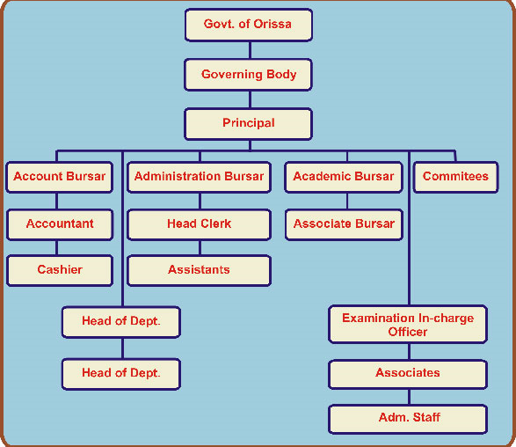
The various committees, associations & cells operating in the College are Development Committee, purchase committee, Planning Board(UGC) , Planning Forum ,UGC committee, Students Advisory Committee ,Admission Committee, IQAC , NAAC Steering Committee , Committee for RUSA , Tabulation & Percentage Committee , Drama Dance & Music Association , Athletic Association , Science Society , Committee for Free studentship & SAF, Construction/Building Committee ,Discipline Committee ,RTI Cell ,Anti-Ragging Cell , Sexual Harassment Cell, Library Advisory Committee , Academic Council(All HODs), Staff Council etc. Besides these committees there are officer-in-charges for various activities, the complete list is made available in the College website.
6.2.4 Give a broad description of the quality improvement strategies of the institution for each of the following
    - Teaching & Learning
- Full transparency is maintained in the admission process due to e-admission process under Students’ Academic Management System developed by DHE , Odisha.
- Teachers are maintaining lesson plan & progress register meticulously which is a powerful tool for self evaluation and also monitoring by the HODs & Principal.
- Teacher’s self appraisal system has been introduced.
- Assessment of Teachers by students’ feedback has been introduced.
- Question Bank has been developed in the Library by the faculties.
- Teachers are encouraged to participate in the refresher , orientation , seminar, symposium , workshops for their capacity building.
- Common Minimum Standard (CMS) developed by DHE Odisha is followed strictly.
- The common academic calendar of DHE Odisha is also followed.
- Free internet facilities for all the teaching staffs to upgrade their knowledge.
- Use of LCD Projector, OHP, document camera in seminar teachings.

    - Research & Development
The UGC Planning Board has been assigned with the duties of Research committee in the College. The Planning Board and the IQAC encourages the teaching staffs to apply for Minor Research Projects of UGC. But due to heavy academic workload and other constraints no teaching staff has applied for this.

    - Community engagement
The College has active NSS male and female units, YRC & Red Ribbon Club. The units have a planned calendar on thrust areas in which different extension activities are organized in and outside the College throughout the year to engage the students in different community oriented activities. These units plan & implement community oriented activities in collaborations with GOs & NGOs. Students are encouraged to participate in seminars to acquaint with the societal problems and to aware them regarding their role & responsibilities in society.

    - Human resource management
- The institution utilises the services of the existing teaching and non-teaching staff in curricular , co-curricular and extracurricular activities of the College.
- The Principal remains vigilant on the academic and administrative performance.
- CCR are sent to higher quarter for the GIA employees and teachers self appraisal system has been introduced to evaluate the annual performance at College level.
- Principal issues warnings & instructions in case of employee’s negligence and ask for explanations.
- Principal engages the Guest and contractual lecturers and support staffs to fill up the vacancies.
- To manage the staff w.r.t accounts , administration, establishment the Government mechanism of HRMS (Human Resource Management System) is in place.

    - Industry interaction
The College is trying to establish link with the Industries of the district for the welfare of the institution. For example the College has received fund for furniture from Monnet Power Ltd. Angul.

6.2.5 How does the Head of the institution ensure that adequate information (from feedback and personal contacts etc.) is available for the top management and the stakeholders, to review the activities of the institution?
Records of different activities of the college are maintained by the members of different committees or by senior member of the OICs. The Principal and IQAC collects feedback from teachers , students & stakeholders and those are analysed. These information are made available for the Governing Body and the stakeholders to review the activities of the college. To help students welfare personal contact numbers of the students and parents are obtained. The mass media plays a vital role in bringing the activities to public notice, and there by exposes them for the review of the other stakeholders. Adequate information is also published in the College website and calendar for public & stakeholders.
6.2.6 How does the management encourage and support involvement of the staff in improving the effectiveness and efficiency of the institutional processes?
The members of the Governing Body hold meetings and interact with the staff on their personal grievances and also for the common matters, and try to diminish problems faced at different levels. The management encourages and supports involvement of the staff by taking them into assurance, giving importance for their suggestions and offering thanks for their services. The participation of students in extra and co-curricular activities under the guidance of the staff helps in improving the effectiveness and efficiencies of the institutional processes.
6.2.7 Enumerate the resolutions made by the Management Council in the last year and the status of implementation of such resolutions.
There is no such Management Council , it is the Governing Body who makes resolutions at College level and the College is directly governed by the DHE , Odisha. The major resolutions adopted in GB meetings of last year are stated below with their status of implementation.
Date | Details of Resolutions | Status of Implementation
8-1-15 | To send the records of eligible teaching staffs for Block Grant, as per GIA in the shape of Block Grant Order 2014. | Records sent and verified at Directorate level
8-1-15 | To appoint VC nominee of the GB in the selection committee for engagement of Teaching staff. | Implemented
8-1-15 | To enhance the salary of Bidyadhar Mahananda , lect. in Odia , Manoj Kumar Biswal, Lect. in IT and Miss. Smitasindhu Mahakul , Demonstrator Zoology from July 2014 | Salary enhanced from the stipulated date.
8-1-15 | Not to deduct the surplus salary of the management staff who are eligible to get Block Grant as per 2014 Notification. | Salary Not deducted
8-1-15 | To regularise the service of Mrs. Priyadarshini Soumya Mohapatra ,Lecturer in Chemistry as per the enhanced workload due to opening of Hons. in Chemistry | Regularised
8-1-15 | Not to collect tuition fees from the female students from the session 2015-16, as per Govt. rules. | Fees not collected
8-1-15 | To approve the amount to be spent for making the website dynamic(flexible) and principal is empowered to activate the work. | Dynamic website hired.  (www.malyagirima havidyalaya.ac.in)
8-1-15 | To regularise the service of Mr. Bidyadhar Mahananda . Lect. in Odia from 01-07-2013 | Regularised
14-9-15 | Permission for giving advertisement in daily news papers for the engagement of contractual faculties in Pol. Sc , Eco. , Odia , Zoology & English(05 Nos.) | Approved by President GB
14-9-15 | To apply for the increase of seats in +3 Science from 64 to 128 due to heavy demands of students. | Approved by President GB

6.2.8 Does the affiliating university make a provision for according the status of autonomy to an affiliated institution? If ‘yes’, what are the efforts made by the institution in obtaining autonomy?
Yes, the affiliating university has the provision for according the status of autonomy by recommending the application of the College to UGC. However due to different problems the College does not think fit to apply for autonomy.

6.2.9 How does the Institution ensure that grievances / complaints are promptly attended to and resolved effectively? Is there a mechanism to analyze the nature of grievances for promoting better stakeholder relationship?
The college has a grievance redressal cell, anti-ragging cell, sexual harassment Cell to look into the grievances or complaints of stake holders. Regular reviews of the activities of such cells by the Principal help in promoting better stake holders relationship.
6.2.10 During the last four years, had there been any instances of court cases filed by and against the institute? Provide details on the issues and decisions of the courts on these?
A court case has been filed by Mr. Bharat Chandra Samal , Ex-Lecturer in English of this College in the State Education Tribunal, Odisha against the Governing Body of Malyagiri Mahavidyalaya Pallahara(Opposite party No. 3) , vide GIA Case No. 131/2012.
Issues :- To approve the appointment in terms of Grant in Aid Order, 1994 till his resignation and to release the salary components in terms of the same Order.
Decisions:- The GIA case is accordingly allowed. The O.P. Nos.1 and 2 are directed to approve the appointment of the petitioner as Lecturer in English in Malyagiri Mahavidyalaya,Pallahara in the district of Angul in terms of Grant in Aid Order , 1994 till 7.4.2000 and to release grant in aid accordance with the Grant in Aid Order , 1994 along with the differential salary components within a period of four months from the date of communication of this order.

6.2.11 Does the Institution have a mechanism for analyzing student feedback on institutional performance? If ‘yes’, what was the outcome and response of the institution to such an effort?
Yes, the College has introduced the system of collecting feedback in a printed format from the students. The feedback has been analysed e.g. for +3 2nd Year Science the analysis report is given below.

Analysis of Feedback on All Aspects of +3 2nd Year Science Students
(2015-16)
Total Number of responses from +3 2nd Science=48

Over All Satisfaction Rate of students in % age of Marks.

There are 20 parameters on which feedback has been collected .
Depending upon the outcome on the analysis of feedback IQAC take necessary measures for improvement in the weak areas.
6.3 Faculty Empowerment Strategies

6.3.1 What are the efforts made by the institution to enhance the professional development of its teaching and non teaching staff?
The efforts made by the institution to enhance the professional development of its teaching and non-teaching staff are :-
a) The faculty members are encouraged to attend in the staff development programmes such as Seminars, conferences , workshops , Orientation & refresher courses etc.
b) Teachers are encouraged to join in the individual research for M.Phil/Ph.D Programmes.
c) Trainings of non-teaching staff like Clerks , peons etc. are conducted to increase their efficiency.
d) Accountant ,Head clerk , Data Entry Operator have been imparted with training on the use of Online HRMS , Accounts software by the Govt. agency.
e) Accountant & Head Clerk have also completed certificate course on the maintenance of accounts.

6.3.2 What are the strategies adopted by the institution for faculty empowerment through training, retraining and motivating the employees for the roles and responsibility they perform?
Strategies adopted for faculty empowerment are as under:

- Ensuring that teachers feel comfortable with their colleagues and the
Principal
- Allowing the teachers to take decisions freely
- Making an environment of faith and mutual respect
- Supporting teachers in their decisions
- Involving teachers in central decisions making process and enhancing their
Leadership quality
- Giving best employee award in the Annual Day Celebration
- Enhancing professional efficiency of teaching and non-teaching staff by
supervising and reviewing performance by the Administrative Bursar/ Accounts Bursar/ Academic Bursar/ Teacher-in-charge/ Heads of the
Departments etc.

6.3.3 Provide details on the performance appraisal system of the staff to evaluate and ensure that information on multiple activities is appropriately captured and considered for better appraisal.
Performance appraisal of each GIA getting lecturer is recorded by the Principal confidentially as per the format supplied by the Govt. of Odisha for each academic session. That is called as Confidential Character Role (CCR).The said CCR is sent to the Director of Higher Education for review and recommendation for promotion. The adverse comments are communicated to the person concerned for improvement in the performance. However for all the teaching staff self appraisal is maintained with different scores for different activities which are finally verified by the Principal. The teachers having very low scores are informed confidentially for improvement.
6.3.4 What is the outcome of the review of the performance appraisal reports by the management and the major decisions taken? How are they communicated to the appropriate stakeholders?
The Performance Appraisal Report (CCR) submitted by the staffs are reviewed by authority and if found to be satisfactory then intimated to the higher authority for future course of action. Promotion and new grade pay are considered as per report approved by the higher authority of DHE. The CCRs are also discussed with the President GB for recommendations .
6.3.5 What are the welfare schemes available for teaching and non teaching staff? What percentage of staff have availed the benefit of such schemes in the last four years?
The different welfare schemes available for the teaching and non-teaching staff are as under :-
- Employee Group Insurance Scheme for GIA getting Staff.
- Employee Depository Linked Insurance (EDLI) of EPFO for Block Grant & management staff.
- Obsequies for death of employees during service.
- Cash Advance is sanctioned to the employee during exigencies.
- Salary is paid from the College fund to the needy staff if there is delayin release of funds from the Govt.
- Recommendations of Applications to Banks for House Building Loan/Motor Cycle Loan.
- Teacher’s Aid Fund
- Duty Leave is granted to staff for attending seminar , conference , workshop, orientation & refresher course.
- Medical Leave & Maternity leave (for female) are granted.
- Provision for GPF or EPF is available for almost all the members.
- Gratuity is provided for retirement for GIA getting staff.

6.3.6 What are the measures taken by the Institution for attracting and retaining eminent faculty?

Our College being a government aided college, faculty members are posted and transferred by the Department of Higher Education, Govt. of Odisha. The institution has no role in this process and only intimates to the DHE about the vacancy and requesting for fill up. Whenever the workload of the college increases due to opening of new subjects , new streams and increase of seats, the management of the college makes new recruitments by creating posts and following due procedure on the basis of merit.
Recently the Govt. has advertised for appointment of 1625 teaching posts in aided Colleges through Service Selection Board(SSB).

6.4 Financial Management and Resource Mobilization

6.4.1 What is the institutional mechanism to monitor effective and efficient use of available financial resources?
The institutional mechanism to monitor available financial resources effectively and efficiently are:-
a) Major policy decisions w.r.t financial planning are made by the DHE , Govt. of Odisha.
b) The College maintains Cash Book , DCR , Ledger Books as per the book keeping practices.
c) All the transactions are generally made through cheque or NEFT/RTGS.
d) Departmental Audit is made annually by local fund auditor or Chartered Accountant as per the direction of Govt.

6.4.2 What are the institutional mechanisms for internal and external audit? When was the last audit done and what are the major audit objections? Provide the details on compliance.
- Internal audit is done by the accounts bursar and officers-in-charge concerned. DCR is checked on every working day by the accounts bursar.
- Annual external audit of the expenditure of the College and UGC grants is done through Govt. approved CA firm.(previously it was done through the Local Fund Audit)
The last audit was done for the financial year 2013-14 by the CA Firm SPM AND Associates and reviewed by Local Fund Audit , Angul vide Audit report No. 55544/AR/2014-2015-ANUGUL. The major audit objections there on are:
- The refundable amount of Rs. 48685.00 towards the inadmissible expenses under XI-Plan UGC Additional Grant-Equipment cannot be treated as genuine and suggested for recovery, in absence of relating vouchers, GB approval & Head of expenditure. The responsible person is Basant Kumar Mohanty , Principal.
Compliance:-This objection has been complied by transferring the vouchers from UGC guard file to General guard file and the head of expenditure is miscellaneous expenses from college development fund.
- Payment of Salary to Management staff beyond Yard stick :-
As the permission has been received from the Govt. to open +3 Science, hence the following posts were given appointed by the governing body. But for these staff block grant salary has not been accorded hence it is paid out of the student development fund. So it is kept in objection till the approval for block grant is received. The total sum of Rs.6,63,938.00 is kept under objection.
Compliance :- The mentioned posts has been appointed as per the workload and yard stick and not to hamper the academic activities as vacant posts are not filled up by the Govt. in time. Moreover the Govt. sanctions block grant for the posts after some years of the appointment by enacting special orders as per Rule 7 (c) of Odisha Education Act. 1969. Therefore salary to management staff has not been paid beyond yard stick. In this regard letter to DHE has been sent vide letter No. 559/dt-5-9-2013.

6.4.3 What are the major sources of institutional receipts/funding and how is the deficit managed? Provide audited income and expenditure statement of academic and administrative activities of the previous four years and the reserve fund/corpus available with Institutions, if any.
The major sources of receipts/funding of the College are:
- Staff salary for the GIA and Block Grant staff is disbursed by the state Govt.
- College development fees and other subsidiary fees are collected from the students.
- UGC funds are received towards infrastructural development, buildings , remedial coaching classes , extension activities , books & Journals , Equipments etc.
- Building grants are received from MLA-LAD and MP-LAD.
- Students Scholarships are received from State & Central Govt. towards various schemes.
- Funds for organising extension and outreach programmes are received from (1) State NSS Cell, Utkal university (2) State AIDS control society (3) DHE , Govt. of Odisha (4) YRC Society
The College tries to make a balanced budget avoiding deficit. However the deficit is managed from the Bank interest received from the various deposits.
The audited income & expenditure statements for last four years are given below:
Receipts/Expenditures for 2013-14 In Rs.
Particulars | Receipts | Expenditures
Govt. Grant  (recur.) | 10384281.00 | 10980517.00
Other Grants | 587509.00 | 3071.00
Fees & Fines | 8281.00 | 13776.00
Students Fund | 1146171.00 | 1253433.00
UGC | 456609.00 | 1575112.00
SAMS | 72977.00 | 34053.70

Receipts/Expenditures for 2012-13 In Rs.
Particulars | Receipts | Expenditures
Govt. Grant  (Recur.) | 7803441.00 | 7803441.00
Other Grants | 1008172.00 | 742588.00
Fees & Fines | 7477.00 | 4316.00
Students Fund | 657090.00 | 1949907.00
UGC | 1398845.00 | 200600.00
SAMS | 50764.00 | 23610.00

Receipts/Expenditures for 2011-12 In Rs.
Particulars | Receipts | Expenditures
Govt. Grant  (Recur.) | 7885358.00 | 7664354.00
Other Grants | 876468.00 | 865735.00
Fees & Fines | 7533.00 | 11962.00
Students Fund | 833706.00 | 757773.50
UGC | 814828.00 | 1523623.00
SAMS | 893.00 | 5.00
Remedial Coaching (UGC) | - | 18135.00

Receipts/Expenditures for 2010-11 In Rs.
Particulars | Receipts | Expenditures
Govt. Grant  (Recur.) | 9502438.00 | 10952769.00
Govt. grant (Recurring)-UGC | 853596.00 | 1490378.00
Others | 6000.00 | 3915.00
Other Grants | 130100.00 | 386651.00
Internal sources | 40684.00 | -
Students Fund | 509004.00 | 575489.00

6.4.4 Give details on the efforts made by the institution in securing additional funding and the utilization of the same (if any).
The College has received & utilised funds from MLA-LAD & MP-LAD towards Building infrastructure and from Industries (Monnet Power Ltd) for furniture. The College has also received funds from Panchayat Samittee Pallahara. Moreover the +3 Science has been opened by collecting interest free loan from the local philanthropist.
6.5 Internal Quality Assurance System (IQAS)

6.5.1 Internal Quality Assurance Cell (IQAC)
a. Has the institution established an Internal Quality Assurance Cell (IQAC)? . If ‘yes’, what is the institutional policy with regard to quality assurance and how has it contributed in institutionalizing the quality assurance processes?
Yes , the institution has established an Internal Quality Assurance Cell (IQAC) in the College with the funding of UGC. The composition of the IQAC is as follows.
- Dr. Chandramani Pradhan : Principal I/c Chairman
- Mr. Kailash Chandra Dash : Teacher Member/Accounts Bursar
- Dr. Prasant Kumar Sahu : Administrative Bursar
- Mr. Harekrishna Pradhan : Teacher member
- Mr. Harihar Pani : Teacher member
- Mr. Rudranarayan Sahu : Teacher Member
- Mr. Prahallad Kumar Sahu : Teacher Member
- Dr. Kishore Chandra Pradhan : External Member
- Mr. Pramod Kumar Pradhan: External Member
- Mr. Rashmi Ranjan Pattanaik: Alumni Member
- Mr. Jogesh Chandra Sahu : Guardian member
- Mr. Arjun Sahoo : Employer member
- Miss. Soni Parbin : Student Member
- Mr. Bhupen Kumar Acharya : Coordinator
The institutional policy with regard to quality assurance is to make teaching learning process interesting and productive to make the process inclusive and holistic. The academic quality of the institution is assessed on the basis of the performance of the students in their examinations. The teachers also judge the student’s academic abilities by way of question-answer and written tests. The administrative system including the different committees look after the quality of education in the institution and the quality assurance in the institution’s administration.
b. How many decisions of the IQAC have been approved by the management / authorities for implementation and how many of them were actually implemented?
The decisions of the IQAC that have been implemented are:
- Obtaining the current affiliation status and application for LOI
- Monitoring of departmental seminars
- File numbering system has been initiated
- Library Automation with OPAC availability
- Submission of AQAR for 2014-15
- Separate page for IQAC in the College website
- Creation of Face book id for College
- Instituting Annual Best User Award for Library
- Conducting User Surveys periodically for Library
- Teachers’ Assessment by Students’ feedback
c. Does the IQAC have external members on its committee? If so, mention any significant contribution made by them.
Yes , the IQAC has external members on its committee , the details of which has been given under para 6.5.1 (a). As the IQAC is only one and half year old and only one meeting has been organised , we are expecting some significant contributions from them. However the external members Dr. Kishore Chandra Pradhan , Ex-Principal and Mr. Pramod Kumar Pradhan , Ex-Chairman Panchayat Samittee ,Pallahara have contributed by providing valuable suggestions from their rich experience on organisational functioning.
d. How do students and alumni contribute to the effective functioning of the IQAC?
Students views and opinions are collected through feedback , induction programme, direct interactions by the Teachers and Principal which are considered for quality assessment by IQAC. The alumni remains constantly in touch t know about the functioning of the College to plan for the betterment. One student member and one alumni member has been included in the committee of IQAC to participate in the decision making process of IQAC.

e. How does the IQAC communicate and engage staff from different constituents of the institution?

The IQAC communicates with the staff members in the staff council and heads of the departments in Academic council meetings and suggestions are received from them.

6.5.2 Does the institution have an integrated framework for Quality assurance of the academic and administrative activities? If ‘yes’, give details on its operationalisation.
Yes, the institution has an integrated framework for Quality Assurance of the academic and administrative activities. The academic activities are inspected at different levels – first at the level of the HODs and Academic Bursar, and then the Principal, the DLC, the Directorate, Higher Education and last the Department of Higher Education, Government of Odisha. The observations are verified and recorded at each level. In case of undesirable findings the concerned members are given a chance to defend themselves. If not satisfied, the authorities take coercive measures for amendment and improvement. The Administrative matters are managed by the Principal with the help of the Administrative and the Account Bursars as well as senior office assistance. The College follows the Common Minimum Standard (CMS) guidelines provided by DHE, Govt. of Odisha. The government is also kept informed on the activities of the College, from time to time.
6.5.3 Does the institution provide training to its staff for effective implementation of the Quality assurance procedures? If ‘yes’, give details enumerating its impact.

No such facility is available in the college. However, the staff members are self sufficient themselves in gaining various skills & knowledge through Internet, Journals, & interaction with eminent personalities.
6.5.4 Does the institution undertake Academic Audit or other external review of the academic provisions? If ‘yes’, how are the outcomes used to improve the institutional activities?
Yes, the Academic Council & staff council meets regularly to monitor the Academic Progress of the students through lesson plan and progress of every teacher. There is no other provisions of academic audit or external review. The final academic audit of the academic provisions depends upon the DHE , Govt. and Utkal university.

6.5.5 How are the internal quality assurance mechanisms aligned with the requirements of the relevant external quality assurance agencies/regulatory authorities?
The internal quality assurance mechanisms have been planned keeping in view the requirements of the regulatory authorities and academic success of the students.

6.5.6 What institutional mechanisms are in place to continuously review the teaching learning process? Give details of its structure, methodologies of operations and outcome?
The IQAC of the college constantly examines and monitors the teaching-learning process of the college in association with the Academic Council, Examination Committee & Academic Bursar. The Principal and the coordinator of the IQAC play active role in the monitoring the process. The members of the IQAC and the staff members in general also contribute to enrich the functioning of the IQAC. These initiatives make the outcomes efficient and productive.
Feedback is collected from stakeholders on all aspects and also on the performance of the teachers. These are analysed and the outcomes are placed in the meeting of IQAC for amendments and improvements on different quality parameters.
6.5.7 How does the institution communicate its quality assurance policies, mechanisms and outcomes to the various internal and external stakeholders?
The quality assurance policies, mechanisms and outcomes and communicated to internal and external stakeholders by the following ways.
To | Through
Internal stakeholders :  Students  Teaching Staff  Non-teaching Staff | College Notice Board , College website ,proctors, college calendar  Circular & notices , College website & calendar , Staff council meetings, Academic Council meeting  Circular & notices , staff council meetings , college website & calendar , Principal’s meeting with non-teaching staff.
External Stakeholders :  Alumni , Parents , Local People | College website , College programme

Any other relevant information regarding Governance
Leadership and Management which the college would like to include.
The college has a governing body. The MLA Pallahara is the President of the Body. Other members are the University VC nominee, members from SC/ST & minority, women member, educationist , donor, teaching & non-teaching staff members, MP-nominee , Chairman Panchayat Samittee etc. The governing body meetings are also convened time to time and that provides directions and suggestions to the college administration on issues relating to planning, governance, leadership & implementation.
As the Principal is the head of the institution, he has lot of responsibilities to shoulder for the smooth management of the institution. The Principal inspects the classes regularly and calls for explanation for negligent teachers and members of the staff. The Principal encourages the teaching staff for organising seminars. Symposium , workshops and extra classes for better benefit of the weaker students , mostly coming from SC/ST and OBC group. He invites the different stakeholders in various fields to impress our students for their future Careers. The Principal is always in touch with the district headquarters College, Utkal University , NTPC , NALCO, CCL, DHE Office, Administrative Headquarters, CHSE , RDE, Secretariate on various occasions for the development of the College. The Principal is never silent in this respect. He is always active and resourceful.
--------

Criterion-VII
(Innovations and Best Practices)

CRITERIA VII: INNOVATIONS AND BEST PRACTICES

7.1 Environment Consciousness

7.1.1 Does the Institute conduct a Green Audit of its campus and facilities?
Yes , the teachers , students and employees of the College are very much aware on the environmental issues. The College is established in a natural eco-friendly green environment with good number of “ Sal “ ( Shorea Robusta) and other trees. During the extension of College buildings special care is taken to save the trees. Moreover a number of initiatives have taken in these aspects such as-

- Protecting trees during infrastructural development.
- Using composite bins for garbage management
- Making the college campus a polythene free zone.
- Proper usage of electricity for saving energy.
- Introduction of environmental studies as a course in all under graduate
programmes.
A proper Green Audit will be conducted in the coming year.

7.1.2 What are the initiatives taken by the college to make the campus eco-friendly?
Energy conservation

- Use of CFL lights and limited use of air conditioners.
- Lights, fans and other appliances are switched off when not in use.
- ISI & 5/3 star mark electrical appliances/ electronic instruments/ apparatus with high efficiency and less energy consumption are used.
- Use of TFT monitors in Computers.
- Creating awareness among the students and the staff on energy conservation.

Use of renewable energy
Not yet used.
Water harvesting
A small pond in the campus is used to collect water mainly during rainy seasons to recharge ground water. Branch of canal for irrigation and the river “Mankada” flows near the College are the alternative sources of water and recharge of ground water in the campus.
Check dam construction
Not applicable.
Efforts for Carbon neutrality
A number of initiatives have been taken for carbon neutrality in the Campus. Those are -
- Steps are taken to save the natural “Sal ”(Shorea robusta) trees of the campus.
- Students are encouraged to use bicycle instead of motor
bikes to assure a pollution free campus.
- College garden has been developed.
- Use of paper plates & packets, Sal leaves containers instead of plastic materials for Tiffin and meals.
- The NSS units of College organize awareness programmes on
global warming, Green environment.
- The Botany department of the college takes the charge of maintaining
The College garden.
Plantation
Excluding the preservation of natural “ Sal “ trees , plantation of useful plants is done by the NSS units.
Hazardous waste management
The NSS volunteers play a vital role in the waste management. The hazardous waste such as plastic materials are collected and send to recycling units, and dangerous materials like broken glass pieces and waste chemicals are taken care of so as not to harm the environment.
e-waste management
The production of e-waste is negligible as most of our electronics gadgets are newly purchased. However the College is planning to dispose off some old defunct computers and peripherals as per the UGC directions.

7.2 Innovations

7.2.1 Give details of innovations introduced during the last four years which have created a positive impact on the functioning of the college.
A number of innovative practices have been introduced in the College during last four years.

- The self-defense programme introduced in the campus for the girl students with financial assistance from the government has created an excellent positive impact on the girls and has boosted their confidence to great extent.
- The introduction of IQAC system has brought about qualitative improvement in the functioning of the College.
- The e-admission system under Students Academic Management System (SAMS) introduced by the DHE , Govt. of Odisha has made the admission system fully automated , transparent and universally accessible.
- Monthly tests are held in the Honours teaching departments to monitor the regular progress of the students.
- Purchase of major equipments like Copiers , Computers, Printers , Fax, Scanner , digital camera , inverters , generators , green chalk boards , software etc. out of UGC funds has helped the institution in qualitative improvement.
- A good number of Laboratory equipments have been developed out of UGC fund to facilitate the B.Sc. practical.
- IT Laboratory has been established with the funding of UGC.
- The extension activities undertaken by the NSS , YRC , Equal Opportunity Cell wings are praiseworthy in generating awareness among common masses on social & environmental issues.
- Remedial coaching classes have been conducted under the funding of UGC to clarify the doubts of students.
- Eco-friendly programmes like Plantations , campus cleaning have conducted through the NSS volunteers & the office bearers of students’ union.
- Renovations of staff common room and toilets have been carried out to make them more hygienic and comfortable.
- Anti-Ragging Cell , Sexual harassment Cell , RTI-Cell , Grievance Redressal Cell has been constituted to look after the problems of the students.
- Networking of all the computers of Office , Library & SAMS with internet facilities has been done along with the purchase of Online CMS-ERP to facilitate the automation of Library and Office.
- Use of LCD-Projectors , OHPs in the departmental seminars have boosted the attitudes of the students towards the use of ICT.
- Use of ICT by teachers to upgrade their knowledge & skills.
- Considerable increase of number of books & purchase of new journals in the library with the UGC funds.
- Two new Class rooms and well furnished Girls’ common room have been constructed with the MLA & MP- LAD funds.
- Steps are being taken for the issue of driving license to students & staffs by organising Camps in the College by the RTO office Talcher.

7.3 Best Practices

7.3.1 Elaborate on any two best practices in the given format, which have contributed to the achievement of the Institutional Objectives and/or contributed to the Quality improvement of the core activities of the college.

BEST PRACTICE-I
1. Title of the Practice : Managing Through Stakeholders’ Participation

2. Goal/Objectives : The Practice has the following objectives :-
- To improve the productivity, quality & employee morale of the institution through participatory management
- To enhance the organizational decision making process and knowledge sharing between stakeholders
- To encourage the stakeholders of the institution to voice their opinions about their current environment
- To delegate the decision making authority to employees and other stakeholders
- To configure power distribution, authority, communication , decision making and better employee relation
- To improve in the process of Total Quality Management.
- To satisfy the stakeholders’ higher level needs
- To increase the attraction and retention of employees
The Goal of this practice is to manage the institution properly towards the increased productivity & quality through the improved decision making, communication, power delegation & TQM by the overall participation of the stakeholders.
3. The Context
In the old system of Management Bureaucracy were controlling the whole organisation and the opinions of the employees and the stakeholders were being neglected. As a result this leads to the stakeholders’ dissatisfaction, poor productivity & quality, autocracy in decision making process and meagre communication.
Participatory management style attempts to add a democratic dimension in modern management, which has generally been top-down and hierarchical in nature. Participative management addresses the relationship between the organization and its workers and stakeholders. It addresses fundamental issues of governance within organizations and the role of employees and external stakeholders in all levels of organizational decision making.
In a College the stakeholders are the Governing Body members , Students , Employees , Alumni , Parents etc. Defining the institution as an Industry the customers are the students and the Parents. So in order to satisfy themselves their opinions and suggestions need to be heard. Therefore the modern method of participatory management is essential.
4. The Practice : A number of good practices are adopted in the College on the Participatory Leadership model as enumerated below :
- Governing Body of the College takes major decisions after discussion with the teaching & non-teaching staff of the College and also being the staff representatives few teaching and non-teaching staff members raise their voices in the GB meetings.
- Major decisions relating to Examinations , Academic, administrative & Accounts matter are taken in the Staff Council meeting where all the teaching and non-teaching staffs are the members.
- Decentralization of administration and delegation of powers are made by constituting various committees, Cells & Officer-in-Charges in the College.
- The Office bearers of Students’ Union and Associations constituted through election/nominations play a vital role in management of the institution in taking decisions on activities to be performed , budget & expenditure in the concerned activities and development.
- Parents’- Teacher-Association has been constituted to involve the Parents/Guardians in various activities and to collect valuable feedback from them.
- Alumni Association has been constituted to involve them in the institutional functioning and development.
- Proctorial system has been introduced to collect the opinions of every student.
- Feedbacks are collected from the stakeholders regarding the curricular , co-curricular and management of the institution.
5. Evidence of Success :- Due to this modern technique the students’ & staff unrests have been reduced to a considerable extent. As the students are involved their leadership quality is being improved and this helps in qualifying interviews for jobs, getting self employment and managing other organizations. The salary of management & block grant staffs of the College has been enhanced as per their claim.

6. Problems Encountered and Resources Required :-
Due to more student strength sometimes it is not possible to hear to the problems of all the students and to get them involved in the decision making process. Therefore funding is necessary to manage the proctorial system effectively in order to give weightage to the views of each & every student. In meetings of Governing Body , Staff Council , Alumni some members raise their voice in such a manner which dominates the other members and compel the Chairman of the meeting to pass resolution , leading to undemocratic principle. Therefore there is a need of introduction of opinion poll such meetings.
7. Notes (Optional)

8. Contact Details
Name of the Principal: Dr. Chandramani Pradhan
Name of the Institution: Malyagiri Mahavidyalaya ,Pallahara
City: Pallahara
Pin Code: 759 119
Accredited Status: Accredited during 2006 at C++ Level (Now expired)
Work Phone : 06765-279232 Fax: 06765-279232
Website: www. Malyagirimahavidyalaya.ac.in
E-mail : malyagiri119@gmail.com
Mobile: 9861446052

BEST PRACTICE-II

1. Title of the Practice- Empowering Women through Special Facilities and Activities
2. Goal/Objectives- The Practice has the following Objectives:-
a) To create a total development of the personality of the students and prepare them as better citizens of the society and meet greater challenges in their lives.
b) To Organizes awareness, skill training and capacity building programmes for the women students.
c) To help women students understand their strength & potential.
d) To provide help , in case of necessity.
e) To counsel women Students.
3. The Context- Gender equality is most important for the economic growth of a country. The culture and tradition of India is considered as old and great all over the world where people used to worship various female goddesses, saints and poets. Women backwardness is also very clear in the Indian society because of the social issues, problems and lots of restrictions against women. Women belong to the lower and middle class family suffers more than the women of higher class family. Women in the Indian society generally face problems of sex discrimination, high percentage of illiteracy, female infanticide, dowry system, etc. To face these challenges there is a need of empowerment of women in the College education by providing them special facilities and by undertaking activities exclusively for them.
4. The Practice- A number of excellent practices has been introduced in the college for the women empowerment. These are:
- Self Defence Training is provided to the women students in order to physically protect themselves when in danger.
- As the College is coeducational in nature gender equality is maintained in every circle.
- The N.S.S. Girls Unit of the college organizes camps to create social awareness & spread socially relevant messages in the nearby areas.
- Tuition fees have been waived for women students to support their financial conditions.
- Separate Games & Sports are organised for them in order to go ahead like men.
- Women students have been the members in various committees of the College like IQAC , Library Advisory Committee ,Anti-Ragging Cell, Sexual Harassment Cell , Grievance Redressal Cell (Election) etc.
- Various Awareness programmes are organised by NSS units on issues relating to women.
- Common dress code for Girls has been implemented and a separate common room has been provided to them.
- Women students are encouraged to contest in College Election and they have been office bearers.
- In case of ill health of the women students during the College hour they are specially supported.
- Financial assistance is provided as Scholarships to women of SC/ST/OBC categories.

5. Evidence of Success- The Self Defence Training and participation in the Annual Athletic meet helps the students to increase their skill and performance in the sporty activities which helps them to get entry into jobs in the police, military and Para-military services, forest departments, Teachings, IT-sectors etc. Moreover dowry system and Women torture has been reduced in the locality as they have been qualified and are getting jobs.
6. Problems encountered and Resources required-
- There is lack of separate infrastructural support to provide a gender specific training in a co-educational environment.
- The College has a location disadvantage which discourages greater participation of women in the self-defence training.
- There is no provision of a women PET in the College.
- Separate financial resource is required to provide financial assistance to the women students belonging to General and economically weaker categories.
- Need of women empowerment cell in the College with proper funding.
- As many women students are coming to the College through public bus , there should be external funding for a College bus.
7. Note- The College inspires the students for more involvement and Participation in the women empowerment activities and all round development of student’s programmes. The college also plans to open some vocational courses exclusively for women students.
8. Contact Details
Name of the Principal: Dr. Chandramani Pradhan
Name of the Institution: Malyagiri Mahavidyalaya ,Pallahara
City: Pallahara
Pin Code: 759 119
Accredited Status: Accredited during 2006 at C++ Level (Now expired)
Work Phone : 06765-279232 Fax: 06765-279232
Website: www. Malyagirimahavidyalaya.ac.in
E-mail : malyagiri119@gmail.com
Mobile: 9861446052

-------------

Principal
Malyagiri Mahavidyalaya
Pallahara
PART-III
(a) EVALUATIVE REPORT OF THE DEPARTMENTS
1. Name of the department :- DEPARTMENT OF ENGLISH

2. Year of Establishment :- 1979

3. Names of Programmes / Courses offered (UG, PG, M.Phil., Ph.D., Integrated Masters; Integrated Ph.D., etc.) UG (Three years Degree Course BA and BSc)

4. Names of Interdisciplinary courses and the departments/units involved
Arts & Science
5. Annual/ semester/choice based credit system (programme wise)
UG-Arts :- Annual , UG-Science :-Annual
6. Participation of the department in the courses offered by other departments
Arts & Science
7. Courses in collaboration with other universities, industries, foreign institutions, etc. N.A.

8. Details of courses/programmes discontinued (if any) with reasons:- Nil

9. Number of Teaching posts
 | Sanctioned | Filled
Professors | NIL | NIL
Associate Professors | 01 | NIL
Asst. Professor | 01 | 01

10. Faculty profile with name, qualification, designation, specialization, (D.Sc./D.Litt./Ph.D. / M. Phil. etc.,)

Name | Qualification | Designation | Specialization | No. of Years of Experience | No. of Ph.D Students guided for the last 04 years.
Mr. Rudra Narayan Sahu | M.A. | Lecturer in English | Professional writings in English | 13 yrs | NIL

11. List of senior visiting faculty NIL

12. Percentage of lectures delivered and practical classes handled (programme wise) by temporary faculty NIL

13. Student -Teacher Ratio (programme wise) BA :-233 :1 , B.Sc-76:1

14. Number of academic support staff (technical) and administrative staff; sanctioned and filled NIL

15. Qualifications of teaching faculty with DSc/ D.Litt/ Ph.D/ MPhil / PG.
PG-01
16. Number of faculty with ongoing projects from a) National b) International funding agencies and grants received NIL

17. Departmental projects funded by DST - FIST; UGC, DBT, ICSSR, etc. and total grants received NIL

18. Research Centre /facility recognized by the University NIL

19. Publications:

∗ a) Publication per faculty NIL

20. Areas of consultancy and income generated NIL

21.Faculty as members in

a) National committees b) International Committees c) Editorial Boards…. Member of Editorial Board of College Magazine

22. Student projects NIL

a) Percentage of students who have done in-house projects including inter departmental/programme

b) Percentage of students placed for projects in organizations outside the institution i.e.in Research laboratories/Industry/ other agencies

23. Awards / Recognitions received by faculty and students NIL

24. List of eminent academicians and scientists / visitors to the department NIL
25. Seminars/ Conferences/Workshops organized & the source of funding
a) National NIL
b) International
26. Student profile programme/course wise:

Name of the Course/programme (refer question no. 4) | Applications received | Selected | Enrolled |  | Pass percentage
 |  |  | *M | *F

*M = Male *F = Female

27. Diversity of Students

Name of the  Course | % of students from the same state | % of students from other States | % of students from abroad
BA | 100% | NIL | NIL
BSc | 100% | NIL | NIL

28. How many students have cleared national and state competitive examinations such as NET, SLET, GATE, Civil services, Defense services, etc.? Data Not Maintained
29. Student progression Data Not Maintained

Student progression | Against % enrolled
UG to PG | YES
PG to M.Phil.
PG to Ph.D.
Ph.D. to Post-Doctoral
Employed  • Campus selection  • Other than campus recruitment | Other Than Campus Recruitment
Entrepreneurship/Self-employment | Yes

30. Details of Infrastructural facilities
a) Library No separate Library (Only Central Library)
b) Internet facilities for Staff & Students Yes

c) Class rooms with ICT facility : No
d) Laboratories : Planning to setup a small Language Lab. shortly
31. Number of students receiving financial assistance from college, university, government or other agencies : About 40 % of students are receiving financial assistance.
32. Details on student enrichment programmes (special lectures / workshops /seminar) with external experts :- Special Lectures

33. Teaching methods adopted to improve student learning : Group Work, Assignments etc.
34. Participation in Institutional Social Responsibility (ISR) and Extension activities YES

35. SWOC (Strength , Weakness , Opportunity , Challenges) analysis of the department and Future plans :-
Strength: Teacher –students Interaction
Weakness : Deficiency in Infrastructure
Opportunity : Communication Ability
Challenge : High Students-Teacher Ratio

(b) EVALUATIVE REPORT OF THE DEPARTMENTS
1. Name of the department :- DEPARTMENT OF ODIA

2. Year of Establishment :- 1979

3. Names of Programmes / Courses offered (UG, PG, M.Phil., Ph.D., Integrated Masters; Integrated Ph.D., etc.) UG (Three years Degree Course BA and BSc)

4. Names of Interdisciplinary courses and the departments/units involved
Arts & Science
5. Annual/ semester/choice based credit system (programme wise)
UG-Arts :- Annual , UG-Science :-Annual
6. Participation of the department in the courses offered by other departments
Arts & Science
7. Courses in collaboration with other universities, industries, foreign institutions, etc. N.A.

8. Details of courses/programmes discontinued (if any) with reasons:- Nil

9. Number of Teaching posts
 | Sanctioned | Filled
Professors | NIL | NIL
Associate Professors | 01 | NIL
Asst. Professor | 02 | 02

10. Faculty profile with name, qualification, designation, specialization, (D.Sc./D.Litt./Ph.D. / M. Phil. etc.,)

Name | Qualification | Designation | Specialization | No. of Years of Experience | No. of Ph.D Students guided for the last 04 years.
Mr. Chittaranjan Panda | M.A. B.Ed | Lecturer in Odia | Linguistic | 21 Yrs | NIL
Mr. Bidyadhar Mahananda | M.A. M.Phil | Lecturer in Odia | Folklore | 08 yrs | NIL
Mr. Sampul Bhutia | M.A | Lecturer in Odia | - | 01 yr | NIL

11. List of senior visiting faculty NIL

12. Percentage of lectures delivered and practical classes handled (programme wise) by temporary faculty NIL

13. Student -Teacher Ratio (programme wise) BA :-233 :1 , B.Sc-76:1, BA-Hons-16 :1

14. Number of academic support staff (technical) and administrative staff; sanctioned and filled NIL

15. Qualifications of teaching faculty with DSc/ D.Litt/ Ph.D/ MPhil / PG.
PG-02, M.Phil-01
16. Number of faculty with ongoing projects from a) National b) International funding agencies and grants received NIL

17. Departmental projects funded by DST - FIST; UGC, DBT, ICSSR, etc. and total grants received NIL

18. Research Centre /facility recognized by the University NIL

19. Publications:

∗ a) Publication per faculty NIL

20. Areas of consultancy and income generated NIL

21.Faculty as members in

a) National committees b) International Committees c) Editorial Boards….Mr. C.R.Panda :-Member of Editorial Board of College Magazine

22. Student projects NIL

a) Percentage of students who have done in-house projects including inter departmental/programme

b) Percentage of students placed for projects in organizations outside the institution i.e.in Research laboratories/Industry/ other agencies

23. Awards / Recognitions received by faculty and students NIL

24. List of eminent academicians and scientists / visitors to the department NIL
25. Seminars/ Conferences/Workshops organized & the source of funding
a) National NIL
b) International NIL
(Only Departmental Seminars are organised)
26. Student profile programme/course wise:

Name of the Course/programme (refer question no. 4) | Applications received | Selected | Enrolled |  | Pass percentage
 |  |  | *M | *F

*M = Male *F = Female

27. Diversity of Students

Name of the  Course | % of students from the same state | % of students from other States | % of students from abroad
BA | 100% | NIL | NIL
BSc | 100% | NIL | NIL

28. How many students have cleared national and state competitive examinations such as NET, SLET, GATE, Civil services, Defense services, etc.? Data Not Maintained
29. Student progression Data Not Maintained

Student progression | Against % enrolled
UG to PG | YES
PG to M.Phil.
PG to Ph.D.
Ph.D. to Post-Doctoral
Employed  • Campus selection  • Other than campus recruitment | Other Than Campus Recruitment
Entrepreneurship/Self-employment | Yes

30. Details of Infrastructural facilities
a) Library No separate Library (Only Central Library)
b) Internet facilities for Staff & Students Yes

c) Class rooms with ICT facility : No
d) Laboratories : NIL
31. Number of students receiving financial assistance from college, university, government or other agencies : About 40 % of students are receiving financial assistance.
32. Details on student enrichment programmes (special lectures / workshops /seminar) with external experts :- Special Lectures

33. Teaching methods adopted to improve student learning : Group Work, Assignments etc.
34. Participation in Institutional Social Responsibility (ISR) and Extension activities YES

35. SWOC (Strength , Weakness , Opportunity , Challenges) analysis of the department and Future plans :-
Strength: Committed and motivated staff
Weakness : Deficiency of DP Staff
Opportunity : Communication Ability
Challenge : No Campus Selection

(c) EVALUATIVE REPORT OF THE DEPARTMENTS
1. Name of the department :- DEPARTMENT OF HISTORY

2. Year of Establishment :- 1979

3. Names of Programmes / Courses offered (UG, PG, M.Phil., Ph.D., Integrated Masters; Integrated Ph.D., etc.) UG (Three years Degree Course BA-Pass & Hons.)

4. Names of Interdisciplinary courses and the departments/units involved
Arts
5. Annual/ semester/choice based credit system (programme wise)
UG-Arts :- Annual
6. Participation of the department in the courses offered by other departments
Arts
7. Courses in collaboration with other universities, industries, foreign institutions, etc. N.A.

8. Details of courses/programmes discontinued (if any) with reasons:- Nil

9. Number of Teaching posts
 | Sanctioned | Filled
Professors | NIL | NIL
Associate Professors | 01 | NIL
Asst. Professor | 02 | 02

10. Faculty profile with name, qualification, designation, specialization, (D.Sc./D.Litt./Ph.D. / M. Phil. etc.,)

Name | Qualification | Designation | Specialization | No. of Years of Experience | No. of Ph.D Students guided for the last 04 years.
Dr. Prasanta Kumar Sahoo | M.A, Ph.D | Lecturer in History | Modern India | 22 yrs | NIL
Mrs. Trupti Rekha Sahoo | M.A. M.Phil | Lecturer in History | Ancient Indian History | 02 yrs | NIL

11. List of senior visiting faculty NIL

12. Percentage of lectures delivered and practical classes handled (programme wise) by temporary faculty BA – 55 %

13. Student -Teacher Ratio (programme wise) BA :-132 :1 , BA-Hons-24 :1

14. Number of academic support staff (technical) and administrative staff; sanctioned and filled NIL

15. Qualifications of teaching faculty with DSc/ D.Litt/ Ph.D/ MPhil / PG.
Ph.D-01, M.Phil-01
16. Number of faculty with ongoing projects from a) National b) International funding agencies and grants received NIL

17. Departmental projects funded by DST - FIST; UGC, DBT, ICSSR, etc. and total grants received NIL

18. Research Centre /facility recognized by the University NIL

19. Publications:

∗ a) Publication per faculty NIL

20. Areas of consultancy and income generated NIL

21.Faculty as members in

a) National committees b) International Committees c) Editorial Boards….

22. Student projects NIL

a) Percentage of students who have done in-house projects including inter departmental/programme

b) Percentage of students placed for projects in organizations outside the institution i.e.in Research laboratories/Industry/ other agencies

23. Awards / Recognitions received by faculty and students NIL

24. List of eminent academicians and scientists / visitors to the department University Professors have visited as Affiliation Team.
25. Seminars/ Conferences/Workshops organized & the source of funding
a) National NIL
b) International NIL
(Only Departmental Seminars are organised)
26. Student profile programme/course wise:

Name of the Course/programme (refer question no. 4) | Applications received | Selected | Enrolled |  | Pass percentage
 |  |  | *M | *F

*M = Male *F = Female

27. Diversity of Students

Name of the  Course | % of students from the same state | % of students from other States | % of students from abroad
BA | 100% | NIL | NIL

28. How many students have cleared national and state competitive examinations such as NET, SLET, GATE, Civil services, Defense services, etc.? Data Not Maintained
29. Student progression Data Not Maintained

Student progression | Against % enrolled
UG to PG | YES
PG to M.Phil.
PG to Ph.D.
Ph.D. to Post-Doctoral
Employed  • Campus selection  • Other than campus recruitment | Other Than Campus Recruitment
Entrepreneurship/Self-employment | Yes

30. Details of Infrastructural facilities
a) Library No separate Library (Only Central Library)
b) Internet facilities for Staff & Students Yes

c) Class rooms with ICT facility : No
d) Laboratories : NIL
31. Number of students receiving financial assistance from college, university, government or other agencies : About 40 % of students are receiving financial assistance.
32. Details on student enrichment programmes (special lectures / workshops /seminar) with external experts :- Special Lectures

33. Teaching methods adopted to improve student learning : Students’ Participatory Method, Departmental Seminars etc.
34. Participation in Institutional Social Responsibility (ISR) and Extension activities YES

35. SWOC (Strength , Weakness , Opportunity , Challenges) analysis of the department and Future plans :-
Strength: Dedicated and motivated staff
Weakness : Deficiency of Staff
Opportunity : Congenial Academic atmosphere
Challenge : Lack of Campus Selection

(d) EVALUATIVE REPORT OF THE DEPARTMENTS
1. Name of the department :- DEPARTMENT OF POL. SCIENCE

2. Year of Establishment :- 1979

3. Names of Programmes / Courses offered (UG, PG, M.Phil., Ph.D., Integrated Masters; Integrated Ph.D., etc.) UG (Three years Degree Course BA-Pass & Hons.)

4. Names of Interdisciplinary courses and the departments/units involved
Arts
5. Annual/ semester/choice based credit system (programme wise)
UG-Arts :- Annual
6. Participation of the department in the courses offered by other departments
Arts
7. Courses in collaboration with other universities, industries, foreign institutions, etc. N.A.

8. Details of courses/programmes discontinued (if any) with reasons:- Nil

9. Number of Teaching posts
 | Sanctioned | Filled
Professors | NIL | NIL
Associate Professors | 01 | 01
Asst. Professor | 02 | 02

10. Faculty profile with name, qualification, designation, specialization, (D.Sc./D.Litt./Ph.D. / M. Phil. etc.,)

Name | Qualification | Designation | Specialization | No. of Years of Experience | No. of Ph.D Students guided for the last 04 years.
Dr. Chandramani Pradhan | M.A, M.Phil, Ph.D | Reader in Political Sc. | International Politics | 25 yrs | NIL
Mr. Bijay Kumar Sahu | M.A. | Lecturer in Pol. Sc | Public Administration | 13 yrs | NIL
Miss Bagmi Manjari Biswal | M.A | Lecturer in Pol. Sc | --- | 01 yr | NIL

11. List of senior visiting faculty NIL

12. Percentage of lectures delivered and practical classes handled (programme wise) by temporary faculty BA – 45 %

13. Student -Teacher Ratio (programme wise) BA :-86 :1 , BA-Hons-16 :1

14. Number of academic support staff (technical) and administrative staff; sanctioned and filled NIL

15. Qualifications of teaching faculty with DSc/ D.Litt/ Ph.D/ MPhil / PG.
Ph.D-01, PG-02
16. Number of faculty with ongoing projects from a) National b) International funding agencies and grants received NIL

17. Departmental projects funded by DST - FIST; UGC, DBT, ICSSR, etc. and total grants received NIL

18. Research Centre /facility recognized by the University NIL

19. Publications:

∗ a) Publication per faculty 04 Publications by Dr. Chandramani Pradhan as described below.
(a) Published in the Journal “Public Administration Review “ with ISSN No. 2249-3360, with Title of the Article :- “ Impact of Srilankan Ethnic Conflict and Human Rights Concern on US Administration “ , Vol. No. 13 , 2012

(b) Published in the Journal “Orissa Review” with ISSN No.-0970-8669 with Title of the Article:- “ Ethnic Conflict and Srilankan-US relations.”, Vol. LXVIII , No. 12 of July 2012.

(c) Published in “ Proceedings of the Seminar “ published by OPS Mahav. Hindol Road , Dhenkanal on behalf of UGC sponsored State level Seminar on “ Criminalisation of Politics in India “ with Title of the Article :- “ Criminalisation of Politics in India and Democracy”.

(d) Published in “ Proceedings of the Seminar “ on behalf of UGC sponsored state level seminar on 28th & 29th Sept. 2015, at Jiral College Dhenkanal with Title of the Article :- “ Sustainable Development in India “.

20. Areas of consultancy and income generated NIL

21.Faculty as members in

a) National committees b) International Committees c) Editorial Boards…. NIL

22. Student projects NIL

a) Percentage of students who have done in-house projects including inter departmental/programme

b) Percentage of students placed for projects in organizations outside the institution i.e.in Research laboratories/Industry/ other agencies

23. Awards / Recognitions received by faculty and students NIL

24. List of eminent academicians and scientists / visitors to the department : University Professors have visited as Affiliation Team.
25. Seminars/ Conferences/Workshops organized & the source of funding
a) National NIL
b) International NIL
(Only Departmental Seminars are organised)
26. Student profile programme/course wise:

Name of the Course/programme (refer question no. 4) | Applications received | Selected | Enrolled |  | Pass percentage
 |  |  | *M | *F

*M = Male *F = Female

27. Diversity of Students

Name of the  Course | % of students from the same state | % of students from other States | % of students from abroad
BA | 100% | NIL | NIL

28. How many students have cleared national and state competitive examinations such as NET, SLET, GATE, Civil services, Defense services, etc.? Data Not Maintained
29. Student progression Data Not Maintained

Student progression | Against % enrolled
UG to PG | YES
PG to M.Phil.
PG to Ph.D.
Ph.D. to Post-Doctoral
Employed  • Campus selection  • Other than campus recruitment | Other Than Campus Recruitment
Entrepreneurship/Self-employment | Yes

30. Details of Infrastructural facilities
a) Library No separate Library (Only Central Library)
b) Internet facilities for Staff & Students Yes

c) Class rooms with ICT facility : No
d) Laboratories : NIL
31. Number of students receiving financial assistance from college, university, government or other agencies : About 40 % of students are receiving financial assistance.
32. Details on student enrichment programmes (special lectures / workshops /seminar) with external experts :- Special Lectures , Seminar

33. Teaching methods adopted to improve student learning : Students’ Participatory Method, Departmental Seminars , Monthly Tests etc.
34. Participation in Institutional Social Responsibility (ISR) and Extension activities YES

35. SWOC (Strength , Weakness , Opportunity , Challenges) analysis of the department and Future plans :-
Strength: Dedicated and motivated staff
Weakness : Vacancy in DP staff.
Opportunity : Congenial Study atmosphere
Challenge : No Campus Selection

(e) EVALUATIVE REPORT OF THE DEPARTMENTS
1. Name of the department :- DEPARTMENT OF ECONOMICS

2. Year of Establishment :- 1979

3. Names of Programmes / Courses offered (UG, PG, M.Phil., Ph.D., Integrated Masters; Integrated Ph.D., etc.) UG (Three years Degree Course BA-Pass & Hons.)

4. Names of Interdisciplinary courses and the departments/units involved
Arts
5. Annual/ semester/choice based credit system (programme wise)
UG-Arts :- Annual
6. Participation of the department in the courses offered by other departments
Arts
7. Courses in collaboration with other universities, industries, foreign institutions, etc. N.A.

8. Details of courses/programmes discontinued (if any) with reasons:- Nil

9. Number of Teaching posts
 | Sanctioned | Filled
Professors | NIL | NIL
Associate Professors | 01 | NIL
Asst. Professor | 02 | 02

10. Faculty profile with name, qualification, designation, specialization, (D.Sc./D.Litt./Ph.D. / M. Phil. etc.,)

Name | Qualification | Designation | Specialization | No. of Years of Experience | No. of Ph.D Students guided for the last 04 years.
Mrs. Surama Pradhan | MA | Lecturer in Economics | Mathematical Economics and  Econometrics | 02 yrs | NIL
Mr. Saroj Kumar Barik | MA | Lecturer in Economics | Finance & Computer Application | 01yr | NIL

11. List of senior visiting faculty NIL

12. Percentage of lectures delivered and practical classes handled (programme wise) by temporary faculty BA – 100 %

13. Student -Teacher Ratio (programme wise) BA :-75 :1 , BA-Hons-24 :1

14. Number of academic support staff (technical) and administrative staff; sanctioned and filled NIL

15. Qualifications of teaching faculty with DSc/ D.Litt/ Ph.D/ MPhil / PG.
PG-02
16. Number of faculty with ongoing projects from a) National b) International funding agencies and grants received NIL

17. Departmental projects funded by DST - FIST; UGC, DBT, ICSSR, etc. and total grants received NIL

18. Research Centre /facility recognized by the University NIL

19. Publications:

∗ a) Publication per faculty NIL
20. Areas of consultancy and income generated NIL

21.Faculty as members in

a) National committees b) International Committees c) Editorial Boards…. NIL

22. Student projects NIL

a) Percentage of students who have done in-house projects including inter departmental/programme

b) Percentage of students placed for projects in organizations outside the institution i.e.in Research laboratories/Industry/ other agencies

23. Awards / Recognitions received by faculty and students NIL

24. List of eminent academicians and scientists / visitors to the department Affiliation Team members of the University have visited.
25. Seminars/ Conferences/Workshops organized & the source of funding
a) National NIL
b) International NIL
(Only Departmental Seminars are organised)
26. Student profile programme/course wise:

Name of the Course/programme (refer question no. 4) | Applications received | Selected | Enrolled |  | Pass percentage
 |  |  | *M | *F

*M = Male *F = Female

27. Diversity of Students

Name of the  Course | % of students from the same state | % of students from other States | % of students from abroad
BA | 100% | NIL | NIL

28. How many students have cleared national and state competitive examinations such as NET, SLET, GATE, Civil services, Defense services, etc.? Data Not Maintained
29. Student progression Data Not Maintained

Student progression | Against % enrolled
UG to PG | YES
PG to M.Phil.
PG to Ph.D.
Ph.D. to Post-Doctoral
Employed  • Campus selection  • Other than campus recruitment | Other Than Campus Recruitment
Entrepreneurship/Self-employment | Yes

30. Details of Infrastructural facilities
a) Library No separate Library (Only Central Library)
b) Internet facilities for Staff & Students Yes

c) Class rooms with ICT facility : No
d) Laboratories : NIL
31. Number of students receiving financial assistance from college, university, government or other agencies : About 40 % of students are receiving financial assistance.
32. Details on student enrichment programmes (special lectures / workshops /seminar) with external experts :- Special Lectures , Seminar

33. Teaching methods adopted to improve student learning : Students’ Participatory Method, Departmental Seminars , Monthly Tests & Assignments etc.
34. Participation in Institutional Social Responsibility (ISR) and Extension activities YES

35. SWOC (Strength , Weakness , Opportunity , Challenges) analysis of the department and Future plans :-
Strength: Motivated staff
Weakness : Vacancy in DP staff.
Opportunity : Good Academic atmosphere
Challenge : No Campus Selection

(f) EVALUATIVE REPORT OF THE DEPARTMENTS
1. Name of the department :- DEPARTMENT OF PHILOSOPHY

2. Year of Establishment :- 1985

3. Names of Programmes / Courses offered (UG, PG, M.Phil., Ph.D., Integrated Masters; Integrated Ph.D., etc.) UG (Three years Degree Course BA-Pass)

4. Names of Interdisciplinary courses and the departments/units involved
Arts
5. Annual/ semester/choice based credit system (programme wise)
UG-Arts :- Annual
6. Participation of the department in the courses offered by other departments
Arts
7. Courses in collaboration with other universities, industries, foreign institutions, etc. N.A.

8. Details of courses/programmes discontinued (if any) with reasons:- Nil

9. Number of Teaching posts
 | Sanctioned | Filled
Professors | NIL | NIL
Associate Professors | NIL | NIL
Asst. Professor | 01 | 01

10. Faculty profile with name, qualification, designation, specialization, (D.Sc./D.Litt./Ph.D. / M. Phil. etc.,)

Name | Qualification | Designation | Specialization | No. of Years of Experience | No. of Ph.D Students guided for the last 04 years.
Mr. Kailash Chandra Dash | MA ,M.Phil | Lecturer in Logic & Philosophy | Wittgenstein (Linguistic Analysis) | 28 yrs | NIL

11. List of senior visiting faculty NIL

12. Percentage of lectures delivered and practical classes handled (programme wise) by temporary faculty BA – 100 %

13. Student -Teacher Ratio (programme wise) BA :-78 :1

14. Number of academic support staff (technical) and administrative staff; sanctioned and filled NIL

15. Qualifications of teaching faculty with DSc/ D.Litt/ Ph.D/ MPhil / PG.
M.Phil-01
16. Number of faculty with ongoing projects from a) National b) International funding agencies and grants received NIL

17. Departmental projects funded by DST - FIST; UGC, DBT, ICSSR, etc. and total grants received NIL

18. Research Centre /facility recognized by the University NIL

19. Publications:

∗ a) Publication per faculty NIL
20. Areas of consultancy and income generated NIL

21.Faculty as members in

a) National committees b) International Committees c) Editorial Boards…. NIL

22. Student projects NIL

a) Percentage of students who have done in-house projects including inter departmental/programme

b) Percentage of students placed for projects in organizations outside the institution i.e.in Research laboratories/Industry/ other agencies

23. Awards / Recognitions received by faculty and students NIL

24. List of eminent academicians and scientists / visitors to the department NIL
25. Seminars/ Conferences/Workshops organized & the source of funding
a) National NIL
b) International NIL
26. Student profile programme/course wise:

Name of the Course/programme (refer question no. 4) | Applications received | Selected | Enrolled |  | Pass percentage
 |  |  | *M | *F

*M = Male *F = Female

27. Diversity of Students

Name of the  Course | % of students from the same state | % of students from other States | % of students from abroad
BA | 100% | NIL | NIL

28. How many students have cleared national and state competitive examinations such as NET, SLET, GATE, Civil services, Defense services, etc.? Data Not Maintained
29. Student progression Data Not Maintained

Student progression | Against % enrolled
UG to PG | YES
PG to M.Phil.
PG to Ph.D.
Ph.D. to Post-Doctoral
Employed  • Campus selection  • Other than campus recruitment | Other Than Campus Recruitment
Entrepreneurship/Self-employment | Yes

30. Details of Infrastructural facilities
a) Library No separate Library (Only Central Library)
b) Internet facilities for Staff & Students Yes

c) Class rooms with ICT facility : No
d) Laboratories : NIL
31. Number of students receiving financial assistance from college, university, government or other agencies : About 40 % of students are receiving financial assistance.
32. Details on student enrichment programmes (special lectures / workshops /seminar) with external experts :- Special Lectures

33. Teaching methods adopted to improve student learning : Highly Interactive Teaching , Counselling , proctorials
34. Participation in Institutional Social Responsibility (ISR) and Extension activities YES

35. SWOC (Strength , Weakness , Opportunity , Challenges) analysis of the department and Future plans :-
Strength: Motivated staff
Weakness : Lack of reference Journals
Opportunity : Remedial Classes
Challenge : No Placement Cell

(g) EVALUATIVE REPORT OF THE DEPARTMENTS
1. Name of the department :- DEPARTMENT OF SOCIOLOGY

2. Year of Establishment :- 1985

3. Names of Programmes / Courses offered (UG, PG, M.Phil., Ph.D., Integrated Masters; Integrated Ph.D., etc.) UG (Three years Degree Course BA-Pass)

4. Names of Interdisciplinary courses and the departments/units involved
Arts
5. Annual/ semester/choice based credit system (programme wise)
UG-Arts :- Annual
6. Participation of the department in the courses offered by other departments
Arts
7. Courses in collaboration with other universities, industries, foreign institutions, etc. N.A.

8. Details of courses/programmes discontinued (if any) with reasons:- Nil

9. Number of Teaching posts
 | Sanctioned | Filled
Professors | NIL | NIL
Associate Professors | NIL | NIL
Asst. Professor | 01 | 01

10. Faculty profile with name, qualification, designation, specialization, (D.Sc./D.Litt./Ph.D. / M. Phil. etc.,)

Name | Qualification | Designation | Specialization | No. of Years of Experience | No. of Ph.D Students guided for the last 04 years.
Mrs. Priyatama Sahu | MA | Lecturer in Sociology | Sociology & Social Pathology | 28 yrs | NIL

11. List of senior visiting faculty NIL

12. Percentage of lectures delivered and practical classes handled (programme wise) by temporary faculty BA – 100 %

13. Student -Teacher Ratio (programme wise) BA :-91 :1

14. Number of academic support staff (technical) and administrative staff; sanctioned and filled NIL

15. Qualifications of teaching faculty with DSc/ D.Litt/ Ph.D/ MPhil / PG.
PG-01
16. Number of faculty with ongoing projects from a) National b) International funding agencies and grants received NIL

17. Departmental projects funded by DST - FIST; UGC, DBT, ICSSR, etc. and total grants received NIL

18. Research Centre /facility recognized by the University NIL

19. Publications:

∗ a) Publication per faculty NIL
20. Areas of consultancy and income generated NIL

21.Faculty as members in

a) National committees b) International Committees c) Editorial Boards…. NIL

22. Student projects NIL

a) Percentage of students who have done in-house projects including inter departmental/programme

b) Percentage of students placed for projects in organizations outside the institution i.e.in Research laboratories/Industry/ other agencies

23. Awards / Recognitions received by faculty and students NIL

24. List of eminent academicians and scientists / visitors to the department NIL
25. Seminars/ Conferences/Workshops organized & the source of funding
a) National NIL
b) International NIL
26. Student profile programme/course wise:

Name of the Course/programme (refer question no. 4) | Applications received | Selected | Enrolled |  | Pass percentage
 |  |  | *M | *F

*M = Male *F = Female

27. Diversity of Students

Name of the  Course | % of students from the same state | % of students from other States | % of students from abroad
BA | 100% | NIL | NIL

28. How many students have cleared national and state competitive examinations such as NET, SLET, GATE, Civil services, Defense services, etc.? Data Not Maintained
29. Student progression Data Not Maintained

Student progression | Against % enrolled
UG to PG | YES
PG to M.Phil.
PG to Ph.D.
Ph.D. to Post-Doctoral
Employed  • Campus selection  • Other than campus recruitment | Other Than Campus Recruitment
Entrepreneurship/Self-employment | Yes

30. Details of Infrastructural facilities
a) Library No separate Library (Only Central Library)
b) Internet facilities for Staff & Students Yes

c) Class rooms with ICT facility : No
d) Laboratories : NIL
31. Number of students receiving financial assistance from college, university, government or other agencies : About 40 % of students are receiving financial assistance.
32. Details on student enrichment programmes (special lectures / workshops /seminar) with external experts :- Special Lectures

33. Teaching methods adopted to improve student learning :
Interactive Teaching , Personal Guidance
34. Participation in Institutional Social Responsibility (ISR) and Extension activities YES

35. SWOC (Strength , Weakness , Opportunity , Challenges) analysis of the department and Future plans :-
Strength: Dedicated staff
Weakness : Lack of reference Journals
Opportunity : Remedial Classes
Challenge : No Placement Cell

(h) EVALUATIVE REPORT OF THE DEPARTMENTS
1. Name of the department :- DEPARTMENT OF PHYSICS

2. Year of Establishment :- 2000

3. Names of Programmes / Courses offered (UG, PG, M.Phil., Ph.D., Integrated Masters; Integrated Ph.D., etc.) UG (Three years Degree Course BSc-Pass)

4. Names of Interdisciplinary courses and the departments/units involved
Science
5. Annual/ semester/choice based credit system (programme wise)
UG-Science :- Annual
6. Participation of the department in the courses offered by other departments
Science
7. Courses in collaboration with other universities, industries, foreign institutions, etc. N.A.

8. Details of courses/programmes discontinued (if any) with reasons:- Nil

9. Number of Teaching posts
 | Sanctioned | Filled
Professors | NIL | NIL
Associate Professors | NIL | NIL
Asst. Professor | 01 | 02

10. Faculty profile with name, qualification, designation, specialization, (D.Sc./D.Litt./Ph.D. / M. Phil. etc.,)

Name | Qualification | Designation | Specialization | No. of Years of Experience | No. of Ph.D Students guided for the last 04 years.
Mr. Kailash Chandra Sahu | M.Sc | Lecturer in Physics | Electronics | 15 yrs | NIL
Mrs. Sanjukta Mishra | M.Sc | Lecturer in Physics | Particle Physics | 11 yrs | NIL

11. List of senior visiting faculty NIL

12. Percentage of lectures delivered and practical classes handled (programme wise) by temporary faculty NIL

13. Student -Teacher Ratio (programme wise) BSc :-28 :1

14. Number of academic support staff (technical) and administrative staff; sanctioned and filled Demonstrator-01, Attendant-01

15. Qualifications of teaching faculty with DSc/ D.Litt/ Ph.D/ MPhil / PG.
PG-02
16. Number of faculty with ongoing projects from a) National b) International funding agencies and grants received NIL

17. Departmental projects funded by DST - FIST; UGC, DBT, ICSSR, etc. and total grants received NIL

18. Research Centre /facility recognized by the University NIL

19. Publications:

∗ a) Publication per faculty NIL
20. Areas of consultancy and income generated NIL

21.Faculty as members in

a) National committees b) International Committees c) Editorial Boards…. NIL

22. Student projects NIL

a) Percentage of students who have done in-house projects including inter departmental/programme

b) Percentage of students placed for projects in organizations outside the institution i.e.in Research laboratories/Industry/ other agencies

23. Awards / Recognitions received by faculty and students NIL

24. List of eminent academicians and scientists / visitors to the department Visit of Affiliation Team members of the University
25. Seminars/ Conferences/Workshops organized & the source of funding
a) National NIL
b) International NIL
26. Student profile programme/course wise:

Name of the Course/programme (refer question no. 4) | Applications received | Selected | Enrolled |  | Pass percentage
 |  |  | *M | *F

*M = Male *F = Female

27. Diversity of Students

Name of the  Course | % of students from the same state | % of students from other States | % of students from abroad
BSc | 100% | NIL | NIL

28. How many students have cleared national and state competitive examinations such as NET, SLET, GATE, Civil services, Defense services, etc.? Data Not Maintained
29. Student progression Data Not Maintained

Student progression | Against % enrolled
UG to PG | YES
PG to M.Phil.
PG to Ph.D.
Ph.D. to Post-Doctoral
Employed  • Campus selection  • Other than campus recruitment | Other Than Campus Recruitment
Entrepreneurship/Self-employment | Yes

30. Details of Infrastructural facilities
a) Library No separate Library (Only Central Library)
b) Internet facilities for Staff & Students Yes

c) Class rooms with ICT facility : No
d) Laboratories: Yes
31. Number of students receiving financial assistance from college, university, government or other agencies : About 40 % of students are receiving financial assistance.
32. Details on student enrichment programmes (special lectures / workshops /seminar) with external experts :- Special Lectures

33. Teaching methods adopted to improve student learning :
Interactive Teaching , Personal Guidance, Assignment Based
34. Participation in Institutional Social Responsibility (ISR) and Extension activities YES

35. SWOC (Strength , Weakness , Opportunity , Challenges) analysis of the department and Future plans :-
Strength: Dedicated staff
Weakness : Lack of reference Journals
Opportunity : Congenial study atmosphere
Challenge : No Hons. subject

(i) EVALUATIVE REPORT OF THE DEPARTMENTS
1. Name of the department :- DEPARTMENT OF CHEMISTRY

2. Year of Establishment :- 2000

3. Names of Programmes / Courses offered (UG, PG, M.Phil., Ph.D., Integrated Masters; Integrated Ph.D., etc.) UG (Three years Degree Course BSc-Pass & Hons.)

4. Names of Interdisciplinary courses and the departments/units involved
Science
5. Annual/ semester/choice based credit system (programme wise)
UG-Science :- Annual
6. Participation of the department in the courses offered by other departments
Science
7. Courses in collaboration with other universities, industries, foreign institutions, etc. N.A.

8. Details of courses/programmes discontinued (if any) with reasons:- Nil

9. Number of Teaching posts
 | Sanctioned | Filled
Professors | NIL | NIL
Associate Professors | NIL | NIL
Asst. Professor | 01 | 03

10. Faculty profile with name, qualification, designation, specialization, (D.Sc./D.Litt./Ph.D. / M. Phil. etc.,)

Name | Qualification | Designation | Specialization | No. of Years of Experience | No. of Ph.D Students guided for the last 04 years.
Mr. Bhupen Kumar Acharya | M.Sc | Lecturer in Chemistry | Advanced Inorganic Chemistry | 15 yrs | NIL
Mr. Nigamananda Jyotish | M.Sc, M.Phil | Lecturer in Chemistry | Physical Chemistry | 11 yrs | NIL
Mrs. Priyadarshini Soumya Mohapatra | M.Sc, M.Phil | Lecturer in Chemistry | Physical Chemistry | 02 yrs | NIL

11. List of senior visiting faculty NIL

12. Percentage of lectures delivered and practical classes handled (programme wise) by temporary faculty NIL

13. Student -Teacher Ratio (programme wise) BSc :-32 :1

14. Number of academic support staff (technical) and administrative staff; sanctioned and filled Demonstrator-01, Attendant-01

15. Qualifications of teaching faculty with DSc/ D.Litt/ Ph.D/ MPhil / PG.
PG-01, M.Phil-02
16. Number of faculty with ongoing projects from a) National b) International funding agencies and grants received NIL

17. Departmental projects funded by DST - FIST; UGC, DBT, ICSSR, etc. and total grants received NIL

18. Research Centre /facility recognized by the University NIL

19. Publications:

∗ a) Publication per faculty NIL
20. Areas of consultancy and income generated NIL

21.Faculty as members in

a) National committees b) International Committees c) Editorial Boards…. Mr. B.K.Acharya as the Member of Editorial Board of College Magazine & Calendar.

22. Student projects NIL

a) Percentage of students who have done in-house projects including inter departmental/programme

b) Percentage of students placed for projects in organizations outside the institution i.e.in Research laboratories/Industry/ other agencies

23. Awards / Recognitions received by faculty and students :Mr. B.K.Acharya :- (1) Best Graduate Award (Gold Medal) in BSc.
(2) University Gold Medal in M.Sc

24. List of eminent academicians and scientists / visitors to the department Visit of Affiliation Team members of the University:- Prof. (Dr.)P.C.Mohanty & Prof. (Dr.) S.K.Badamali
25. Seminars/ Conferences/Workshops organized & the source of funding
a) National NIL
b) International NIL
(Departmental Seminars are organised every year with the Students’ fund)
26. Student profile programme/course wise:

Name of the Course/programme (refer question no. 4) | Applications received | Selected | Enrolled |  | Pass percentage
 |  |  | *M | *F

*M = Male *F = Female

27. Diversity of Students

Name of the  Course | % of students from the same state | % of students from other States | % of students from abroad
BSc | 100% | NIL | NIL

28. How many students have cleared national and state competitive examinations such as NET, SLET, GATE, Civil services, Defense services, etc.? Data Not Maintained
29. Student progression Data Not Maintained

Student progression | Against % enrolled
UG to PG | YES
PG to M.Phil.
PG to Ph.D.
Ph.D. to Post-Doctoral
Employed  • Campus selection  • Other than campus recruitment | Other Than Campus Recruitment
Entrepreneurship/Self-employment | Yes

30. Details of Infrastructural facilities
a) Library : Seminar Library has been developed.
b) Internet facilities for Staff & Students Yes

c) Class rooms with ICT facility : No
d) Laboratories : Yes
31. Number of students receiving financial assistance from college, university, government or other agencies : About 40 % of students are receiving financial assistance.
32. Details on student enrichment programmes (special lectures / workshops /seminar) with external experts :- Departmental Seminars

33. Teaching methods adopted to improve student learning :
Interactive Teaching , Unit Tests, Assignments
34. Participation in Institutional Social Responsibility (ISR) and Extension activities YES

35. SWOC (Strength , Weakness , Opportunity , Challenges) analysis of the department and Future plans :-
Strength: Dedicated & Motivated staff
Weakness : Lack of adequate reference Journals
Opportunity : Congenial study atmosphere
Challenge : Delay in Sanction of GIA by Govt.

(j) EVALUATIVE REPORT OF THE DEPARTMENTS
1. Name of the department :- DEPARTMENT OF MATHEMATICS

2. Year of Establishment :- 2000

3. Names of Programmes / Courses offered (UG, PG, M.Phil., Ph.D., Integrated Masters; Integrated Ph.D., etc.) UG (Three years Degree Course BSc-Pass )

4. Names of Interdisciplinary courses and the departments/units involved
Science
5. Annual/ semester/choice based credit system (programme wise)
UG-Science :- Annual
6. Participation of the department in the courses offered by other departments
Science
7. Courses in collaboration with other universities, industries, foreign institutions, etc. N.A.

8. Details of courses/programmes discontinued (if any) with reasons:- Nil

9. Number of Teaching posts
 | Sanctioned | Filled
Professors | NIL | NIL
Associate Professors | NIL | NIL
Asst. Professor | 01 | 02

10. Faculty profile with name, qualification, designation, specialization, (D.Sc./D.Litt./Ph.D. / M. Phil. etc.,)

Name | Qualification | Designation | Specialization | No. of Years of Experience | No. of Ph.D Students guided for the last 04 years.
Mr. Balabhadra Pradhan | M.Sc | Lecturer in Math. | Number Theory | 15 yrs | NIL
Mr. Prahallad Kumar Sahu | M.Sc, M.Phil | Lecturer in Math. | Cosmology | 11 yrs | NIL

11. List of senior visiting faculty NIL

12. Percentage of lectures delivered and practical classes handled (programme wise) by temporary faculty NIL

13. Student -Teacher Ratio (programme wise) BSc :-40 :1

14. Number of academic support staff (technical) and administrative staff; sanctioned and filled

15. Qualifications of teaching faculty with DSc/ D.Litt/ Ph.D/ MPhil / PG.
PG-01, M.Phil-01
16. Number of faculty with ongoing projects from a) National b) International funding agencies and grants received NIL

17. Departmental projects funded by DST - FIST; UGC, DBT, ICSSR, etc. and total grants received NIL

18. Research Centre /facility recognized by the University NIL

19. Publications:

∗ a) Publication per faculty NIL
20. Areas of consultancy and income generated NIL

21.Faculty as members in

a) National committees b) International Committees c) Editorial Boards….

22. Student projects NIL

a) Percentage of students who have done in-house projects including inter departmental/programme

b) Percentage of students placed for projects in organizations outside the institution i.e.in Research laboratories/Industry/ other agencies

23. Awards / Recognitions received by faculty and students

24. List of eminent academicians and scientists / visitors to the department Visit of Affiliation Team members of the University
25. Seminars/ Conferences/Workshops organized & the source of funding
a) National NIL
b) International NIL
26. Student profile programme/course wise:

Name of the Course/programme (refer question no. 4) | Applications received | Selected | Enrolled |  | Pass percentage
 |  |  | *M | *F

*M = Male *F = Female

27. Diversity of Students

Name of the  Course | % of students from the same state | % of students from other States | % of students from abroad
BSc | 100% | NIL | NIL

28. How many students have cleared national and state competitive examinations such as NET, SLET, GATE, Civil services, Defense services, etc.? Data Not Maintained
29. Student progression Data Not Maintained

Student progression | Against % enrolled
UG to PG | YES
PG to M.Phil.
PG to Ph.D.
Ph.D. to Post-Doctoral
Employed  • Campus selection  • Other than campus recruitment | Other Than Campus Recruitment
Entrepreneurship/Self-employment | Yes

30. Details of Infrastructural facilities
a) Library Only Central Library
b) Internet facilities for Staff & Students Yes

c) Class rooms with ICT facility: No
d) Laboratories: No
31. Number of students receiving financial assistance from college, university, government or other agencies : About 40 % of students are receiving financial assistance.
32. Details on student enrichment programmes (special lectures / workshops /seminar) with external experts :- Special Lectures

33. Teaching methods adopted to improve student learning :
Interactive Teaching , Unit Tests, Assignments
34. Participation in Institutional Social Responsibility (ISR) and Extension activities YES

35. SWOC (Strength , Weakness , Opportunity , Challenges) analysis of the department and Future plans :-
Strength: Dedicated & Motivated staff
Weakness : Need of Laboratory.
Opportunity : Congenial study atmosphere
Challenge : No Hons. Subjects

(k) EVALUATIVE REPORT OF THE DEPARTMENTS
1. Name of the department :- DEPARTMENT OF BOTANY

2. Year of Establishment :- 2000

3. Names of Programmes / Courses offered (UG, PG, M.Phil., Ph.D., Integrated Masters; Integrated Ph.D., etc.) UG (Three years Degree Course BSc-Pass )

4. Names of Interdisciplinary courses and the departments/units involved
Science & Arts
5. Annual/ semester/choice based credit system (programme wise)
UG-Science :- Annual
6. Participation of the department in the courses offered by other departments
Science
7. Courses in collaboration with other universities, industries, foreign institutions, etc. N.A.

8. Details of courses/programmes discontinued (if any) with reasons:- Nil

9. Number of Teaching posts
 | Sanctioned | Filled
Professors | NIL | NIL
Associate Professors | NIL | NIL
Asst. Professor | 01 | 02

10. Faculty profile with name, qualification, designation, specialization, (D.Sc./D.Litt./Ph.D. / M. Phil. etc.,)

Name | Qualification | Designation | Specialization | No. of Years of Experience | No. of Ph.D Students guided for the last 04 years.
Mr. Harekrishna Pradhan | M.Sc, M.Phil | Lecturer in Botany | Plant Pathology | 15 yrs | NIL
Mr. Harihar Pani | M.Sc | Lecturer in Botany | Plant Pathology | 11 yrs | NIL

11. List of senior visiting faculty NIL

12. Percentage of lectures delivered and practical classes handled (programme wise) by temporary faculty NIL

13. Student -Teacher Ratio (programme wise) BSc :-48 :1

14. Number of academic support staff (technical) and administrative staff; sanctioned and filled . Demonstrator-01 , Lab. Attendant-01

15. Qualifications of teaching faculty with DSc/ D.Litt/ Ph.D/ MPhil / PG.
PG-01, M.Phil-01
16. Number of faculty with ongoing projects from a) National b) International funding agencies and grants received NIL

17. Departmental projects funded by DST - FIST; UGC, DBT, ICSSR, etc. and total grants received NIL

18. Research Centre /facility recognized by the University NIL

19. Publications:

∗ a) Publication per faculty NIL
20. Areas of consultancy and income generated NIL

21.Faculty as members in

a) National committees b) International Committees c) Editorial Boards….

22. Student projects NIL

a) Percentage of students who have done in-house projects including inter departmental/programme

b) Percentage of students placed for projects in organizations outside the institution i.e.in Research laboratories/Industry/ other agencies

23. Awards / Recognitions received by faculty and students

24. List of eminent academicians and scientists / visitors to the department Visit of Affiliation Team members of the University
25. Seminars/ Conferences/Workshops organized & the source of funding
a) National NIL
b) International NIL
26. Student profile programme/course wise:

Name of the Course/programme (refer question no. 4) | Applications received | Selected | Enrolled |  | Pass percentage
 |  |  | *M | *F

*M = Male *F = Female

27. Diversity of Students

Name of the  Course | % of students from the same state | % of students from other States | % of students from abroad
BSc | 100% | NIL | NIL
BA | 100% | NIL | NIL

28. How many students have cleared national and state competitive examinations such as NET, SLET, GATE, Civil services, Defense services, etc.? Data Not Maintained
29. Student progression Data Not Maintained

Student progression | Against % enrolled
UG to PG | YES
PG to M.Phil.
PG to Ph.D.
Ph.D. to Post-Doctoral
Employed  • Campus selection  • Other than campus recruitment | Other Than Campus Recruitment
Entrepreneurship/Self-employment | Yes

30. Details of Infrastructural facilities
a) Library Only Central Library
b) Internet facilities for Staff & Students Yes

c) Class rooms with ICT facility : No
d) Laboratories : Yes
31. Number of students receiving financial assistance from college, university, government or other agencies : About 40 % of students are receiving financial assistance.
32. Details on student enrichment programmes (special lectures / workshops /seminar) with external experts :- Special Lectures

33. Teaching methods adopted to improve student learning :
Interactive Teaching , Unit Tests, Assignments
34. Participation in Institutional Social Responsibility (ISR) and Extension activities YES

35. SWOC (Strength , Weakness , Opportunity , Challenges) analysis of the department and Future plans :-
Strength: Dedicated & Motivated staff
Weakness : Need of GIA from Govt.
Opportunity : Congenial study atmosphere
Challenge : No Hons. Subjects

(l) EVALUATIVE REPORT OF THE DEPARTMENTS
1. Name of the department :- DEPARTMENT OF ZOOLOGY

2. Year of Establishment :- 2000

3. Names of Programmes / Courses offered (UG, PG, M.Phil., Ph.D., Integrated Masters; Integrated Ph.D., etc.) UG (Three years Degree Course BSc-Pass and Hons. )

4. Names of Interdisciplinary courses and the departments/units involved
Science & Arts
5. Annual/ semester/choice based credit system (programme wise)
UG-Science :- Annual
6. Participation of the department in the courses offered by other departments
Science
7. Courses in collaboration with other universities, industries, foreign institutions, etc. N.A.

8. Details of courses/programmes discontinued (if any) with reasons:- Nil

9. Number of Teaching posts
 | Sanctioned | Filled
Professors | NIL | NIL
Associate Professors | NIL | NIL
Asst. Professor | 01 | 02

10. Faculty profile with name, qualification, designation, specialization, (D.Sc./D.Litt./Ph.D. / M. Phil. etc.,)

Name | Qualification | Designation | Specialization | No. of Years of Experience | No. of Ph.D Students guided for the last 04 years.
Mr. Sanjib Kumar Pradhan | M.Sc | Lecturer in Zoology | Physiology | 15 yrs | NIL
Mr. Bhaskar Chandra Sahu | M.Sc. M.Phil | Lecturer in Zoology | Fishes and Fisheries | 11 yrs | NIL

11. List of senior visiting faculty NIL

12. Percentage of lectures delivered and practical classes handled (programme wise) by temporary faculty NIL

13. Student -Teacher Ratio (programme wise) BSc :-56 :1

14. Number of academic support staff (technical) and administrative staff; sanctioned and filled Demonstrator-01 , Lab.Attendant-01

15. Qualifications of teaching faculty with DSc/ D.Litt/ Ph.D/ MPhil / PG.
PG-01, M.Phil-01
16. Number of faculty with ongoing projects from a) National b) International funding agencies and grants received NIL

17. Departmental projects funded by DST - FIST; UGC, DBT, ICSSR, etc. and total grants received NIL

18. Research Centre /facility recognized by the University NIL

19. Publications:

∗ a) Publication per faculty NIL
20. Areas of consultancy and income generated NIL

21.Faculty as members in

a) National committees b) International Committees c) Editorial Boards….

22. Student projects NIL

a) Percentage of students who have done in-house projects including inter departmental/programme

b) Percentage of students placed for projects in organizations outside the institution i.e.in Research laboratories/Industry/ other agencies

23. Awards / Recognitions received by faculty and students

24. List of eminent academicians and scientists / visitors to the department Visit of Affiliation Team members of the University
25. Seminars/ Conferences/Workshops organized & the source of funding
a) National NIL
b) International NIL
(Only Departmental Seminars Conducted)
26. Student profile programme/course wise:

Name of the Course/programme (refer question no. 4) | Applications received | Selected | Enrolled |  | Pass percentage
 |  |  | *M | *F

*M = Male *F = Female

27. Diversity of Students

Name of the  Course | % of students from the same state | % of students from other States | % of students from abroad
BSc | 100% | NIL | NIL

28. How many students have cleared national and state competitive examinations such as NET, SLET, GATE, Civil services, Defense services, etc.? Data Not Maintained
29. Student progression Data Not Maintained

Student progression | Against % enrolled
UG to PG | YES
PG to M.Phil.
PG to Ph.D.
Ph.D. to Post-Doctoral
Employed  • Campus selection  • Other than campus recruitment | Other Than Campus Recruitment
Entrepreneurship/Self-employment | Yes

30. Details of Infrastructural facilities
a) Library Only Central Library
b) Internet facilities for Staff & Students Yes

c) Class rooms with ICT facility : No
d) Laboratories : Yes
31. Number of students receiving financial assistance from college, university, government or other agencies : About 40 % of students are receiving financial assistance.
32. Details on student enrichment programmes (special lectures / workshops /seminar) with external experts :- Special Lectures , seminar

33. Teaching methods adopted to improve student learning :
Interactive Teaching , Unit Tests, Assignments, supply of lesson notes
34. Participation in Institutional Social Responsibility (ISR) and Extension activities YES

35. SWOC (Strength , Weakness , Opportunity , Challenges) analysis of the department and Future plans :-
Strength: Dedicated staff
Weakness : Need of GIA from Govt.
Opportunity : Congenial academic atmosphere
Challenge : No Hons. Subjects

(m) EVALUATIVE REPORT OF THE DEPARTMENTS
1. Name of the department :- DEPARTMENT OF INFORMATION TECHNOLOGY

2. Year of Establishment :- 2011

3. Names of Programmes / Courses offered (UG, PG, M.Phil., Ph.D., Integrated Masters; Integrated Ph.D., etc.) UG (Three years Degree Course BSc )

4. Names of Interdisciplinary courses and the departments/units involved
Science (IT & Computer Application)
5. Annual/ semester/choice based credit system (programme wise)
UG-Science :- Annual
6. Participation of the department in the courses offered by other departments
Science
7. Courses in collaboration with other universities, industries, foreign institutions, etc. N.A.

8. Details of courses/programmes discontinued (if any) with reasons:- Nil

9. Number of Teaching posts
 | Sanctioned | Filled
Professors | NIL | NIL
Associate Professors | NIL | NIL
Asst. Professor | NIL | 01

10. Faculty profile with name, qualification, designation, specialization, (D.Sc./D.Litt./Ph.D. / M. Phil. etc.,)

Name | Qualification | Designation | Specialization | No. of Years of Experience | No. of Ph.D Students guided for the last 04 years.
Mr. Manoj Kumar Biswal | MCA | Lecturer in IT |  | 04 yrs | NIL

11. List of senior visiting faculty NIL

12. Percentage of lectures delivered and practical classes handled (programme wise) by temporary faculty NIL

13. Student -Teacher Ratio (programme wise) BSc :-60 :1

14. Number of academic support staff (technical) and administrative staff; sanctioned and filled

15. Qualifications of teaching faculty with DSc/ D.Litt/ Ph.D/ MPhil / PG.
PG-01
16. Number of faculty with ongoing projects from a) National b) International funding agencies and grants received NIL

17. Departmental projects funded by DST - FIST; UGC, DBT, ICSSR, etc. and total grants received NIL

18. Research Centre /facility recognized by the University NIL

19. Publications:

∗ a) Publication per faculty NIL
20. Areas of consultancy and income generated NIL

21.Faculty as members in

a) National committees b) International Committees c) Editorial Boards….

22. Student projects NIL

a) Percentage of students who have done in-house projects including inter departmental/programme

b) Percentage of students placed for projects in organizations outside the institution i.e.in Research laboratories/Industry/ other agencies

23. Awards / Recognitions received by faculty and students

24. List of eminent academicians and scientists / visitors to the department Visit of Affiliation Team members of the University
25. Seminars/ Conferences/Workshops organized & the source of funding
a) National NIL
b) International NIL
26. Student profile programme/course wise:

Name of the Course/programme (refer question no. 4) | Applications received | Selected | Enrolled |  | Pass percentage
 |  |  | *M | *F

*M = Male *F = Female

27. Diversity of Students

Name of the  Course | % of students from the same state | % of students from other States | % of students from abroad
BSc | 100% | NIL | NIL

28. How many students have cleared national and state competitive examinations such as NET, SLET, GATE, Civil services, Defense services, etc.? Data Not Maintained
29. Student progression Data Not Maintained

Student progression | Against % enrolled
UG to PG | YES
PG to M.Phil.
PG to Ph.D.
Ph.D. to Post-Doctoral
Employed  • Campus selection  • Other than campus recruitment | Other Than Campus Recruitment
Entrepreneurship/Self-employment | Yes

30. Details of Infrastructural facilities
a) Library Only Central Library
b) Internet facilities for Staff & Students Yes

c) Class rooms with ICT facility : No
d) Laboratories : Yes
31. Number of students receiving financial assistance from college, university, government or other agencies : About 40 % of students are receiving financial assistance.
32. Details on student enrichment programmes (special lectures / workshops /seminar) with external experts :- Special Lectures

33. Teaching methods adopted to improve student learning :
Interactive Teaching , Unit Tests, Assignments
34. Participation in Institutional Social Responsibility (ISR) and Extension activities YES

35. SWOC (Strength , Weakness , Opportunity , Challenges) analysis of the department and Future plans :-
Strength: Student & Teacher Cooperation
Weakness : Not sufficient Books in the Library.
Opportunity : Job opportunities even in rural, tribal area
Challenge : No Campus Selection for Job .

------------

PART-IV
POST ACCREDITATION INITIATIVES
Recommendation-01
There is a need of induction of new courses like B.Com, BCA and some Diploma and Certificate courses along with the regular courses may be planned.
The College faces many obstacles in implementing this recommendation. Firstly the GB of the College which is the final authority in the decision making process, remains un-constituted by Govt. for a long interval. Secondly, the College runs in a non-profitable manner with the students’ money as the only regular source of income. If some courses will be opened then the staff recruitment is to be done by the GB and their payment has to be borne out of the College fund. For most of the years College runs with deficit budget due to the burden of staff payment. Nevertheless there is less demand on the courses like B.Com in the locality and the courses BCA , Diploma & Certificate Courses can only be opened through self financing mode. But as the College is situated in a SC/ST/OBC dominated area in which most of the people belong to economically weaker sections, much capitation fees cannot be charged from the students. However the College has a plan to open some of the new courses in future.
Recommendation-02
The College can offer innovative and job oriented courses like Fashion technology, Dress making, etc.
The College encounters problems similar to that in recommendation-01. The major problems are un-constitution of GB, financial burden due to new staff recruitment, non-availability of faculties, poor building infrastructure, poor economical conditions of the local people, requirement of seed money for opening new courses, lack of consciousness for the courses etc. However proposals on opening of these courses shall be placed in the coming GB meetings. Nevertheless Govt. of Odisha has permitted the College to open vocational courses in Financial Literacy and Banking, Horticulture, Information & Communication Technology, Travel & Tourism Management from the sessions 2015-16.
Recommendation-03
The College may start Honours course in Biology and Physical Sciences at UG level.
After the recommendation of Peer-Team, the Honours courses in Chemistry & Zoology and in Economics & Odia have been started from the session 2012-13. The College is also planning to open other Honours courses in Botany , Mathematics , Physics after developing the Laboratory and Class room infrastructures. Utkal University has planned to implement CBCS from the 2016-17 academic sessions in which there are compulsory provisions for all Hons. subjects. Some of the problems are faced by the College in implementing this recommendation as described in recommendation-02.
Recommendation-04
The College may think of diversifying the existing courses to meet the demand of the student community like Bio Chemistry and Bio Technology.
The College encounters problems similar to those narrated in recommendation-01 & 02 in implementing this recommendation. However these topics are taught to students in subjects like Chemistry , Zoology & Botany as per the BSc syllabus designed by Utkal University.
Recommendation-05
Courses on herbal medicine preparation and mushroom cultivation may be introduced.
The major problems in implementing this recommendation are already described. Moreover there is need of seed money , support from affiliating university, improvement in the infrastructure , financial support from Govt. However Govt. of Odisha has permitted the College to open vocational courses in Financial Literacy and Banking, Horticulture, Information & Communication Technology, Travel & Tourism Management from the sessions 2015-16.
Recommendation-06
Add-On course may be introduced on Sericulture.
Govt. of Odisha has permitted the College to open vocational courses in Financial Literacy and Banking, Horticulture, Information & Communication Technology, Travel & Tourism Management from the sessions 2015-16. The College some difficulties (already explained) in opening new courses such as non-constitution of GB ,non-availability of faculties ,poor financial conditions of the parents, lack of financial support from Govt. , non-availability of seed money ,tedious process of concurrence & affiliation etc.
Recommendation-07
Statistics as a Course may be introduced along with Mathematics.
The full fledged GB has not been constituted yet. The College is planning to open this subject in coming year after ratification in the GB. However the life Science students are studying “Mathematics & Statistics “ as one Minor Elective paper as per the curricula designed by the University.
Recommendation-08
Internal Quality Assurance Cell may be established.
The College has established IQAC on 09/08/2014 with the funding of UGC-ERO. Meetings have been conducted and a number of quality enhancement activities have been undertaken. IQAC has an exclusive window in the institutional website by creating separate web page. All the activities have been reported and AQAR-2014-15 has been hosted there.
Recommendation-09
Library be automated.
As the College is lacking of technical persons , it is difficult to automate the library with the Offline software. Hence Online Campus Management System-ERP has been purchased through which the library is to be automated. Now the data entry works is going on steadily and the automation will be fully functional within a short period with the availability of OPAC. In this connection the networkings of computers have been completed.
Recommendation-10
The College library may be further strengthened.
After the accreditation in 2006 the College library has been strengthened by purchasing new Books and some Journals out of UGC & College fund. Separate reading space for students has been built up. Moreover separate library has also been developed in Remedial Coaching Course under UGC and seminar library has been started in Chemistry & Zoology department with the contribution of students.
Recommendation-11
Teachers may be encouraged further to improve their research qualifications under Faculty Improvement Programme.
Teachers have been encouraged to do M.Phil & Ph.D by the College authority by allowing study leave to Dr. N.K.Majhi , Ex-lecturer in History and the College has allowed Mr. N.N.Jyotish , Lecturer in Chemistry and Mr. B.C.Sahoo , Lecturer in Zoology for completion of M.Phil. GB of the College has the standing provision for recommending teachers for Ph.D & M.Phil by allowing study leave with pay protection. Moreover teachers have been encouraged to attend refresher & orientation courses on research methodology under academic staff college of Universities.
Recommendation-12
A Computer Laboratory may be established with high priority.
UGC fund is the primary source for purchasing equipments in the College. After the accreditation in 2006 , the College has developed an Information Technology Laboratory with 08 (eight) computers out of the XI-Plan-UGC MS-BA-Fund and the College has a future plan to add more number of computers in this Lab.
Recommendation-13
Research Journals may be subscribed to cater to the needs of the faculty.
The College has subscribed to some of the research Journals with the funding of UGC in Remedial Coaching Course Schemes & XII-PlanPBG-35 grants. Besides the IQAC of the College is planning to subscribe more number of Journals , e-journals within a short period with the XII-Plan-UGC fund.

----------

PART-V
FUTURE PLANS

- To expand the infrastructure by constructing more class rooms, extension of Library buildings , seminar room , Smart Class room , Boys Common Room, Boys & Girls Hostel , Staff quarters & College boundary.

- To extend the IT Laboratory with at least 30 computers.

- To begin vocational courses in Financial Literacy and Banking, Horticulture, Information & Communication Technology, Travel & Tourism Management as per the permission of Govt.

- To construct new Science Laboratories.

- To open some self financing courses.

- To construct a sports complex with gymnasium facility under UGC Schemes.

- To make the auditorium sound proof.

- To increase the number of books in the library.

- To undertake massive extension activities programmes in the villages of the periphery.

-----------

PART-VI
8(a) DECLARATION BY THE HEAD OF THE INSTITUTION

I certify that the data included in this Self-study Report (SSR) are true to the best of my knowledge.

This SSR is prepared by the institution after internal discussions, and no part thereof has been outsourced.

I am aware that the Peer team will validate the information provided in this SSR during the peer team visit.

Signature of the Head of the institution with seal:
Place: Pallahara

Date: 28-12-2015

8(b) Certificate of Compliance
(Affiliated/ Constituent/Autonomous Colleges and Recognized Institutions)

This is to certify that MALYAGIRI MAHAVIDYALAYA, PALLAHARA fulfils all norms of

1. Stipulated by the affiliating University and/or
2. Regulatory Council/Body [UGC] and
3. The affiliation and recognition is valid as on date.

In case the affiliation/recognition is conditional, then a detailed enclosure with regard to compliance of conditions by the institution will be sent.

It is noted that NAAC’s accreditation , if granted , shall stand cancelled automatically, once the institution loses its University affiliation or Recognition by the Regulatory Council ,as the case may be.

In case the undertaking submitted by the institution is found to be false then the accreditation given by NAAC is liable to be withdrawn. It is also agreeable that the undertaking given to NAAC will be displayed on the College website.

Principal/Head of the Institution
(Name and Signature with Office seal)
Place: Pallahara

Date: 28-12-2015

-------

PART-VII
ANNEXURES

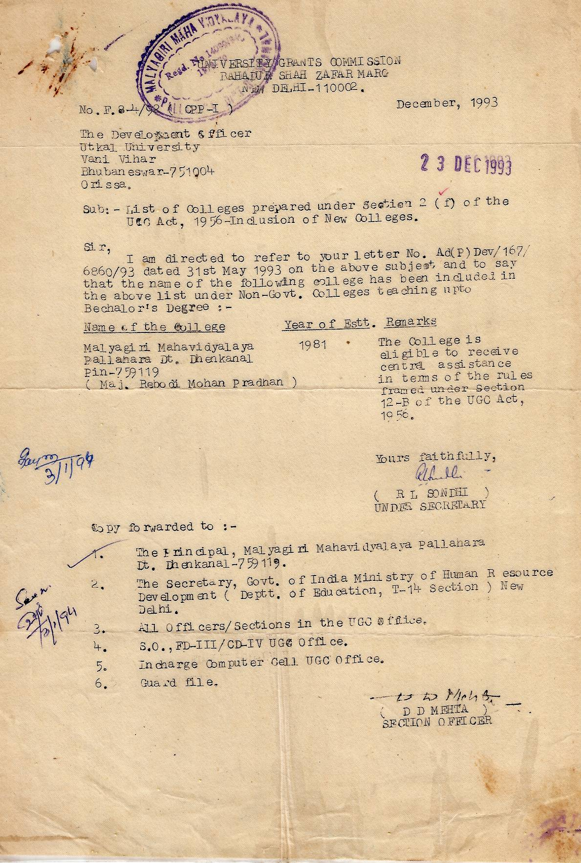
ANNEXURE-I
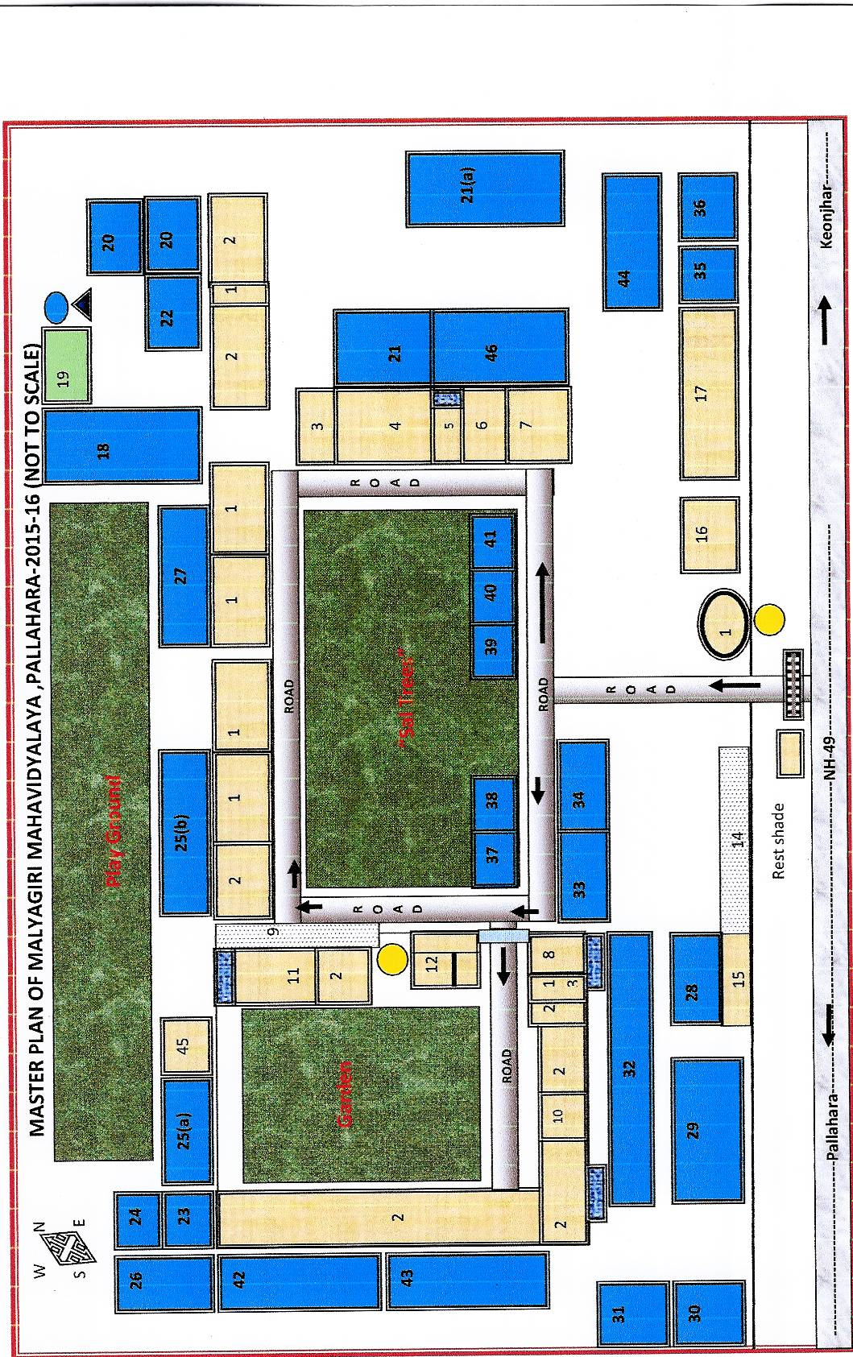
ANNEXURE-II
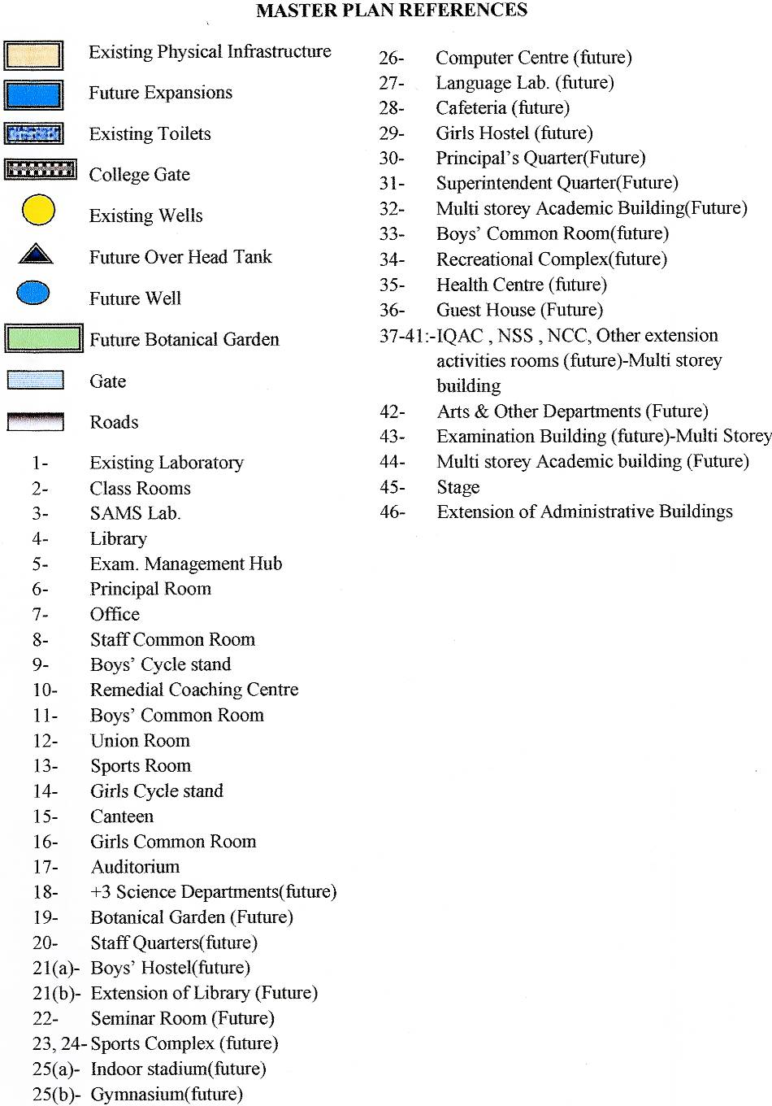
ANNEXURE-III
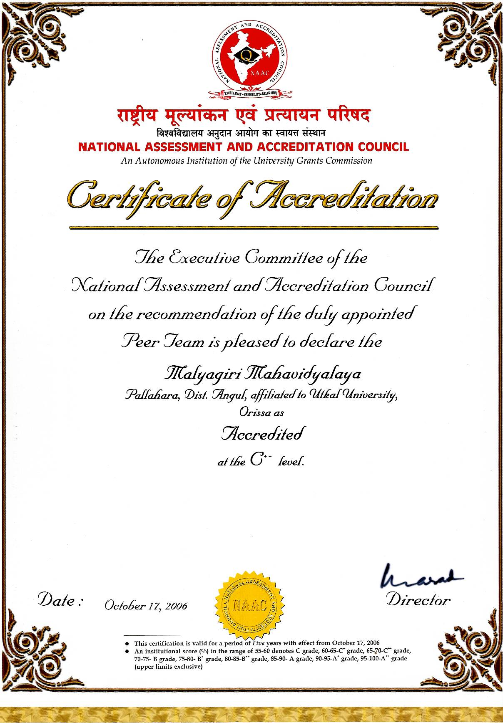
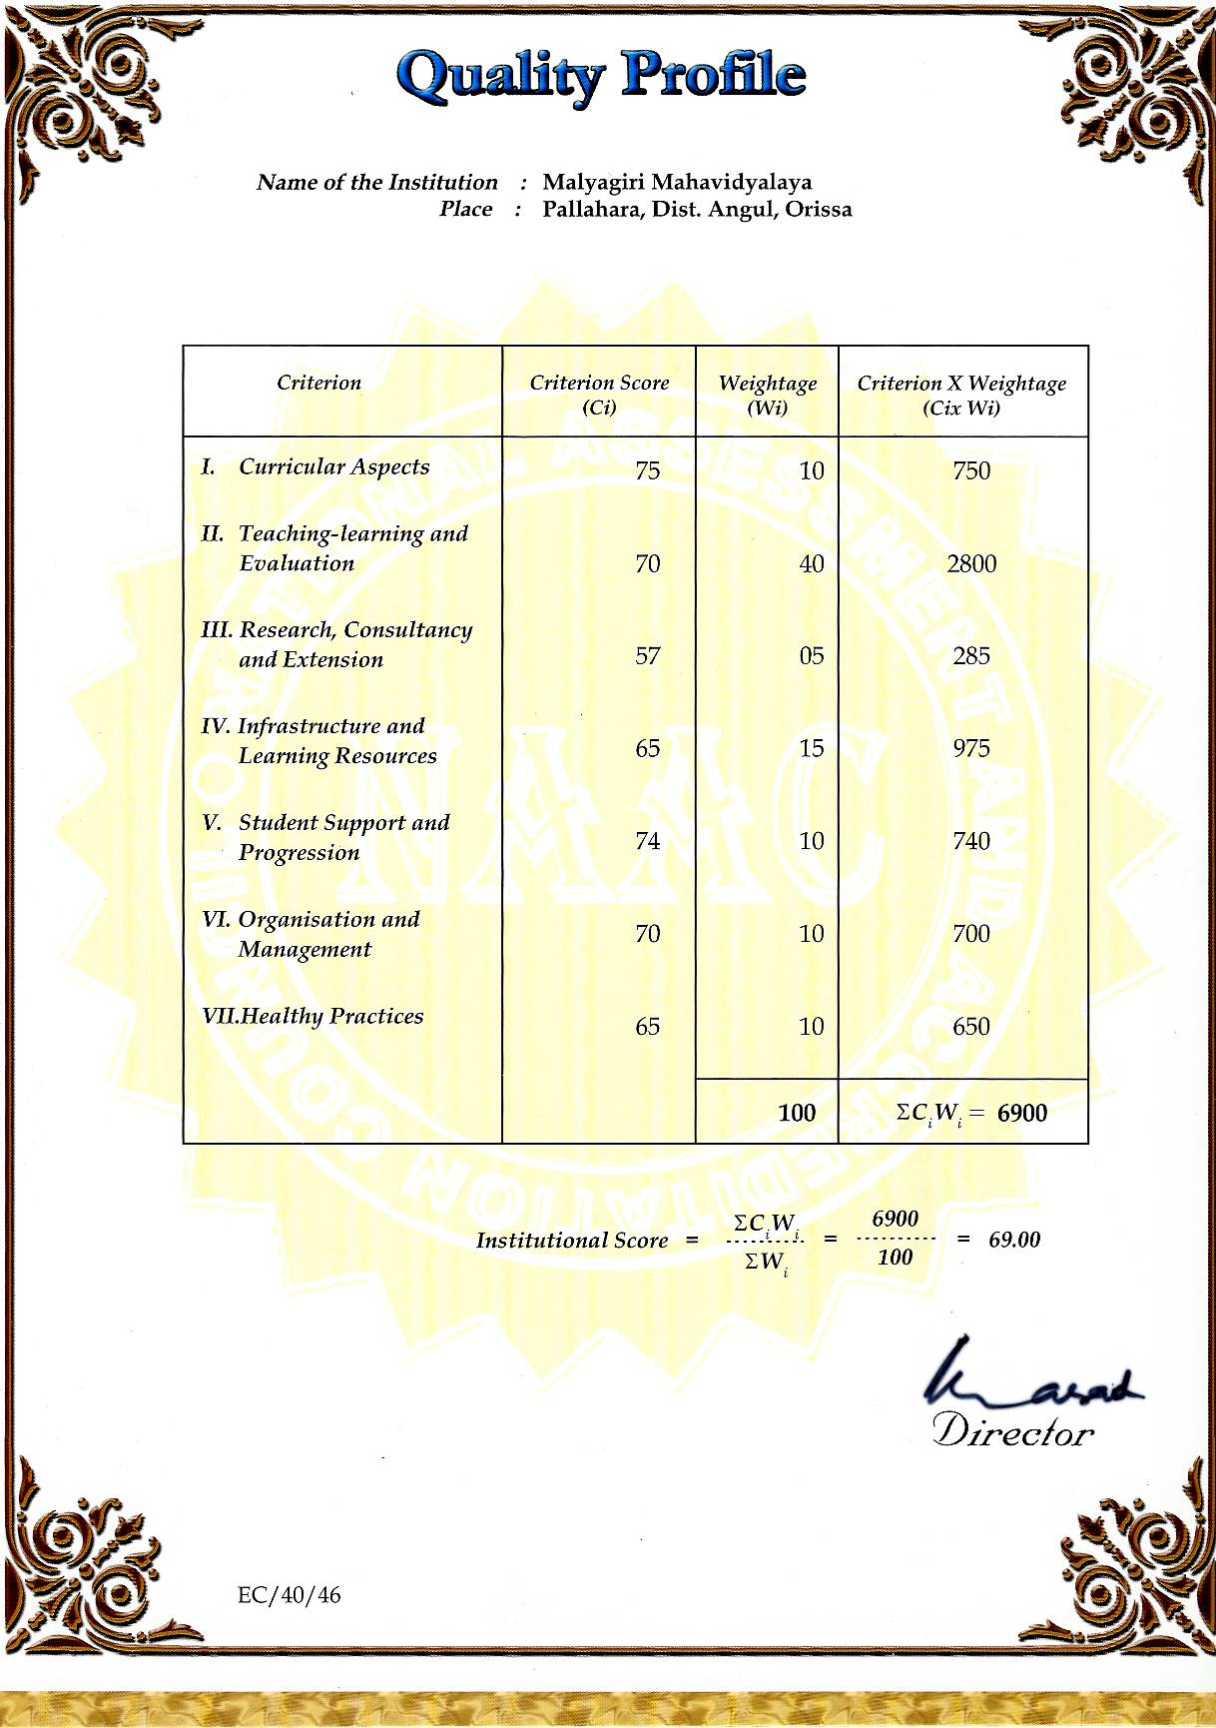

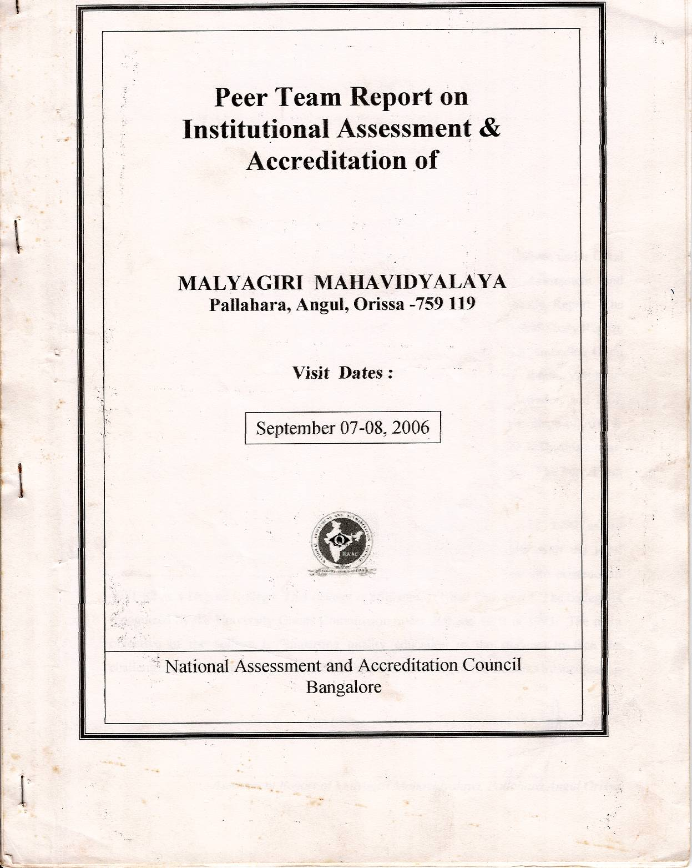
ANNEXURE-IV
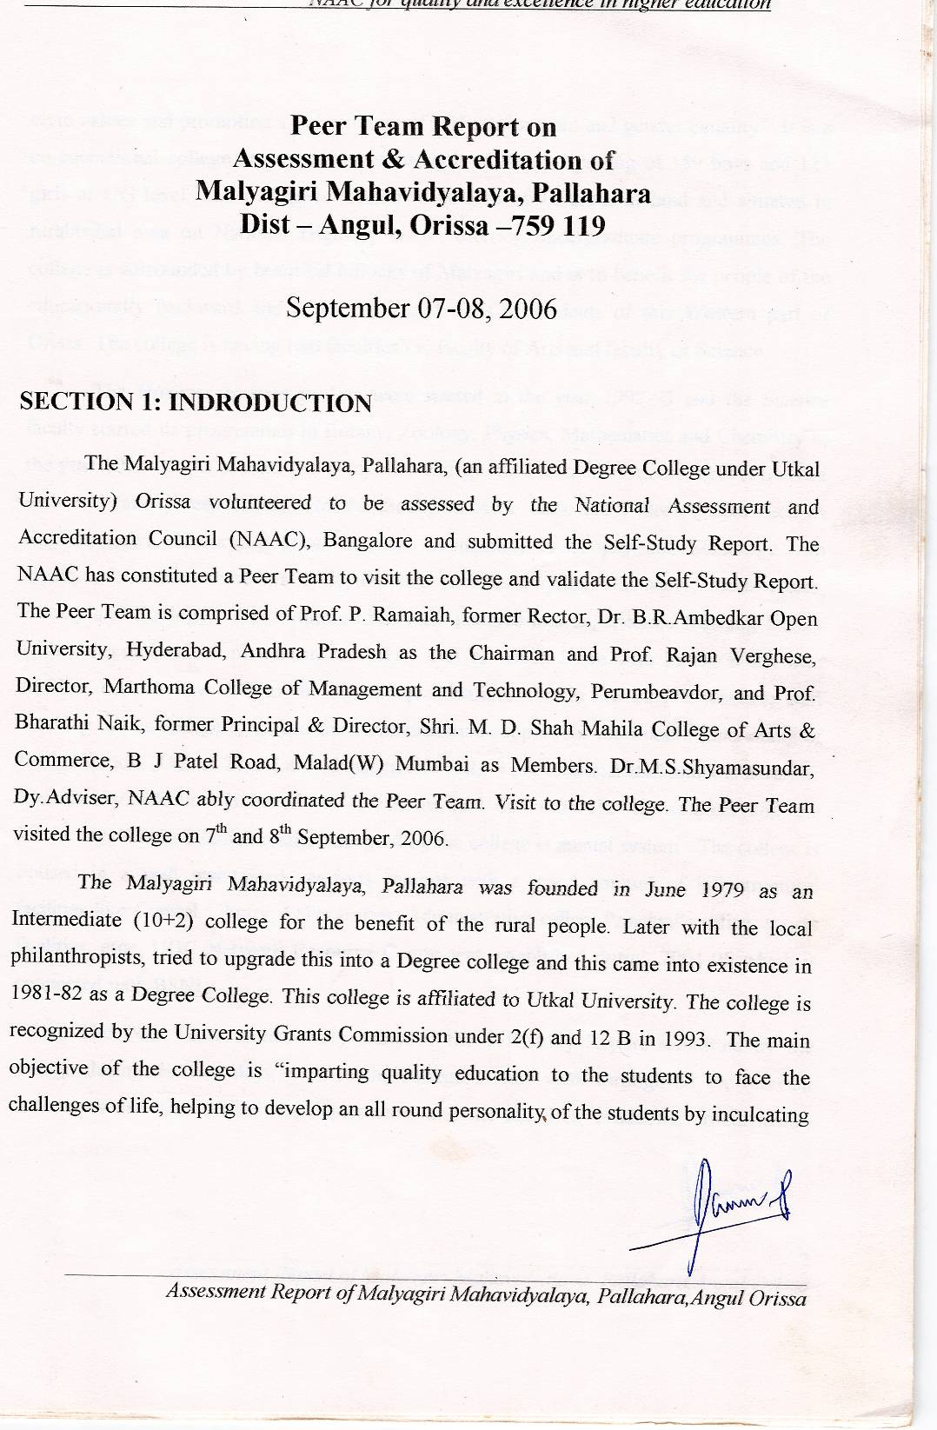

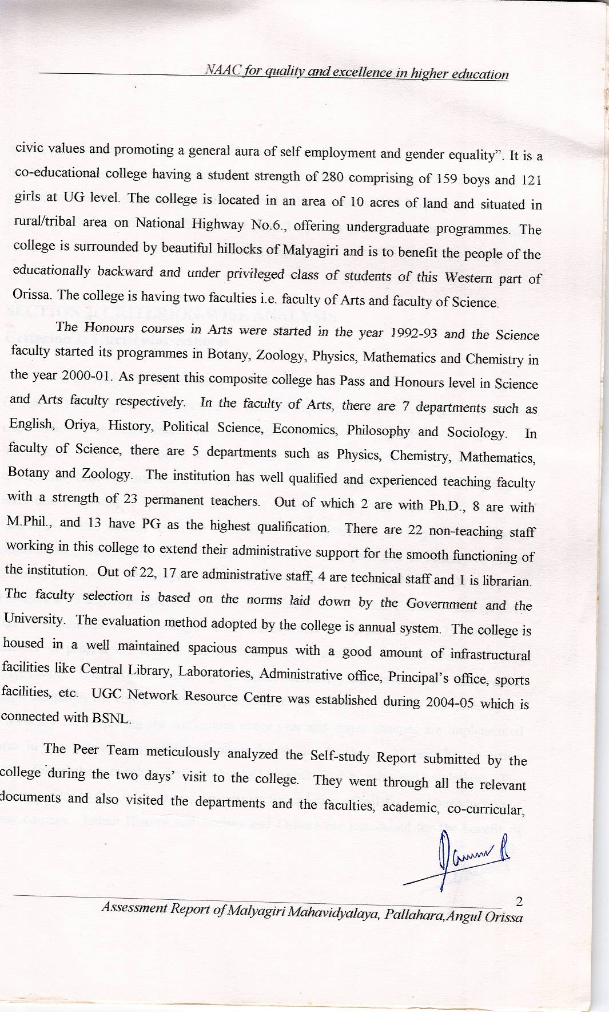
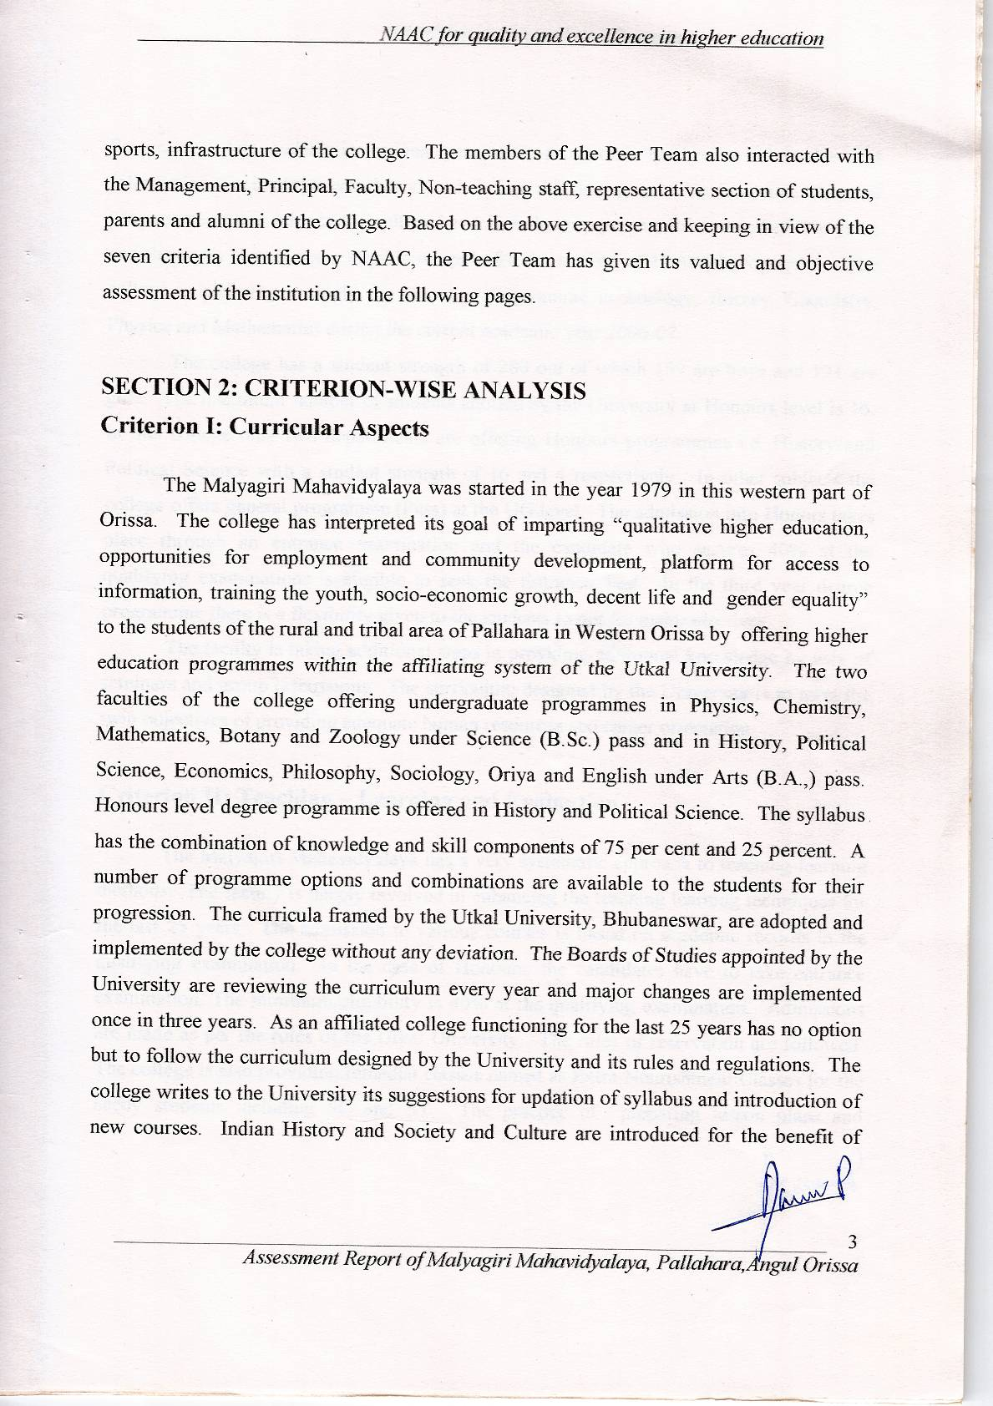

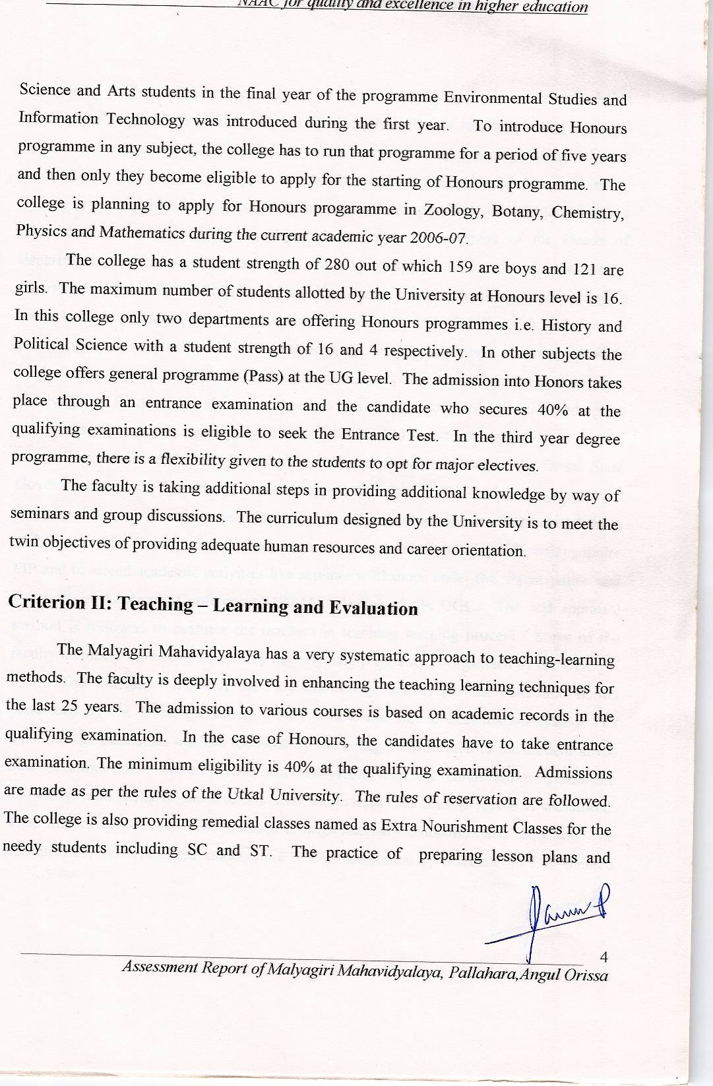

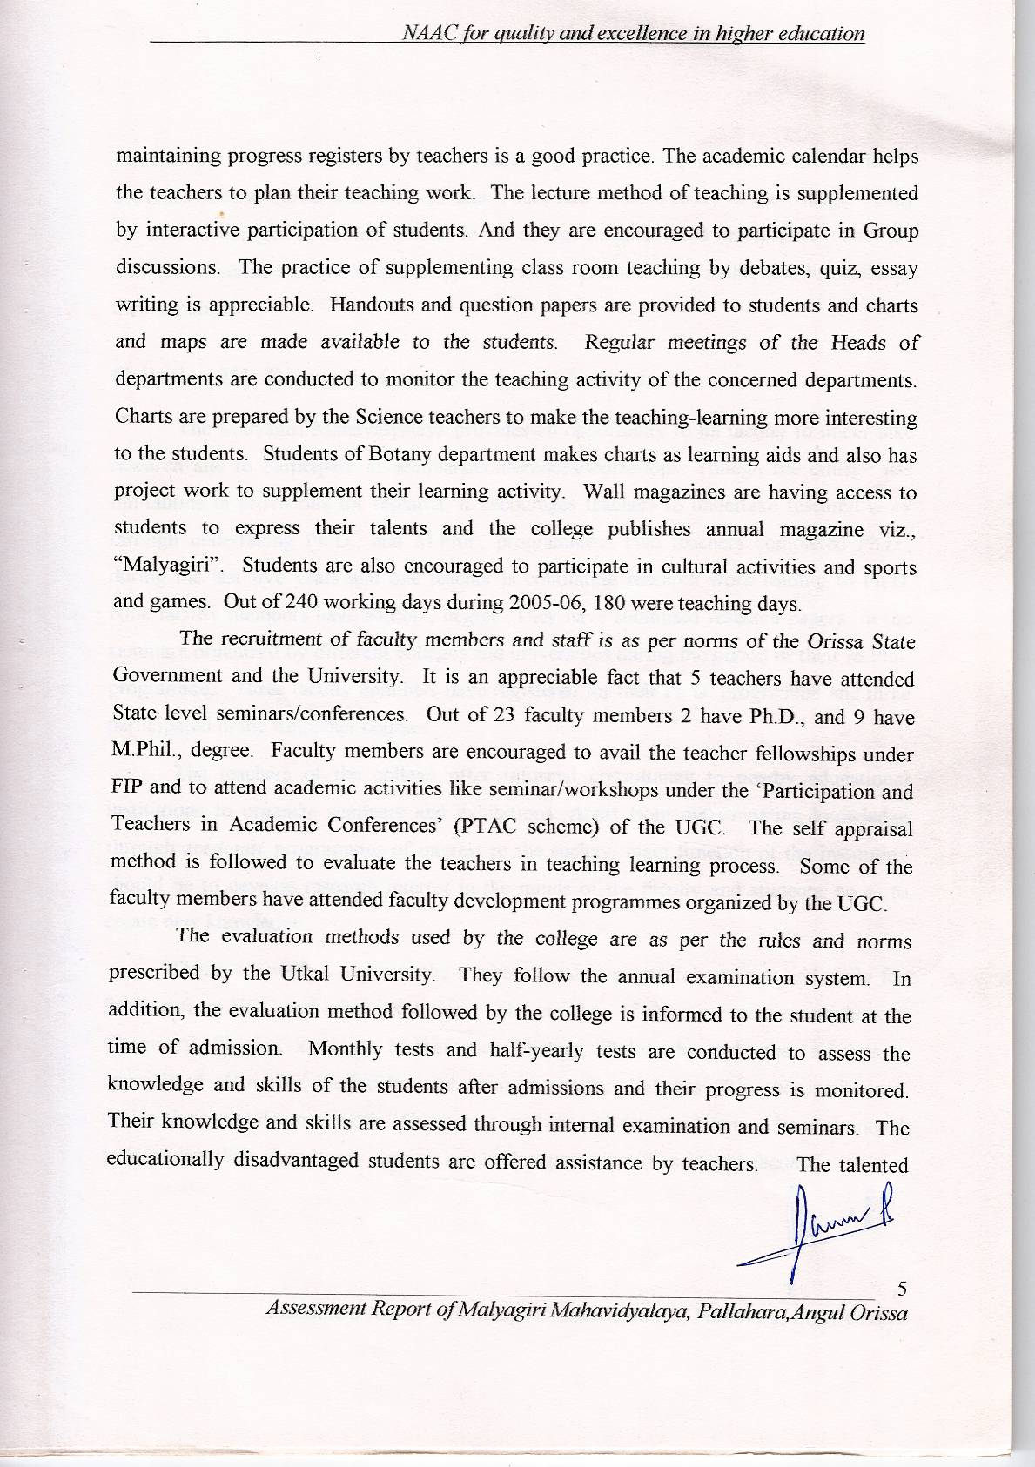
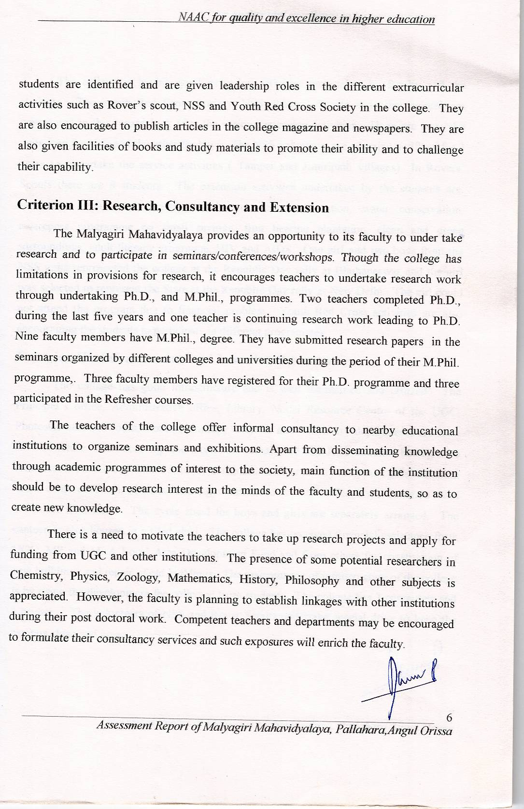
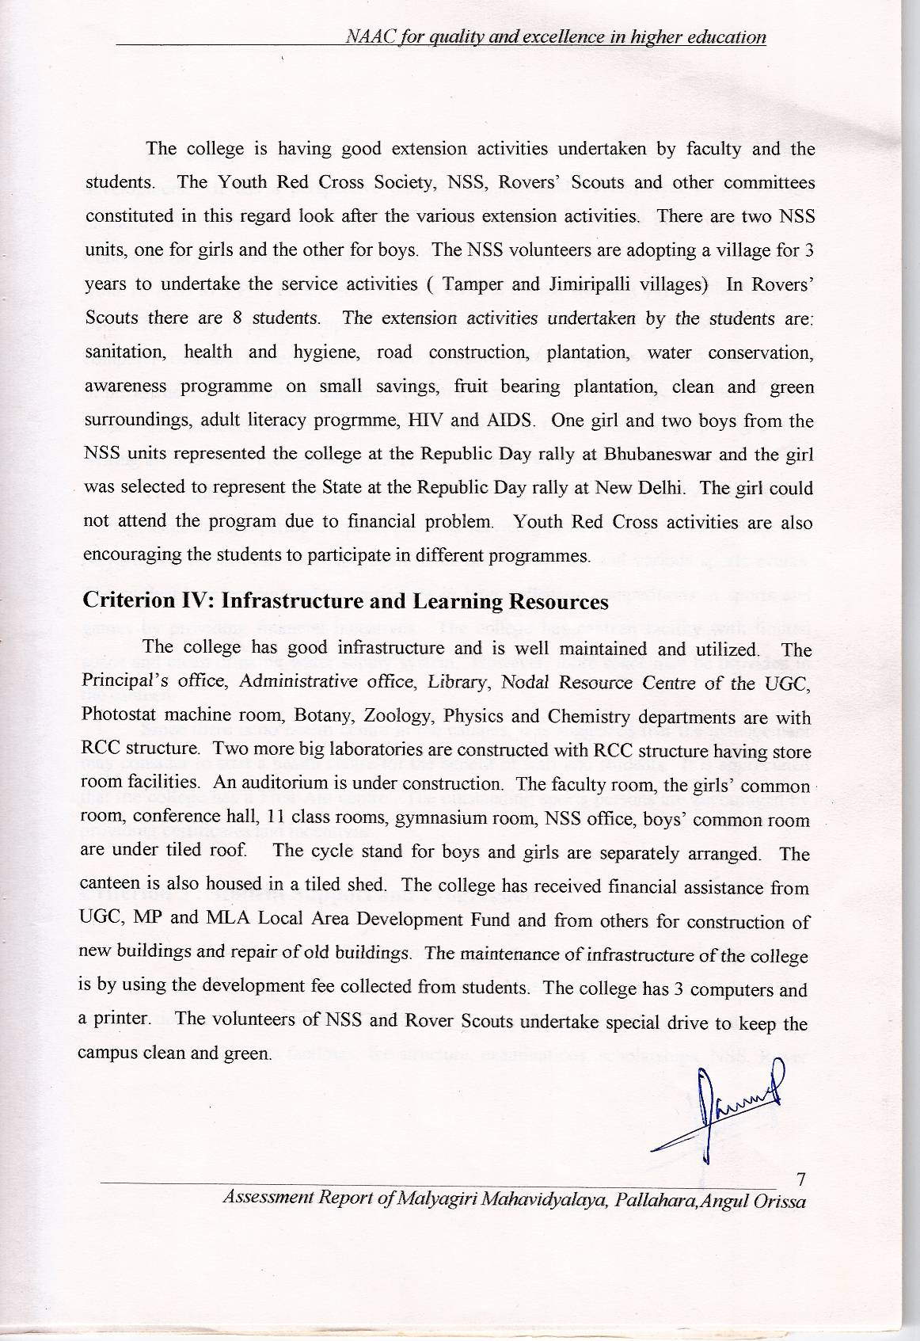

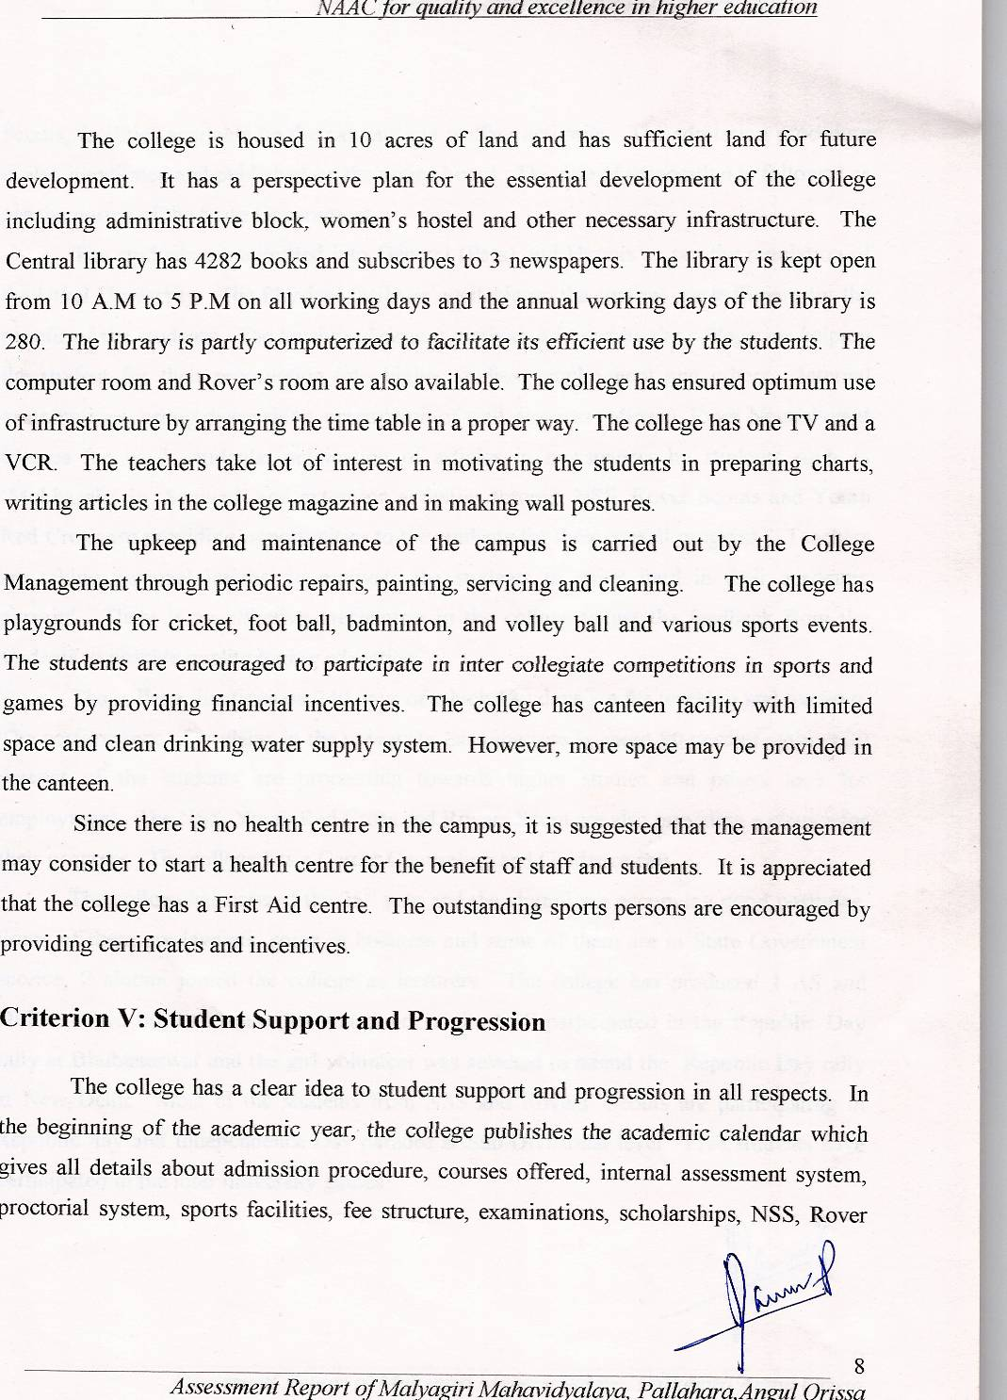

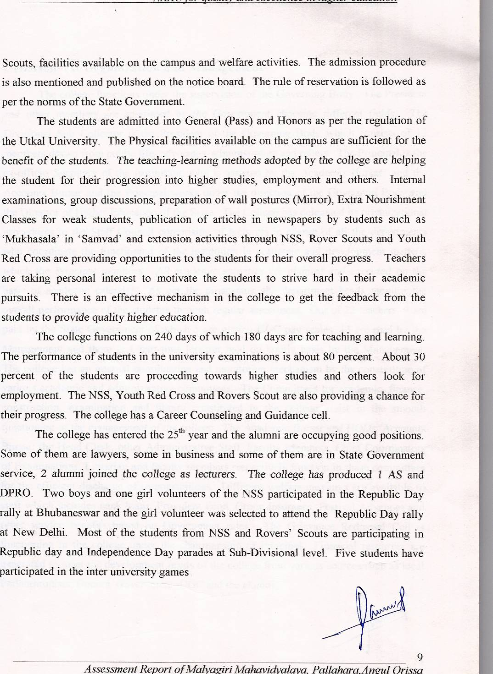

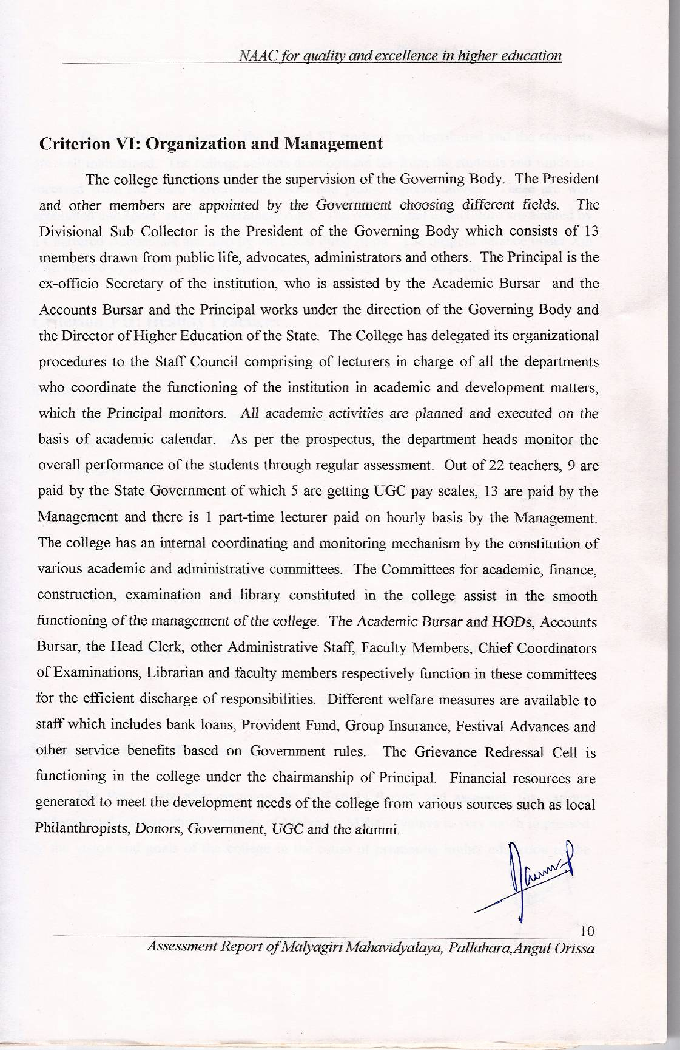
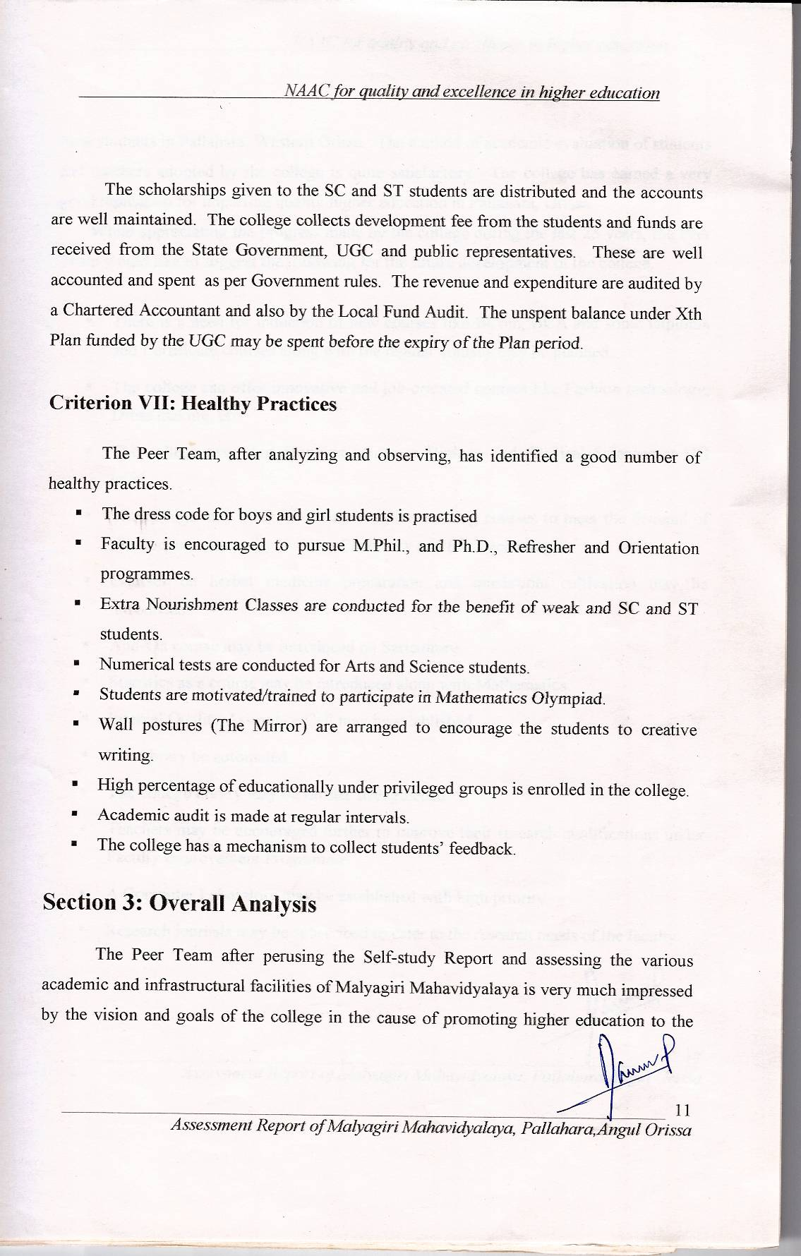
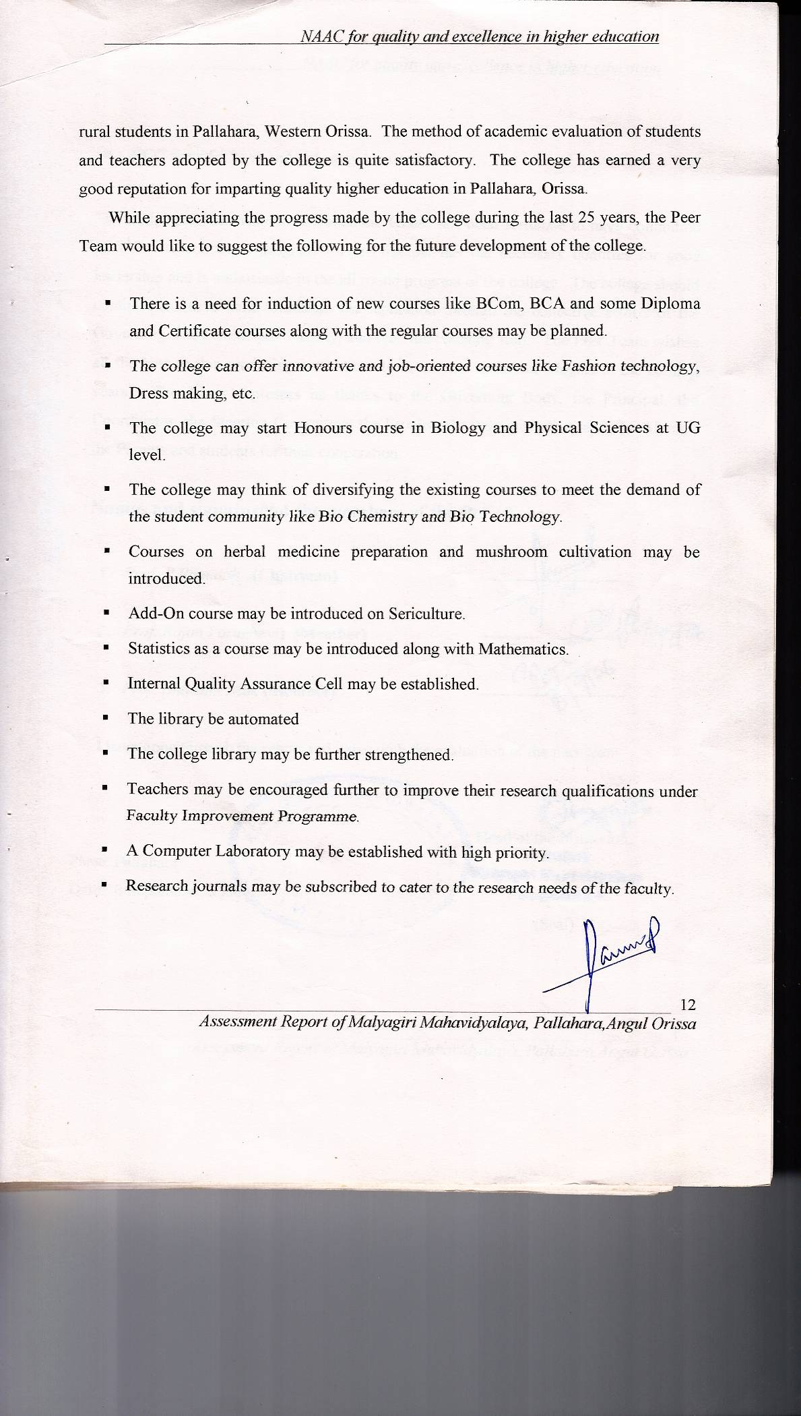
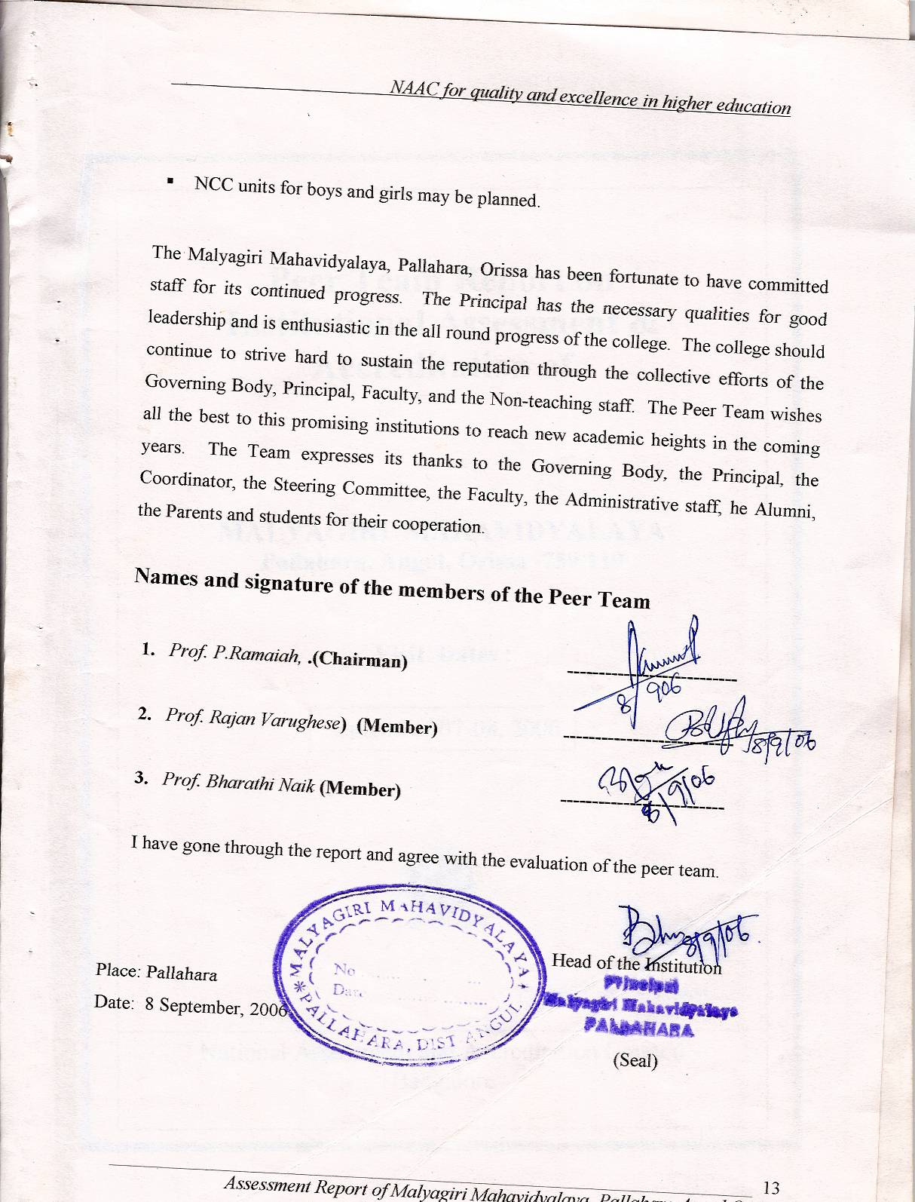

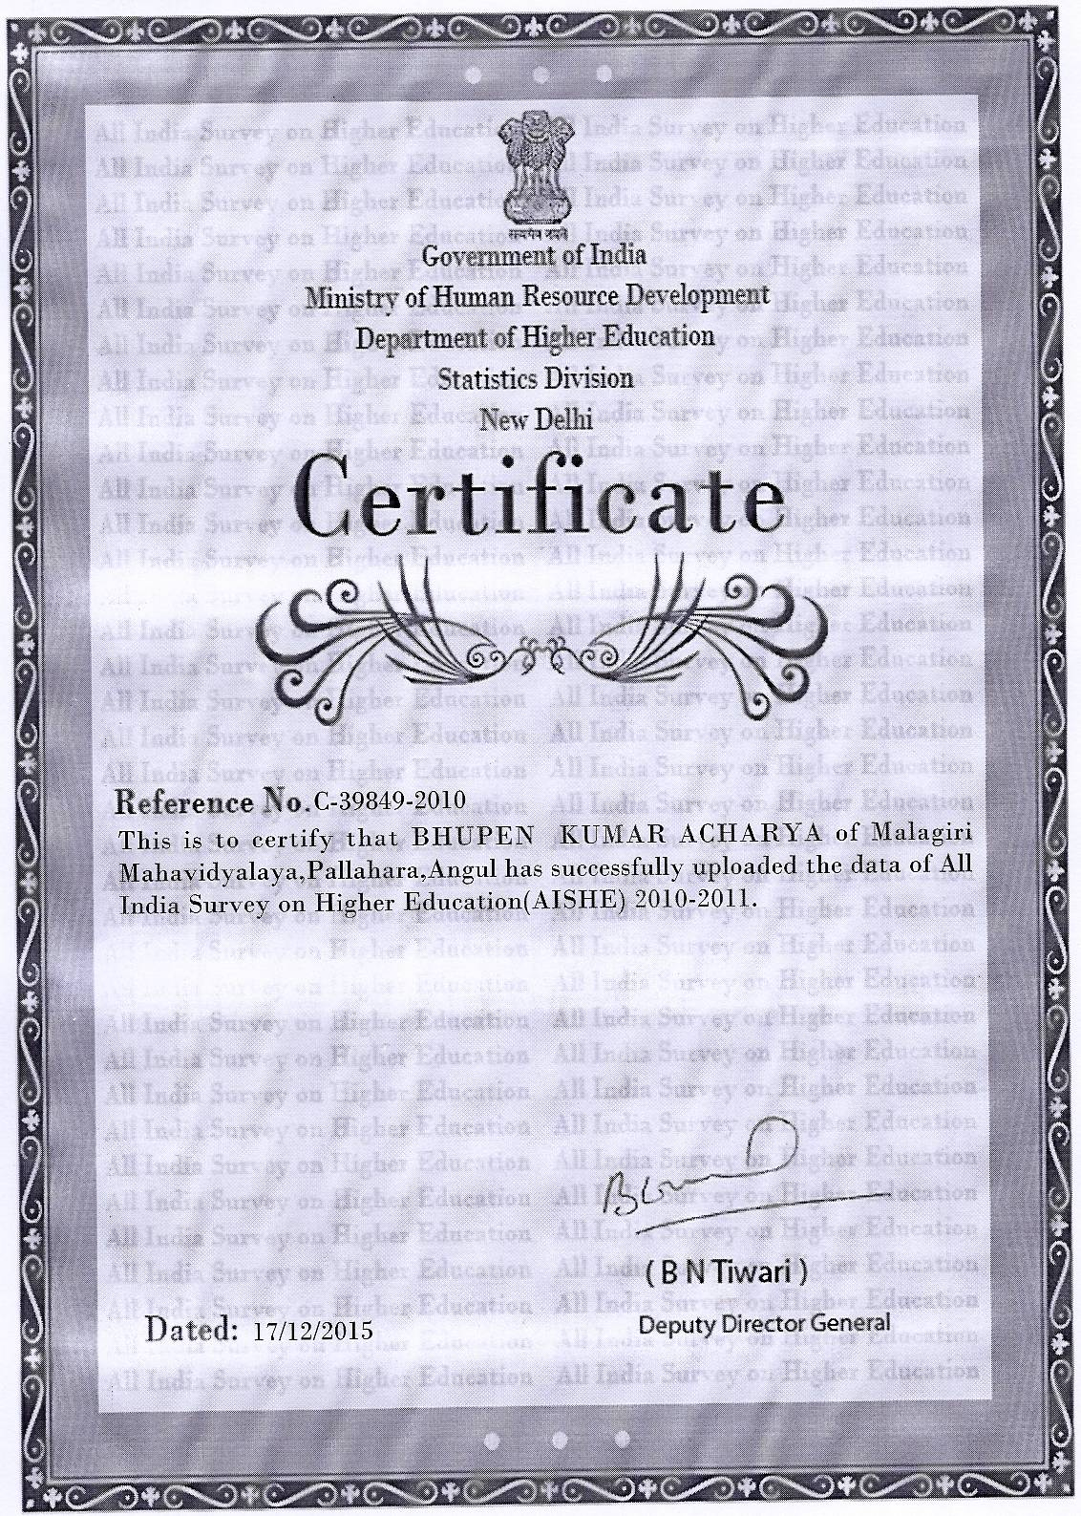
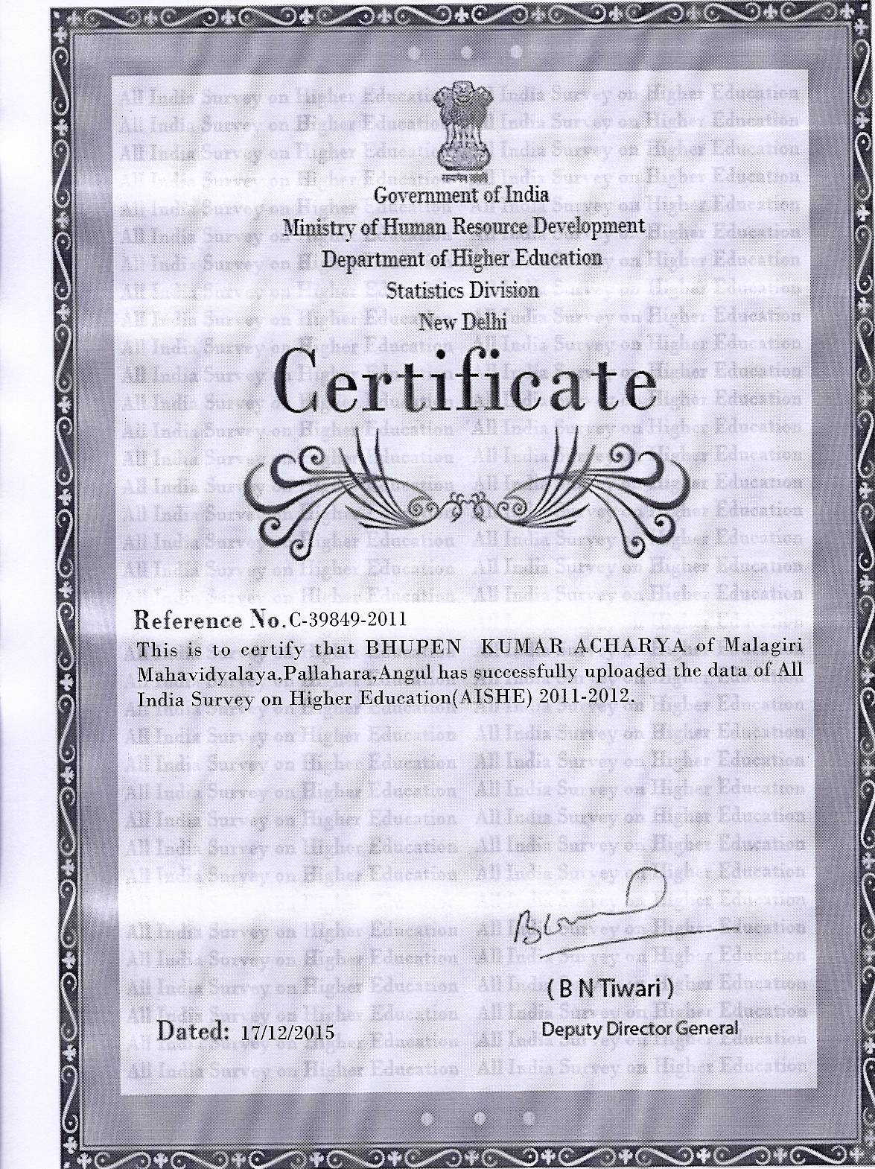
ANNEXURE-V
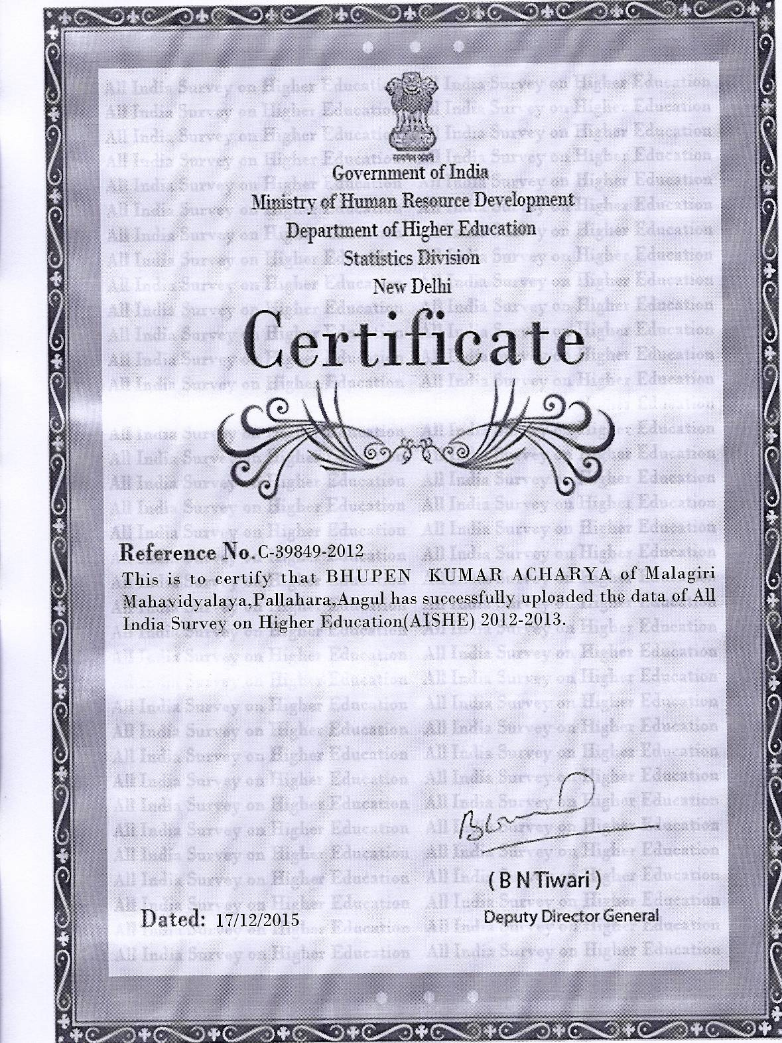

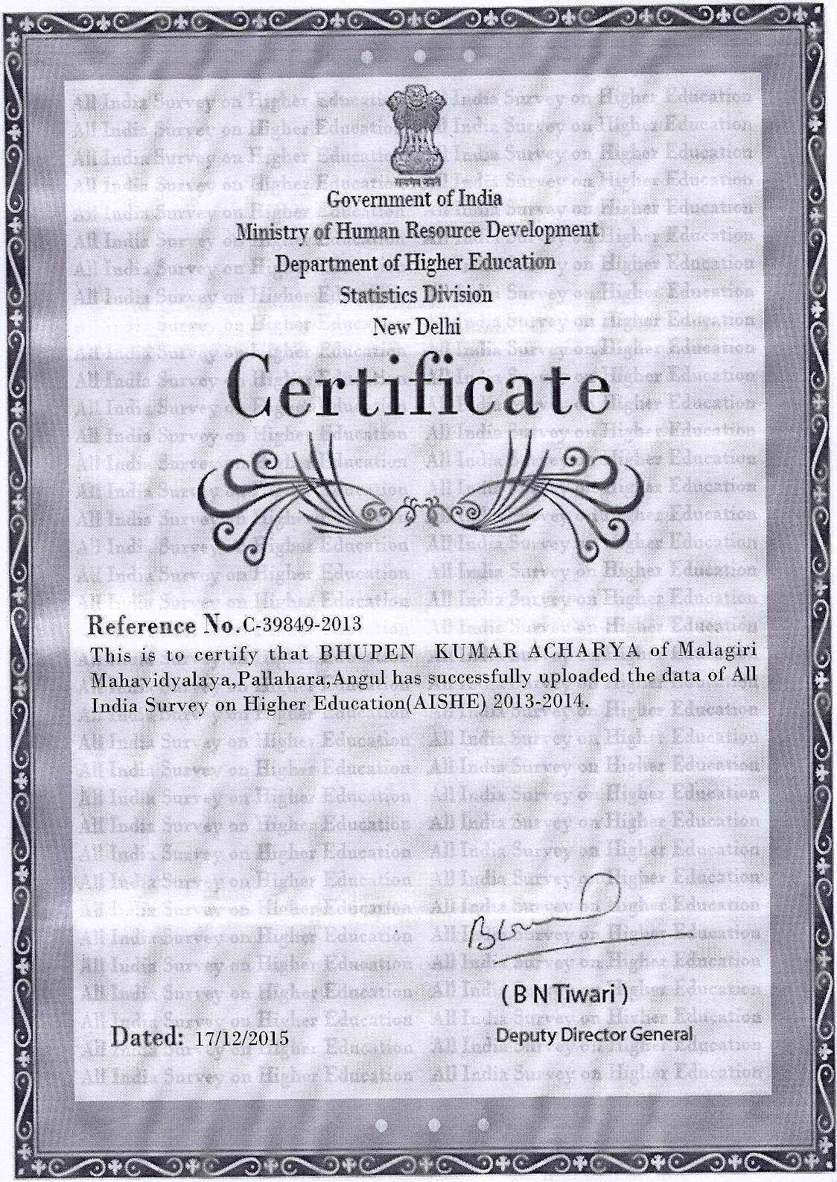

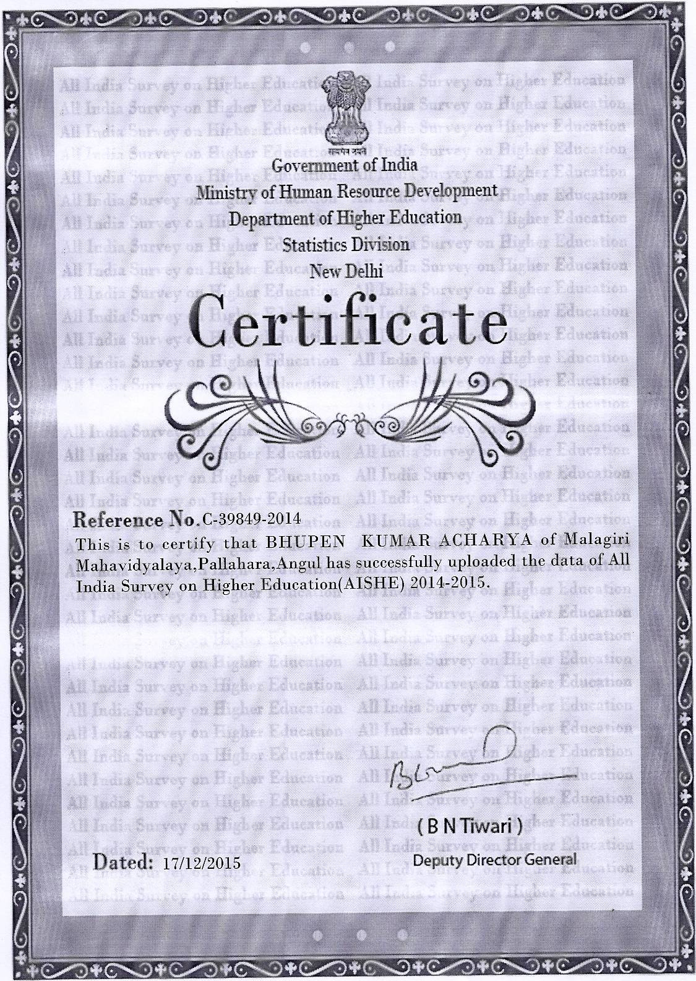
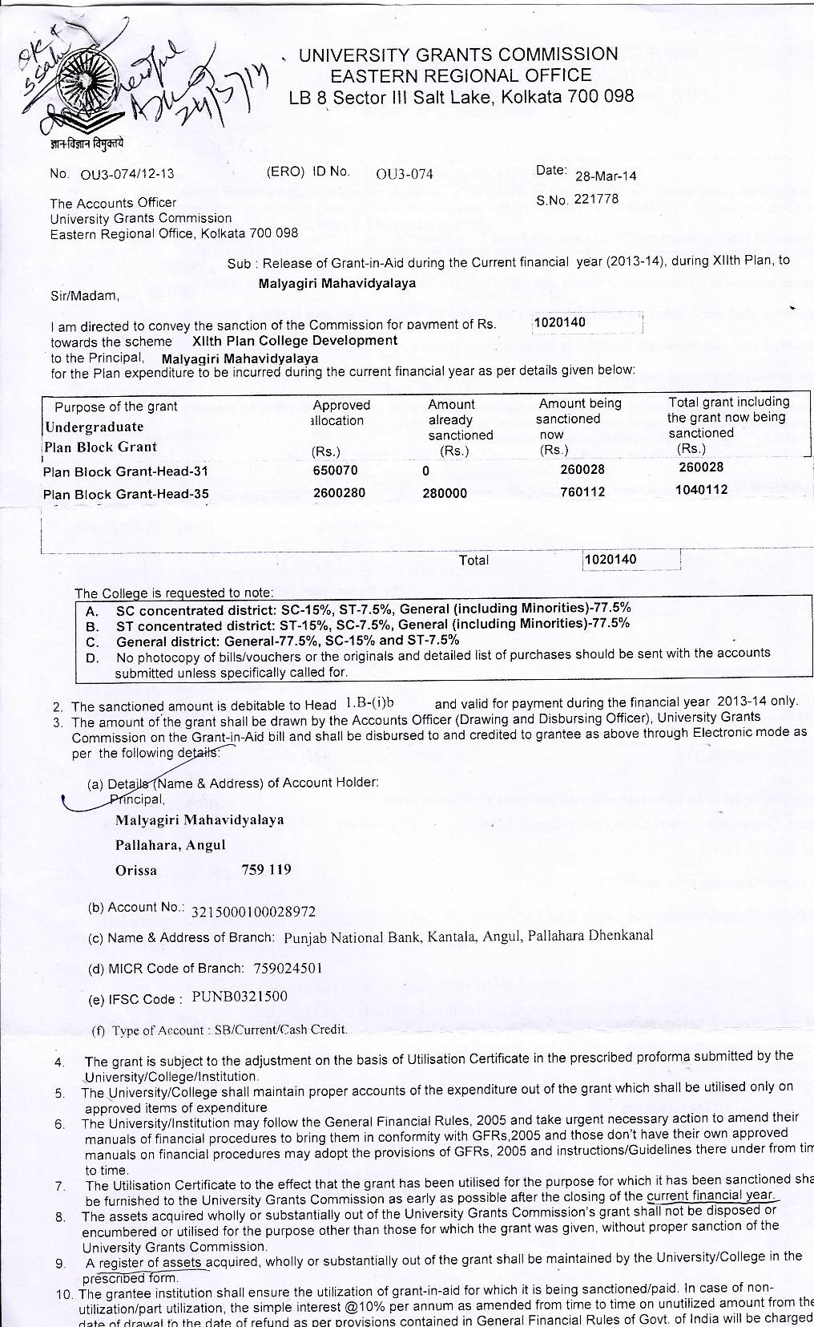
ANNEXURE-VI

The END
MALYAGIRI MAHAVIDYALAYA, PALLAHARA
(ODISHA)
NAAC Self Study Report-2015-16
(for 2nd Cycle)
LOCATION of the College
- Address :- AT/PO-Pallahara , Dist-Angul , Odisha PIN-759119
- Distance in Road from the Capital Bhubaneswar :- 220 KMs
- Nearest Railway Stations and road distance from Pallahara
a)Angul-Odisha :- 100 KMs
b) Dhenkanal ,Odisha- 150 Kms
c) Talcher –Odisha- 70 Kms
d) Rourkela-Odisha-130 Kms e) Bhubaneswar :- 200 Kms
4. Nearest Air Port : Biju Pattanaik International Air Port ,
Bhubaneswar (225 Kms from Pallahara by Road)

